 | June 2026
Sun | Mon | Tue | Wed | Thu | Fri | Sat
 | 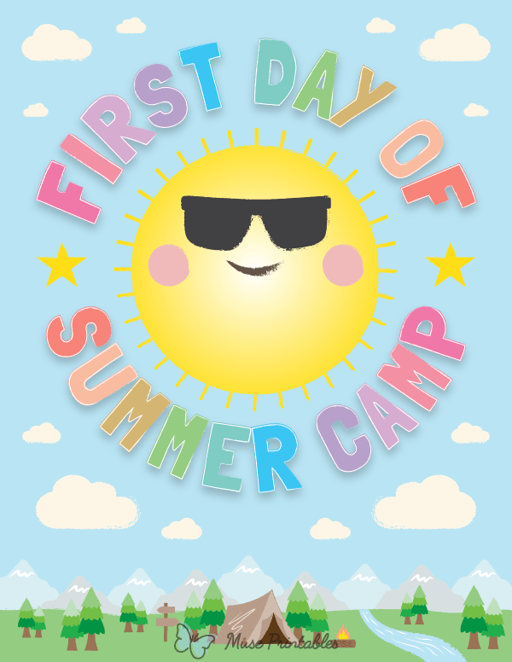  1 | 2 | 3 | 4 | 5  Civic Center Gym  South Gym  9:30-11:00 | 6  ACPL  Summer Reading Kick-Off  Washington Park    1-3 p.m. Shelter #1
7 | 8  Visit the Library | 9 | 10 | 11  WA Park  storytime 10:30 | 12  Civic Center Gym  South Gym  9:30-11:00 | 13
14 | 15  Visit the Library | 16 | 17 | 18  WA Park  storytime 10:30 | 19  Civic Center – North Gym  Open Public Play  OR  Park Outing  Father’s Day Treats in office | 20
  21 | 22  Visit the Library | 23 | 24 | 25  WA Park  storytime 10:30 | 26  Civic Center Gym  South Gym  9:30-11:00 | 27
28 | 29  Visit the Library | 30  Turn in reading logs for a prize! | Upcoming: July 24 last day of summer school  August 25 - First day of 2026-27 school year  **Other field trips and outings – to be determined and we will post where we are going on the office door**

