
The Open School
Director’s News

📅 Important Upcoming Dates
June 1: First Day of Summer School
July 24: Last Day of Summer School
July 25 – August 24: School Closed
August 25: First Day of 2026–27 School Year

Contact Information:
📞 School Phone: 307-745-7256
🌐 Website: www.laramieopenschool.org
📘 Facebook: facebook.com/laramieopenschool
From the Director – Shelly McFate
I’m available by email Monday through Friday from 8:00 AM to 5:00 PM at openschool1@hotmail.com. My in-person summer hours will be posted on my desk—please reach out if you need to meet with me outside of those times.
Assistant Director – Laura Shuler
If I’m unavailable, please contact Laura Shuler during the morning session.
📧 Email: prek1class@laramieopenschool.org
Weekly Summer Adventures
Each week is filled with fun, learning, and outdoor exploration! Here’s a look at our regular weekly activities:
- Monday Mornings: Library Visits
- Tuesday Mornings: Parks & Field Trips
- Wednesday Mornings: Science Activities or Water Play
- Thursday Mornings: Storytime at the Park
- Friday Mornings: Civic Center Gym Time
Outdoor Fun & Special Adventures
Children will also enjoy a variety of planned and spontaneous activities, including field trips, park walks, campus visits, splash pad outings, and special events at the library.
Please Note:
Whenever we are away from the school for an activity, a sign will be posted on the front door with our location. We will always be on-site during regular drop-off and pick-up times: morning arrival, 11:30 AM, and 3:00 PM through closing.
Water Play Days
To help your child stay cool and have fun this summer, we’ll enjoy water play on hot days!
Please keep a labeled towel and swimsuit at school throughout the season. We'll wash them as needed. Activities may include sprinklers, kiddie pools, and visits to the splash pad or wading pool.
Independence Day
We are scheduled to be open normal hours on July 3rd. However, if your child normally attends on Friday and will be absent for that Friday holiday weekend, please let me know so we can adjust our staffing needs for that day. Thank you.
Summer Schedules & Attendance
We understand that summer plans can change! If you need to make a schedule change for your child, please connect with Shelly directly. We do appreciate a message if your child is going to be absent.
To add a session (such as a morning, afternoon, lunch, or after-school slot), please check with our staff first to see if space is available. If we’re able to accommodate, your child is welcome to attend, and the additional session will be included on your next statement. Extra session fees are outlined in the parent handbook.
Please note that we must follow teacher-to-child ratios to remain in compliance with licensing requirements, so all schedule changes and additions are subject to availability.
As a reminder, we do not offer make-up days. If your child misses a scheduled session, we are unable to reschedule it without applying the extra session fee. This policy is in place year-round to ensure we have the appropriate staffing for the number of children scheduled each day.
Thank you for your understanding and cooperation!
Classrooms:
If your child will be attending Kindergarten this August, they will be in Room 2 (currently Miss Joni’s classroom). If they will be returning to Open School this August, they will be in Room 1 (Miss Laura’s classroom). The children will vote to choose names for their classrooms for the summer (for example: Bears, Sharks, etc.).
Summer Staff:
Room 1 – Laura/Brea
Room 2 – LeeAnna/Alison
Support Staff/After School: Myah, Lucy, Avery


Thanks to UniWyo!
Each child will have a UniWyo drawstring bag to use to carry to field trips and park walks. Please leave those here for daily use. Your child can bring their own backpack daily if they wish as well, but the drawstring bags are for school use. UniWyo donated the bags for summer! Thank you!

Summer Supply List – Please label all belongings
*Swimsuit – to be left here all summer (we will wash)
*Towel – to be left here all summer (we will wash)
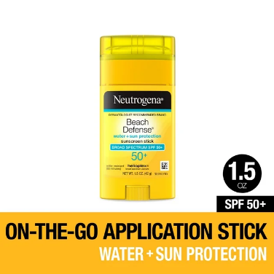
*Sneakers – walking shoes - if you have an extra pair to leave here, in case they arrive in sandals, or have them wear comfortable walking shoes to school daily, as we will walk frequently to parks
*Spray Sunscreen – please bring 1-2 bottles of spray sunscreen bottles to share, unless your child requires their own. If your child requires their own, please bring it on the first day, labeled.
*Stick Sunscreen – an application stick, labeled with your child’s name – to be used on their faces/heads (not shared).
*Bug spray – 1 bottle to be shared of family friendly spray. If your child requires their own, please bring it labeled the first day.
*Water bottle – non-leaking, labeled – will be carried to the parks, outside, used daily. Please wash it here in kitchen or take it home and wash it regularly.
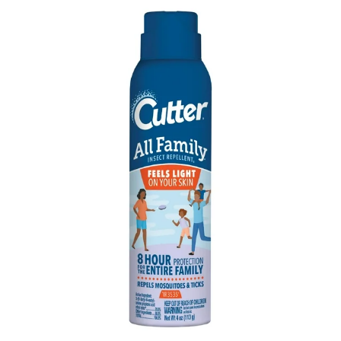
*1 package of “otter pops” or other freeze stick popsicles– we go through a lot of these during the summer!
*1 pack of flowers/vegetable – something to plant in our garden boxes and flowerpots during the first week, a small veggie/fruit like strawberries, cherry tomatoes, peppers, etc. or a flower pack for the pots on the front patio
*Snacks – daily morning snack, after school snack (if attending) and extra snacks on hand– kiddos get hungry a lot in the summer with extra activity. We always appreciate donations of general shared snacks as well – goldfish, graham crackers, etc.
*Lunch box – if attending lunch time 11:30-12:30
*Light jacket – if you have a spare jacket or hoody to leave here in case the weather changes or bring one daily.
*Bike helmet – labeled, to be used anytime children are riding bikes/trikes/cars on bike path

Please note: There will be a $25 supply fee for other summer school supplies added to your June statement to cover general classroom supplies for the summer.
