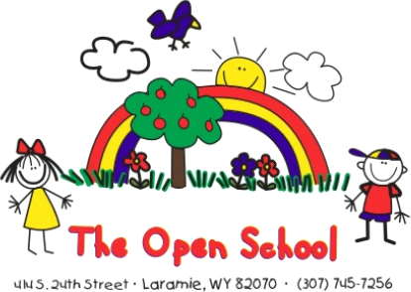

The Open School News and Updates

Upcoming:
Week of the Young Child Fair – April 11
Week of the Young Child –April 11-17
Scholastic Book Fair – End of April
May 15- Graduation/Year-End Celebration – Year End Event: May 15th, 2:00 p.m.
May 22 – Last day of school year (school closed May 23-May 31)
June 1- first day of summer school

Year-End Graduation Celebration - Save the Date!
Our Year-End Graduation Celebration will be held on
Friday, May 15 at 2:00 p.m. in the Civic Center South Gym.

While our final day of school is May 22, we celebrate a little early so that more of our families and staff can be present to share in this special occasion.
This joyful event is a time for our entire school community to come together and celebrate the growth, accomplishments, and milestones of our students. All classrooms will participate in a move-up or graduation celebration, and we look forward to honoring each child as they take their next exciting step!

Summer Enrollment
It’s not too late to enroll in our summer program—we have 8 weeks of fun planned!
- Summer session: June 1–July 24
- Enrollment forms are available in the office
- Please contact Shelly for assistance or more information

Kindergarten Registration – April 20-24
From the ACSD1 website, Kindergarten Registration for the 2026–2027 school year will be open April 20–24. Children must be five (5) years old on or before August 1, 2026 (birthdate on or before August 1, 2021) to enter Kindergarten in 2026–2027. A pre-registration form is available on the ACSD1 website to begin the process.

You can find more information here:
acsd1.org/page/student-enrollment

Flyers for Snowy Range Academy and the District’s Dual Language Immersion Program were placed in cubbies and are also available in the office.
Staff Changes
We are excited to welcome Miss Eralys, Miss Maddie, and Miss Lucy to our team! These new staff members will be helping support students, especially during lunch and after-school hours. We are also happy to share that Mr. Corbin will be assisting during some after-school times as well. A special note of pride: Miss Lucy and Mr. Corbin are both Open School alumni, and we are thrilled to have them as part of our school community!
As mentioned in last month’s newsletter, we also have some upcoming changes in our teaching staff for the next school year. Miss Brea will be stepping into the role of Preschool teacher this fall, and Miss Reanna will be moving into our TK classroom as lead teacher.
We are excited for both of them as they begin these new roles and are grateful for the consistency, care, and dedication they will continue to bring to our school community.

Spring Raffle Fundraiser
Our Spring Raffle kicks off May 1, and we are currently gathering items for this year’s event! We will officially launch the raffle at the beginning of May—but now is the perfect time to donate. We are currently seeking raffle contributions such as gift certificates, art-related items, themed baskets, and unique experiences. If you or your employer would like to support The Open School through a donation, please see Shelly. As a nonprofit organization, we are happy to provide a tax receipt for all donations. All donors will be recognized on our website, social media, and raffle materials, making this a wonderful opportunity to support our school while also highlighting your business or organization. To help us prepare for the online auction, we hope to have all donations collected by mid-April. Thank you for helping make our Spring Raffle a success!
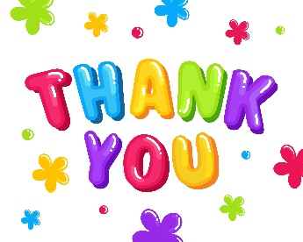
A special thank you to the Aukerman family, Stacie Morrison and Summit View Dentistry, the Pischel family, and the Tupling family for the generous donations they have already provided for the raffle.

Week of the Young Child
We are excited to celebrate the National Association for the Education of Young Children (NAEYC) 2026 Week of the Young Child®, taking place April 11–17!

Week of the Young Child is a joyful celebration of early learning, young children, and the adults who support them. Through fun themed days like Music Monday, Tasty Tuesday, and Artsy Thursday, the week highlights the importance of play, creativity, and hands-on learning in early childhood development. www.naeyc.org

Here in Laramie, The Open School will also be participating in the Week of the Young Child Fair on April 11. Please see the attached flyer for more information, and stop by to visit The Open School table!
We will also be celebrating all week long in our classrooms with activities tied to each of the themed days.

