 | THE OPEN SCHOOL - MARCH 2026
Sun | Mon | Tue | Wed | Thu | Fri | Sat
1 | 2  Fall Enrollment Papers Due | 3    Music with Miss Meghan – afternoon | 4  Swim lessons in the afternoon  PreK 1:30-2:00  TK – 2:00-2:30 | 5  Spanish with Miss Brea – aft. | 6  UW Art Museum  Miss Joni’s Class 10:00    Storytime with Miss Margaret - afternoon | 7
  8 Daylight Saving Begins | 9  Sign Language –  last session for school year – with Miss Savannah - afternoon | 10  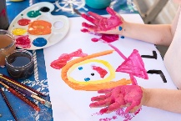  Music with Miss Meghan – aft.  Art Show – UW Art Museum, Ground Level, 5:30-7:00  Open house style – stop by when you can to enjoy the art | 11  Swim lessons in the afternoon  PreK 1:30-2:00  TK – 2:00-2:30 | 12  Spanish with Miss Brea – aft. | 13  UW Art Museum  Miss Laura’s Class 10:00  Storytime with Miss Margaret – afternoon | 14
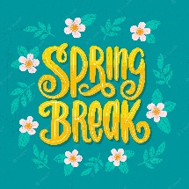  15 | 16  Spring Break  School Closed | 17 St Patrick's Day    School closed | 18  School closed | 19  School closed | 20 Start of Spring  (Spring Equinox)    School closed | 21
22 | 23 | 24  Music with Miss Meghan – afternoon | 25  Swim lessons in the afternoon  PreK 1:30-2:00  TK – 2:00-2:30 | 26  Spanish with Miss Brea – aft. | 27  UW Art Museum  Miss Reanna’s Class 10:00 | 28
29 | 30 | 31  Music with Miss Meghan – afternoon | Upcoming Dates:  May 15- Graduation/Year-End Celebration May 15th, 2:00 p.m.  May 22 – Last day of school year (school closed May 23-May 31)  June 1 – First day of summer school

