 | The Open School - January 2026
Sun | Mon | Tue | Wed | Thu | Fri | Sat
 |  |  | 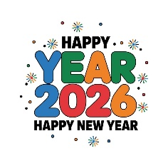 | 1 New Year's Day  School Closed | 2  School Closed | 3
4 | 5  School Resumes  Sign Language – afternoon | 6 | 7 | 8  Spanish – afternoon | 9  UW Art Museum  10:00 Miss Joni’s Class  Storytime with Miss Margaret | 10
11 | 12  Sign Language – afternoon | 13 | 14 | 15  Spanish – afternoon | 16  UW Art Museum  10:00 Miss Laura’s Class  Storytime with Miss Margaret | 17
18 | 19 Martin Luther King Jr.  School Closed – District Wide | 20  Music – afternoon | 21 | 22  Spanish – afternoon | 23  UW Art Museum  10:00 Miss Reanna’s Class  Storytime with Miss Margaret | 24
25 | 26  Sign Language – afternoon | 27  Music – afternoon | 28 | 29  Spanish – afternoon | 30  Storytime with Miss Margaret | 31
Upcoming Dates:
February 13, 11:30 dismissal (district wide early dismissal)
February 16, school closed (district wide)

