 | The Open School - February 2026
Sun | Mon | Tue | Wed | Thu | Fri | Sat
1 |   2 Groundhog Day  Sign Language afternoon | 3  Music - afternoon | 4  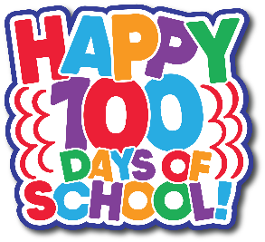 | 5  Spanish - afternoon | 6  Art Museum - 10:00  Miss Joni | 7
8 | 9  Sign Language afternoon | 10  Music – afternoon  Board Meeting 6 p.m. | 11  Swim lessons afternoon  PreK - 1:30-2:00  TK - 2:00-2:30 | 12  Spanish - afternoon | 13  School Dismissal 11:30 a.m. | 14 Valentine's Day  
15 | 16 Presidents Day  No School – District Wide  Open School Closed | 17  Picture Day #1    Info will be in cubbies  Music - afternoon | 18  Picture Day #2  Swim lessons afternoon  PreK - 1:30-2:00  TK - 2:00-2:30 | 19  Spanish - afternoon | 20  Art Museum 10:00  Miss Laura | 21
22 | 23  Sign Language afternoon | 24  Music - afternoon | 25  Swim lessons afternoon  PreK - 1:30-2:00  TK - 2:00-2:30 | 26  Spanish - afternoon | 27  Art Museum 10:00 a.m.  Miss Reanna | 28

Upcoming Dates: March 10, Open School Art Show at UW Art Museum (5:30-6:45 open house style)
March 16-20 Spring Break – Open School (and District) Closed

