
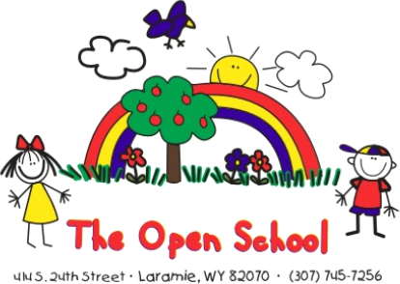
Miss Shelly’s December News

UPCOMING DATES
December 20 thru January 4 – Winter Break, school closed, district wide
January 5 – school resumes, normal hours
January 19 -School closed, district wide, MLK Day
Hold the Dates:
Spring Student Art Show – UW Art Museum – March 10 – evening
May Graduation – Year End Event: May 15th, 2:00 p.m.
*****************************************************************************

Just a quick December news to say THANK YOU! We had a great semester!

Poppin’ Popcorn Fundraiser
Our Poppin Popcorn was a success, raising almost $3500! This is our first year with this fundraiser, so please provide any feedback as to the quality, taste, ease – positive or negative thoughts – so we can decide whether to keep this as our fall fundraiser. We appreciate all the support!

Community Connections – Angel Tree
A big thanks to all of you that were able to pitch in to help make Christmas special for Laramie families! It was short notice this year, and you really came through and made a difference!

A note from Julie Radosevich – Event Organizer: “Just for an update we have adopted 205 families this year this adds up to 910 individuals 515 of which are children. This is nine more families than last year and with everyone's help they have all been adopted. Thank you so much for your help again this year. You can join me in my tradition of getting up on Christmas morning and imagining how happy all the children are across Laramie because of all the amazing people like you who have made sure our children are able to have a Merry Christmas.”

Holiday Spirit Week
See attached flyer for fun leading up to winter break!! (optional, but always fun)

Food Drive
I had families ask how they could help our community, since the Angel Tree was all taken care of already. We will continue the holiday spirit with a food drive, and we will deliver any donated food to Laramie Interfaith on Wednesday afternoon (12/17). You can drop donations off in the office or in the classrooms. Most needed items:
·Canned meat, canned fruit, easy-to-make meals (Hamburger Helper, Rice-A-Roni, etc.), spices, condiments, and holiday food items.

Winter Break
School will be closed December 20th until January 4th. We hope you have fun with friends and families, and safe travels if you are visiting out of town. Homework during break:
*Fine motor activities (beading, playdough, coloring, Legos, etc.)
*Independence in dressing – practice snow gear on/off – we use this order to teach the process: 1) snowpants 2) boots 3) coat 4)hat 5)mittens/gloves
*Continue December reading and fill out reading logs -bring back after break for a prize!
(extra copies in the office)

