 | The Open School - December 2025
Sun | Mon | Tue | Wed | Thu | Fri | Sat
 | 1  Fire Drill Morning  Sign Language afternoon | 2 | 3  Peppermint Parade  Rehearsal 10 a.m.  Gryphon Theater  Swim - afternoon | 4  Peppermint Parade    Music Program  5:45 Gryphon Theater  Spanish afternoon | 5  Art Museum Miss Joni | 6
7 | 8  Sign Language afternoon | 9 | 10  Swim – afternoon – last swim    Community Angel Tree Gifts  due back to office | 11  Spanish afternoon | 12  Art Museum Miss Laura | 13
14 | 15  Sign Language afternoon | 16 | 17 | 18  Spanish afternoon | 19  Art Museum  Miss Reanna  G Rated Movies – afternoon in classrooms | 20  Winter break begins
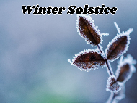  21 Start of Winter | 22  CLOSED | 23  CLOSED | 24  CLOSED | 25 Christmas    CLOSED | 26  CLOSED | 27  CLOSED
28 | 29  CLOSED | 30  CLOSED | 31  CLOSED  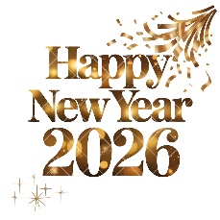 | School reopens January 5, 2026  January 19 – No school district-wide (MLK Jr. day)

