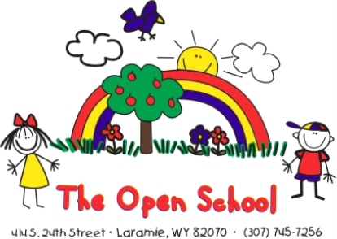

**Miss Shelly’s October School News**

UPCOMING DATES

October 18 – UW Big Event – fall maintenance day, starting at 10 a.m.

October 29 -Halloween parties in classrooms, costume parade at 11:10 a.m.

October 29 – 11:30 dismissal for all students

October 30 & 31 – Open School closed – (district-wide school closures)

October – family/teacher conferences the week of October 20

November – normal hours November 3 (district schools are closed, we are open)

Scholastic Bookfair

Our Scholastic Book Fair will be held in the office October 13–24!

* Sales: Begin Tuesday, October 14 and continue through noon on October 24.

Books can be purchased directly from the fair and taken home the same day. Every purchase helps our school earn Scholastic points, which we use to buy items like circle time carpets, bookshelves, and new learning materials.

Payment options: Cash (exact change, please), check, or debit/credit card.  
Books also make great gifts—thank you for supporting reading and our school!

Shop online:https://bookfairs.scholastic.com/bf/theopensch1

Halloween Fun

We’ll celebrate Halloween on Tuesday, October 29 with classroom parties in the morning, followed by a costume parade at 11:10 a.m. on the bike path (weather permitting). Families are invited to come watch!

School will dismiss early at 11:30 a.m. (district-wide).

Costume reminders: Please avoid anything too scary or that includes play weapons. Students are welcome to participate in the party and parade even without a costume.

Family/Teacher Conferences

Conferences will take place the week of October 20. Your child’s teacher has emailed you a link to sign up for a 15-minute time slot. If you haven’t seen the email, let us know so we can resend it to you. This is a terrific opportunity to discuss your child’s progress, ask questions, and connect with the teacher.

* Morning sessions: 7:30–11:00 a.m. (teachers’ classes will continue as usual with a substitute)
* Afternoon sessions: Thursday, October 23, from 3:30–6:30 p.m.

Fundraising

As a 501(c)(3) nonprofit school, we rely on fundraisers to help bring new projects and materials to life. Past efforts have funded our bike path, passenger vans, new flooring, and more.

This year’s fundraisers:

* 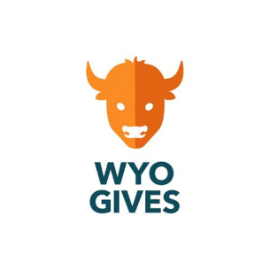**Fall (November):** *Poppin Popcorn* — an online/in-person hybrid with popcorn and treats (pre-holiday delivery)
* **Winter:** *Art Show* — student artwork, collaborative projects, and a creative celebration of art
* **Spring:** *Online Raffle* — fantastic prizes from local and regional businesses
* **Summer (July 15, 2026):** *WyoGives Day* — an online giving event for Wyoming nonprofits with donor-matching opportunities

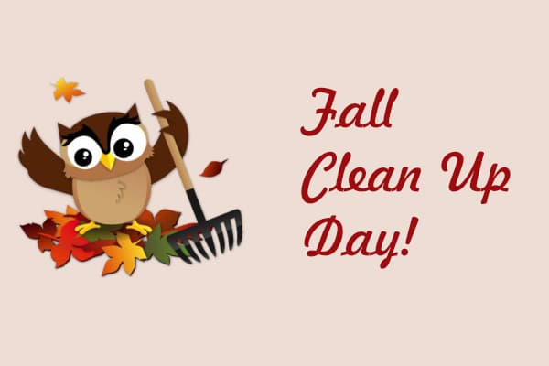

UW Big Event- Fall Maintenance Day

Join us on Saturday, October 18 at 10:00 a.m. for our fall maintenance day (usually wraps up around noon). We’re partnering with the UW Big Event, where university volunteers help local organizations and give back to the community.

Families are invited to help prepare our school grounds for winter—bring tools like rakes, leaf blowers, or trimming shears if you have them. Donuts and fruit will be provided, and children are welcome to help or play!

Find us

Website: http://www.laramieopenschool.org

Facebook: https://www.facebook.com/laramieopenschool

Miss Shelly’s Email: openschool1@hotmail.com

Miss Laura’s email: prek1class@laramieopenschool.org

Miss Joni’s email: prek2class@laramieopenschool.org

Miss Reanna’s email: preschoolclass@laramieopenschool.org