 | The Open School - September 2025
Sun | Mon | Tue | Wed | Thu | Fri | Sat
 | 1  LABOR DAY  CLOSED | 2  Assembly:  Bike path opens  Social Skills | 3 | 4 | 5  UW Art Museum  Miss Joni’s Class  10:00 a.m. | 6
7  Turn in Developmental Screenings Paperwork this week   | 8  Sign Language – afternoon | 9  Music 1:30-2:45    Board Meeting 6 p.m. | 10  Fire Drill 9:00 a.m.   | 11  Spanish - afternoon | 12  UW Art Museum  Miss Laura’s Class  10:00 a.m.  Storytime with Miss Margaret – afternoon, 1:00 -2:30 | 13
14 | 15  Developmental Screenings  Sign Language – afternoon | 16  Developmental Screenings  Music 1:30-2:45 | 17 | 18  Spanish - afternoon  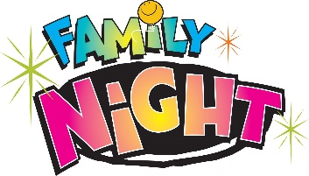  Family Night 6-7 p.m.  All welcome – open house style | 19  UW Art Museum  Miss Reanna’s Class  10:00 a.m.  Storytime with Miss Margaret – afternoon, 1:00-2:30 | 20
21 | 22  UW PE at Open School  TK 1:15-1:45  PreK 1:45-2:15  Sign Language – afternoon | 23  Music 1:30-2:45 | 24 | 25  UW PE  TK 1:15-1:45  PreK 1:45-2:15  Spanish - afternoon | 26  SCHOOL CLOSED  DISTRICT WIDE  STAFF DAY | 27
28 | 29  UW PE at Open School  TK 1:15-1:45  PreK 1:45-2:15  Sign Language - afternoon | 30  Music 1:30-2:45 | Upcoming Dates:  UW Big Event – fall cleanup day, 9:00 a.m. all are welcome to help  Teacher Conferences in October  October 29- early dismissal at 11:30 all students  October 30/31 – no school (District wide, including Open School)

