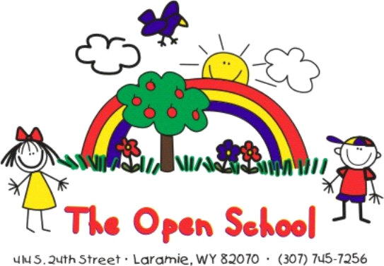

Miss Shelly’s Newsletter
August 2025

Welcome Open School Families! We are so excited for our school year and look forward to getting to know new families and welcoming back returning families.

Below is the initial back to school information as you start planning and thinking about the upcoming school year:

UPCOMING DATES:

August 21nd - Open house 9:00 a.m. until 12:00 p.m. Stop by anytime that morning to meet your child’s teacher, find your child’s cubby, drop off belongings

August 26th – First day of school (for those that attend Tuesdays), 11:30 a.m. dismissal of all students (district wide early dismissal day). If your child does not attend Tuesdays, don’t worry, their first day will be an intro to school day as well!

August 27th – First day of normal school hours

September 1– School closed – district wide – Labor day holiday

OPEN SCHOOL WEBSITE
We hope you have had a chance to visit our website! It is a great place to read your teacher’s weekly newsletter and lesson plans as the year progresses, and learn about our school, staff, curriculum, philosophy and more www.laramieopenschool.org. We are also on Facebook – follow us there!

ProCare APP
If you are new to The Open School - sometime in August you will receive an invite to download the ProCare app if you have not already done that. When you get the invite, please download the app, and enable location services while using the app. This app is used to check children in/out of the school using your phone. More information on how to use the app will be shared as we get closer.

TUITION/SCHEDULES
The first tuition payment for the school year will be due by September 10th. You will receive a statement by the first of September. No tuition is due in August. Tuition is prorated for the school year – September through May. You can request semester pay, pay via auto draft, pay with check/cash – just let me know which method you prefer, and we will help get you set-up. If you had auto draft last year, it will remain in place unless you tell me otherwise. If you haven’t paid the annual $60 enrollment fee, that will be on your September statement, as well as the first semester supply fee of $50.

GETTING READY FOR PRESCHOOL/PREK
We will work with the children during the first few weeks on adjusting to the school, new friends, transitions, bathroom breaks, and all of the new adventures of preschool/PreK. The teachers will be teaching all kinds of new things all year – social emotional skills, independence, academic, gross motor, fine motor – your child will gain a lot of new skills!

Things you can practice and talk about in August as you get ready for school:

- Using the bathroom independently – pulling pants up/down, wiping, practice going to the bathroom in public bathrooms away from home. We will build in reminders, especially in the beginning and with our youngest class, but being potty trained is a requirement. During open house, your child can check out the school bathrooms too and make sure they are familiar and comfortable.
- Teach handwashing skills and hygiene skills. Practice using a tissue to blow nose, throwing it away, coughing or sneezing by covering or coughing into elbow. We do wash hands a lot, so if your child has dry skin, you can leave lotion with your child’s teacher to apply as needed.
- Practice lunch time – if your child stays for lunch, it is fun to get a lunch box early, practice opening containers, opening items like string cheese and yogurts, talk to your child about asking teachers for whatever they need for lunch help. We can warm things up, help open containers, or provide any help that they need during lunch.
- Practice putting shoes on/off. We will take outdoor shoes off and on for recess many times throughout the day. Shoes that are easy to manage for children are appreciated!
- A special goodbye – a handshake, hug, kiss – whatever is fun for your family – a good way to transition at drop off and have a positive experience each morning. It is expected that initially your child may be excited and leave you without hesitation, but a few weeks in they may have a more difficult time as the excitement wears off. Our teachers are all trained to help manage the transition. Drop off with positive thoughts and our teachers will take it from there. It is typically just a couple of minutes before they get engaged with their friends and start having fun.
- Read books or watch book videos about preschool and starting school.

MORE INFORMATION
The parent handbook and calendar were sent out with paperwork and are also available on our website. You will find the answers to the most asked questions in the handbook. We will send out more information in August as well, such as specific school year information and a meet the teacher document. We are happy to help answer any specific questions. The easiest way for a quick response in August is through email: openschool1@hotmail.com

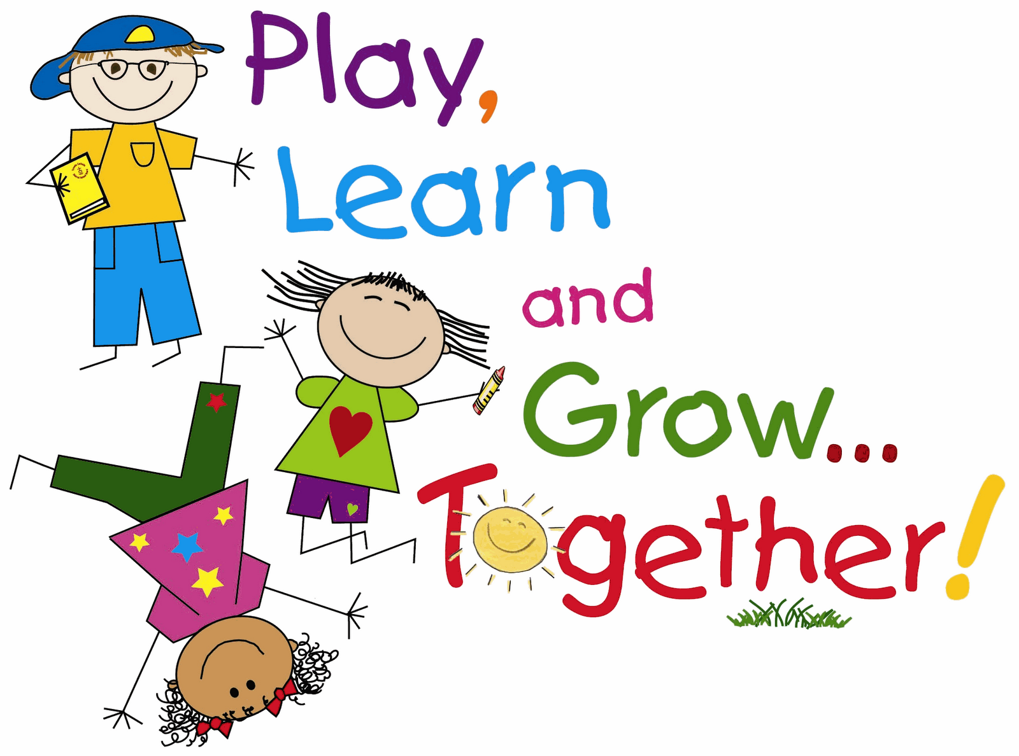
We look forward to seeing you at the Open House on
August 21st
9:00-12:00 anytime

Supply List

There will be a supply fee of $50 on your September and January statements for each semester. This covers supplies such as crayons, paper, markers, pencils, paint, glue, etc. The following is a list of other supplies to bring for your child:

1. Water bottle (labeled with name) to be taken home to be washed/refilled daily
2. Backpack – if your child wants a backpack or you want the ease of carrying things
3. 1 Box of Kleenex/tissues for your child’s classroom
4. 1 tub of Clorox/sanitizing wipes for your child’s classroom
5. A complete change of clothing – in case of accident, messy, whatever. To be stored in their cubby bin to use as needed
6. Indoor shoes – easy to manage, Crocs, slippers, something to manage taking on/off to help keep the floors clean
7. Daily snacks for your child– a morning snack (around 9:30 a.m.) and an afternoon snack (around 3:45) if your child stays for after school. You can bring a box of snacks to leave or provide daily snacks for your child if that is easier, and we will let you know when they are running low
8. Daily lunch/lunchbox if your child stays for lunch (11:30-12:30) We can store lunches in the refrigerator and warm things in microwave. You can also leave a condiment bottle (ketchup, ranch, etc.) labeled with your child’s name in their class refrigerator if that is something they use frequently, instead of packing that for lunch daily.

9. 1 bottle of sunscreen to be shared (unless you have a specific sunscreen for your child) If your child requires a specific sunscreen, please bring that labeled with their name and discuss this with the teacher
10. 1 wide face stick of sunscreen labeled with your child’s name
11. Walking shoes – sneakers, something comfortable to walk to the park, play soccer, impromptu physical activities. If you have an extra pair that can stay at the school in case your child wears sandals, boots, etc.
12. Winter clothing – snow pants, snow boots, hats, mittens, coat – when the weather turns, labeled please, extras to leave her during the school year are handy. We do go outside unless it is below zero with wind chill
13. Bike helmet – fitted to your child’s head and labeled with their name. We have bikes/trikes/striders, but a helmet is required to ride.


If you need assistance with purchasing any of these items, please contact Shelly.

