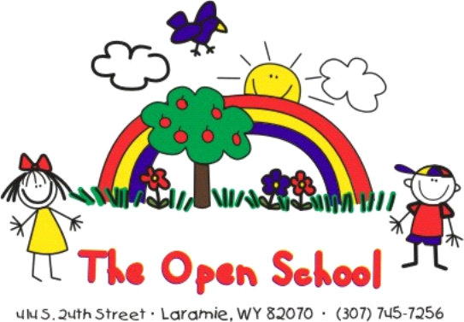

_________________________________________________________________________________________
Registration – Wait List Form

Please complete this form to place your child on The Open School wait list. This will add your child to our list by date of receipt. When a spot in a classroom is offered, you will need to complete the enrollment paperwork and pay a non-refundable enrollment fee of $60/school year or $30/summer session to complete enrollment and reserve your child’s classroom spot.

Date of Application_________________
Parent/Guardian’s Name____________________________________________________________
Address_________________________________________________________________
Email Address____________________________________________________________
Phone Number___________________________________________________________
Child’s Name____________________________________________________________
Date of Birth_____________________________________________________________
Previous childcare/preschool experience? (how long/where)________________________
________________________________________________________________________
Other information you would like us to know? ___________________________________
Previous Open School family? __________ Yes _________No
Preferred time of enrollment: Spring:___________ Fall:_______________ Year:___________
We have 3 classrooms: Preschool age 3, Pre-Kindergarten (PreK) age 4, and Transitional Kindergarten (TK) age 5. Class placement will be made based on age, previous childcare/preschool experience and the discretion of the classroom teacher and director.

Please indicate your preferred schedule:
___Full Time (7:30-5:30)
___Full Day (8:30-3:00)
___5 Half Days (8:30-11:30 or 12:30-3:00) circle your time preference.
___4 Half Days (M-TH 8:30-11:30) this is the minimum schedule for our TK class
___3 Half Days (8:30-11:30 or 12:30-3) for Preschool and PreK only
Please list days and times you prefer (MWF etc.) ______________
___Other __________________________________________________________

To enroll in The Open School’s Preschool program:
- Be at least three (3) years of age upon entry (and provide a birth certificate);
- Be toilet trained; (independent in all areas, which includes wiping, pulling clothing up and down, telling staff when they need to use the bathroom)
3. Satisfy a teacher evaluation of the child, if requested by the teacher; and
- Meet State of Wyoming requirements for immunizations.

To enroll in The Open School’s Pre-Kindergarten (PreK) and Transitional-Kindergarten (TK) classes:
- Satisfy all requirements for the Preschool program (see above);
- Be at least 4 years old by September 15th of the current year for PreK; or 5 years old by December 31 of the current year for TK (and provide a birth certificate as proof of age);
- Be ready for more structure and gaining independence;
- Satisfy a teacher evaluation of the child, if requested by the teacher.

