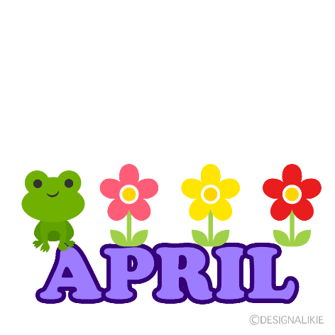
THE OPEN SCHOOL
Miss Shelly’s News
UPCOMING DATES
April 17-April 26 Book Fair in office
April 27 -Spring cleaning day (details below)
May 9 – Graduation/Celebration (details below)
May 24 – Last school day for year
May 27 – June 2 - Closed
June 3 – July 26 Summer Camp
July 10- WyoGives Day

Summer Enrollment
It is not too late to enroll for summer! The initial enrollment deadline gave us time to plan staffing and classrooms. If you are still interested in summer and have not enrolled, please let me know. Our summer session runs for 8 weeks from June 3-July 26. Our last day of the 2023-2024 school year session is May 24th. We are closed the week of Memorial Day. We will start the 2024-2025 school year with the district on August 26th.

Weather/Clothing
As you know, the weather continues to be unpredictable. Please make sure your child has a jacket at school each day, as it can start out warm and change quickly. We will also be walking to the parks as it warms up, so walking shoes are important each day as well. We appreciate your help in making sure your child has appropriate outdoor clothing, so they are warm and comfortable throughout the day. The bike path is open again, so please send your child with a helmet fitted to their head so they can enjoy the bike path.

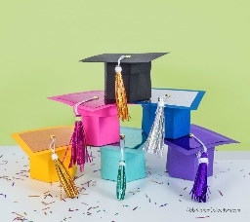
Graduation/Year End Celebration
You are invited! May 9th at 6:00 p.m. we have a graduation event at the Civic Center south gym. This will include all children regardless of whether they are moving up to a different classroom here or going on to Kindergarten. We hope you can join us to celebrate!

Enrichment
We are wrapping up our regular enrichment offerings such as swimming, soccer, library, and art museum, but we will add different activities in the afternoons instead – field trips, walks to parks, gym play, and fun at the school.

Spring Cleaning Day
April 27th, starting at 9:00 a.m. until finished (usually around noon), we will be meeting at the school to clean up the school grounds and playground. Raking, sweeping, picking up garbage and sticks around the property, light maintenance, adding mulch, and more spring duties need to be complete. We do have a few UW fraternity and sorority members joining us as well! If you have any rakes, please bring them along. We will have some light snacks. Children are welcome to play or pitch in as well! Thank you!

Book Fair
The book fair will be open in the office starting 4/17 at 11:30. Books will be available to purchase until Friday 4/26. Check, cash, credit, or debit are accepted. We earn “Scholastic Dollars” for all sales, which allows us to buy items for the school. All of our center time rugs, library bookshelves, listening centers, and other quality items have been purchased with past Scholastic Dollars. We appreciate your support of reading and the school!

Fundraising
Art Show and Raffle: Thank you for your support of the art show and the raffle. The funds raised will go towards another transportation van. We are hoping to add a third van to help transport the children to enrichment more efficiently. We also have a bike shelter on our fundraising wish list. Your support is appreciated. The children really enjoy showing their art at the museum. We are incredibly grateful for our generous artists’ donations as well. We were able to raise close to $2500 with the show and raffle!
Chipotle Night: Together with your help, we raised $268 on Chipotle night! Thank you for going out and supporting the school that night!

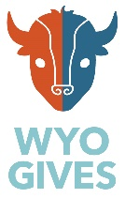
Upcoming: We have a couple more fundraising opportunities coming up. First, we will have a small summer bundle raffle – buy a ticket for a chance to win a summer family fun pack. Next we will be participating in WyoGives Day on July 10, 2024. www.wyogives.org On WyoGives Day, online donations made to the school on July 10th will be “boosted” by matching donors, so your donation is able to make more of a difference on this day. Statewide non-profits participate, so you can also support your other favorite organizations on this day! We will be distributing more information and a pledge card before the end of school.

Our goal for fundraising is to continue to make improvements to the school. Right now, our wish list includes another transportation van, a bike shelter, and specific toys for the classrooms such as sensory tables, vertical gear walls, and STEAM materials. Your support of our fundraisers makes a difference!

Young Athletes Program
We have partnered with Special Olympics and the Young Athletes program. They will be donating Strider bikes and PE equipment to enhance our physical education offerings to all students! Learn more at:
https://www.specialolympics.org/what-we-do/inclusive-health/young-athletes

Wyoming Department of Health Community Health Grant – UW Partnership
We have received grant funding from the WY Department of Health to purchase PE curriculum and materials as well. We are continuing to work with UW Department of Kinesiology and Health on our physical education offerings, and we are able to purchase SPARK early childhood curriculum and materials through State grant funds to continue to build our physical education program. The UW partnership helps offer student teaching opportunities to UW students, as well as PE classes for Open School students!

Laramie Soccer
We would like to thank Kirsten Cushman and Laramie United Soccer for all of the soccer lessons! The children love learning soccer skills. Learn more about Laramie soccer at: https://laramiesoccer.org/

Laramie Recreation Center
Swimming lessons are complete for this school year. We appreciate the Rec Center aquatics staff offering lessons! We will resume lessons again next school year. We will visit the splash pad and wading pool in the summer.

Healthy Kids Rx
https://www.healthykidsrx.org/about_us
We hope to coordinate with Healthy Kids Rx again for summer classes. Check out their website for classes offered during after school and summer sessions!

We appreciate these partnerships and value the importance of physical education starting in early childhood to build lifetime skills and healthy habits!

