 | May 2024
Sun | Mon | Tue | Wed | Thu | Fri | Sat
 |  |  | 1  Music – morning | 2  Spanish -morning | 3  Art Museum –  Miss Reanna’s class  Mother’s Day treats – office  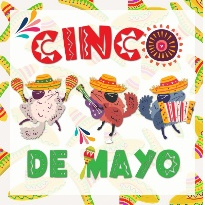  Cinco De Mayo – afternoon with Miss Brea | 4  Maintenance Day  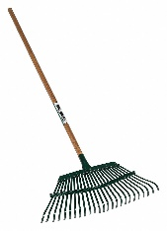  9:00 a.m. - ?  Bring a rake, families welcome and appreciated – pitch in to get clean the school grounds  Snacks provided
5 Cinco De Mayo | 6  Sign Language – afternoon | 7  UW Planetarium –  Afternoon 1:15 p.m. | 8  Music - morning | 9 Spanish – morning  Graduation – Year End  Celebration  6:00 p.m. South Gym  Civic Center – all welcome! | 10  Art Museum –  Miss Laura’s Class | 11
12 | 13  Sign Language – afternoon | 14 | 15  Music – morning | 16  Spanish - morning | 17  Art Museum –  Miss Joni’s Class | 18
19 | 20  Sign Language – afternoon | 21 | 22  Music - morning | 23  Spanish - morning | 24  LAST DAY  NORMAL HOURS | 25
26 | 27 Memorial Day  CLOSED | 28  CLOSED | 29  CLOSED | 30  CLOSED | 31  CLOSED | SUMMER SCHOOL STARTS  JUNE 3

