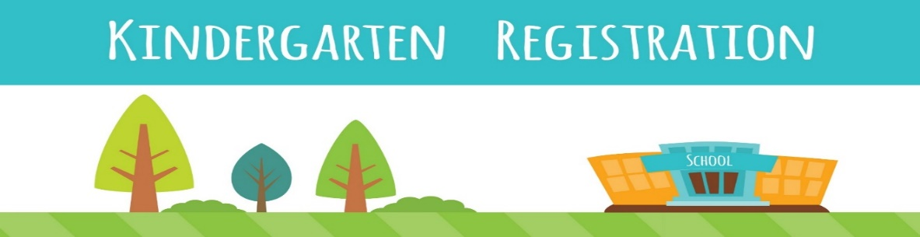

Kindergarten registration for Albany County School District #1 (ACSD1) begins in April each year. Children must be 5 years old on or before August 1, 2024, to enter Kindergarten in the 2024-2025 school year. Parents who wish to request a waiver to this requirement, for prospective students whose birthdates are between August 2 and September 15, 2024, must do so at their neighborhood school during the week of registration (per School Board Policy 4001). The Open School does have Transitional Kindergarten with Miss Joni for those that are 5 by December 31, 2024, that miss the August 1st cut-off, or that could attend Kindergarten but want an additional year.
Other lottery applications for Snowy Range Academy, Laramie Montessori, UW Lab School, and the Dual Language Immersion Program at Slade will be available from these schools and the drawings for the lottery spots will be in April.
Albany County School District #1 (ACSD#1) Registration
https://www.acsd1.org 307-721-4400
Public school serving PreK-12th grade students
Kindergarten registration will be held April 8 – 12, 2024, and a link will be available on the acsd1.org website
To find your child’s home school: https://www.acsd1.org/en-US/school-boundary-maps-447942d7

DLI (Dual Language Immersion) – Spanish
Dual Language Immersion is a bilingual program where two languages are used for instruction.
Enrollment
Children who will be Kindergarten or first grade students in the 2024-2025 school year are eligible to participate in this program. Enrollment will be determined through a lottery process which will take place on April 3. If your student is offered a spot in the program, Slade Elementary will contact you.
Slade Elementary School (307) 721-4446, see attached flyer for more information.
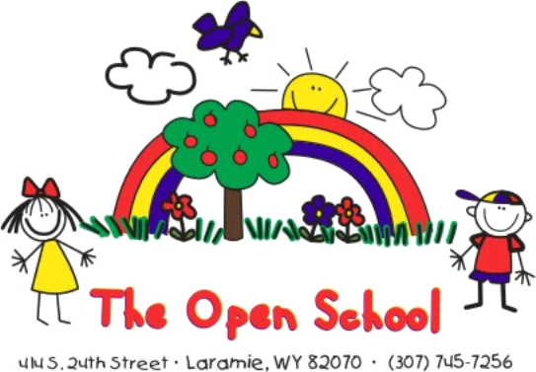
The Open School
The Open School offers a Transitional Kindergarten program with a licensed teacher for children that are 5 by December 31, 2024, miss the August 1st cut-off, or for families that would like an extra year of early childhood education before Kindergarten. The Open School is licensed through the Department of Family Services as a private childcare center. Visit www.laramieopenschool.org or call 307-745-7256 for more information.
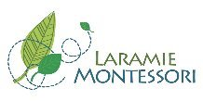

Laramie Montessori
https://www.laramiemontessori.org/kindergarten
Laramie Montessori Charter School is a free public school that works within the Albany County School District #1 to provide a child-centered Montessori education for students from Kindergarten - 6th grade in Laramie, WY. Our mission is to support the development of the whole child through an authentic Montessori environment that honors the child's intrinsic motivation to learn and supports each individual's unique intellectual, physical, social, and emotional development.
Registration
Fill out the registration form on the website and return it to the Laramie Montessori School Office by email to cclar@acsd1.org or mail (608 S. 4th St.) or in person (Mon-Fri 8am- 4pm). If you would like to schedule a tour or have any questions, please contact the school at 307-742-9964. A lottery is held for open spaces and remaining spaces are filled on a first come, first served basis.
Snowy Range Academy
https://www.snowyrangeacademy.org
Snowy Range Academy is a free K-8 public charter school in Laramie, Wyoming. At SRA, we use the Core Knowledge sequence alongside EnVision Math, character education, and most importantly, parental involvement
Letter of Intent
To be included in the enrollment pool for the upcoming school year, parents must complete a letter of intent form no later than April 1. The lottery is held on April 3rd.
- Upcoming Observation Open Houses: See our classrooms in action and tour the school. Seating will be available in each grade, and no reservations are necessary. Come and go as you please, visit more than one room, and pick up literature about the school. Tours are available.
Thursday, March 21, 9:00 -11:00 a.m.
Wednesday, March 27, 12:00—2:00 p.m.

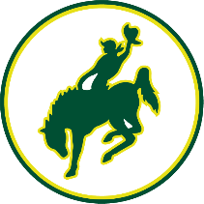
UW Lab School
UWLab.acsd1.org
The UW Lab School is a public school of choice in ACSD#1. The school is located in the College of Education building on the University of Wyoming campus. The UW Lab School offers an innovative research-based, free public education to students entering kindergarten through 8th grade—in the heart of the University of Wyoming’s campus—through a partnership with Albany County School District 1.

UW Lab School tours and lottery - for more information or to enter your child(ren) in the lottery now, visit UWLab.acsd1.org, call 307-721-2155 or email uwlabschool@acsd1.org. The lottery will be held on April 3rd.

Helpful Links
https://www.acsd1.org
Boundary map: https://www.acsd1.org/en-US/school-boundary-maps-447942d7
Dual Language Immersion program information: Dual Language Info 2024
Transportation: https://www.acsd1.org/en-US/transportation-4e3d8965
Bus Finder: https://www.infofinderi.com/ifi/?cid=ACSD30P58TZI6
School contacts:
Beitel: jfowler@acsd1.org (307) 721-4436
Centennial: (307) 745-9585
Harmony: (307)745-5720
Indian Paintbrush: jnutter@acsd1.org 307-721-4490
Linford: kdouville@acsd1.org (307) 721-4439
Rock River: sims@acsd1.org (307) 721-4265
Slade: kburns@acsdl.org (307) 721-4446
Spring Creek: jrauer@acsd1.org (307) 721-4410
UW Lab School: vchai@acsd1.org (307) 721-2155
Snowy Range Academy: chubenthal@acsd1.org (307) 745-9930
Laramie Montessori: bthompson@acsd1.org (307) 742-9964
ACED (Albany County Early Development Coalition https://acedit.acplwy.org/kindergarten
WY Quality Counts https://wyqualitycounts.org/child-development/kindergarten-readiness/

