 | March 2024
Sun | Mon | Tue | Wed | Thu | Fri
 |  |  |  |  | 1  Miss Reanna’s class  Art Museum – 10-11 a.m. | 2
3 | 4  Sign Language – afternoon | 5  Soccer – afternoon @ the Pitch  Miss Reanna’s class 1:00  Miss Joni’s and Miss Laura’s classes 1:30  Staff Meeting 5:30 p.m. | 6  Music – morning  Swim lessons – afternoon | 7  Spanish - morning | 8  Music – afternoon  Miss Joni’s class  Art Museum – 10-11 a.m. | 9
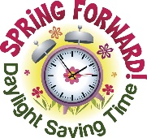  10 | 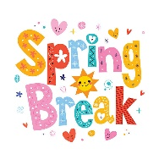  11 CLOSED | 12  SPRING BREAK  CLOSED | 13  SPRING BREAK  CLOSED | 14  SPRING BREAK  CLOSED | 15  SPRING BREAK  CLOSED | 16
17 | 18  Sign Language – afternoon | 19  Soccer – afternoon @ the Pitch  Miss Reanna’s class 1:00  Miss Joni’s and Miss Laura’s classes 1:30  Board Meeting 6:00 p.m. | 20 Start of Spring (Spring Equinox)  Music – morning  Swim lessons – afternoon | 21  Spanish - morning | 22  Miss Laura’s class  Art Museum – 10-11 a.m.  Music – afternoon | 23
24 | 25  Sign Language – afternoon | 26  Library Storytime afternoon  1:00 – Miss Joni’s class  1:30-Miss Reanna’s and Miss Laura’s classes | 27  Music – morning  Swim lessons - afternoon | 28 Spanish – morning  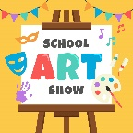  Art Show –  UW Art Museum  Bottom Floor  6-7 p.m. Open House Style | 29  Music – afternoon | 30
31 | Upcoming Dates:  April – family/teacher conferences to be scheduled, Kindergarten registration begins District April 8th  Book Fair in office mid April  April 6-12 Week of the Young Child: April 6 Family Resource Fair for WOYC at Civic Center  April 10 – Chipotle Open School Fundraising Night 4-8 p.m. (need flyer)  April 12 – No School (District Wide)

