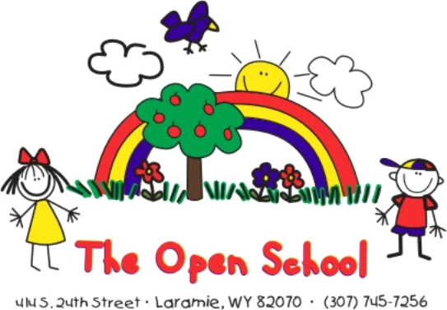

Summer Enrollment Information:

Summer enrollment is now open for all current and incoming Open School students!

The summer program begins June 3rd and ends July 26th. We will be closed July 4 & 5 for the holiday. The 2024-2025 school year will begin August 26th.

The summer program is a separate program from our school year program. You can enroll your child for June, July, or both months. Indicate your schedule preferences on the form. The class and teaching staff arrangements will depend on enrollment and will be different than the regular school year. Typically, we have 2 classrooms: 3/4 years and 4/5 years. Tuition and packages are different for the summer than the school year as well.

To enroll for summer, please complete the form on the back and return it to the office.
Priority enrollment is given to current families who enroll by February 26. We will then begin enrolling children from our wait list. You can enroll your child after February 26th, as long as we still have availability.
Activities will include fun themes, academics, visiting local parks, field trips, arts and crafts, STEAM activities, water fun days, outdoor exploration, and a lot of fun with friends!

Please see Shelly with any questions.

Enrollment Form on back ---›

SUMMER 2024 Enrollment Form

Enrollment | Sessions/times | Monthly Tuition | Select one package
5 Full Days  With before/after school care | 7:30 a.m. to 5:30 p.m. | $895
5 Full School Days  Without before/after school care | 8:30 a.m. to 3:00 p.m. | $740
5 Half Days  Monday-Friday | 8:30 a.m. to 11:30 a.m.  OR  12:30 p.m. to 3:00 p.m.  Circle your choice | $445
Indicate months enrolling for (June or July or both)
Custom schedule request  with Director approval:  (The equivalent of 5 half days weekly is the minimum summer package) |  | To be determined by Director

Current Enrolled Child(ren)

Child’s Name: __________________________

Child’s Name: __________________________

Other Children Enrolling (that will also be enrolled for the 2024-2025 school year)

Child’s Name: ________________________________ Birthday: ______________

Child’s Name: ________________________________ Birthday: ______________

Parent/Guardian Signature: Date:

Received by Director: Date:

