 | December 2023
Sun | Mon | Tue | Wed | Thu | Fri | Sat
 |  |  |  |  | 1  Art Museum 10:00 a.m.  Miss Reanna’s class  Music afternoon with Mr. Bravo | 2
3 | 4  Sign language – all classes aft. | 5 | 6  Rehearsal 10:00 a.m.  Gryphon Theater  Swimming - afternoon | 7  Spanish – all classes a.m  Peppermint Parade  Arrive by 5:45 p.m.  Gryphon Theater | 8  Art Museum 10:00 a.m.  Miss Joni’s class  Music afternoon with Mr. Bravo | 9
10 | 11  Giving Tree gifts due back  Wrapped with tag attached  Sign language – all classes aft. | 12  Storytime Library –  1:00 Miss Joni  1:30 Miss Reanna and  Miss Laura | 13  Music – all classes a.m.  Last swim for semester:  Swimming – afternoon | 14  Spanish – all classes a.m. | 15  Art Museum 10:00 a.m.  Miss Laura’s class  Music afternoon with Mr. Bravo  Reanna – movie aft | 16
17  Winter Break Spirit Week | 18  Wear a fun or holiday hat  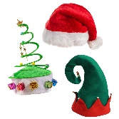  Sign language – all classes aft. | 19  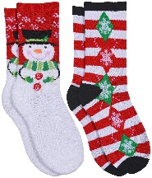  Wear fun or holiday socks | 20  Fun hair day - “Who Hair”  Music – all classes a.m.  1:00 sign language stories  With Dr. Mandy Jairell | 21  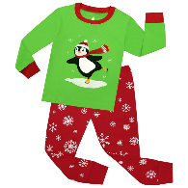  Wear pajamas to school  G movies – Miss Laura and Miss Joni  11:30 Dismissal District Wide | 22  CLOSED | 23
24 | 25  CLOSED | 26  CLOSED | 27  CLOSED | 28  CLOSED | 29  CLOSED | 30
31  New Year’s Eve | Upcoming Dates:  Winter Break – 11:30 dismissal 12/21, reopen on January 8th  January 15 – closed Martin Luther King, Jr. Day

