THE OPEN SCHOOL
MISS SHELLY’S NEWSLETTER
UPCOMING DATES
September 29th – Open School closed – district wide school closed
October 10 – Board retreat 6:00 p.m.
Book Fair – October 9-20 in office
October 25– Parent/Teacher Conferences (plus 1 other a.m. per classroom tbd)
October 25 – Half day (District Wide) 11:30 dismissal at Open School for all students
October 26-27 – No school

Parent/Teacher Conferences
Parent/Teacher conferences will begin the week of October 23, as well as one morning per teacher the week prior as well. October 25 is a district wide half day – 11:30 dismissal here for all students. We are closed on October 26 and 27 as well, the same as district schools.

I will be sending out a sign-up link at the beginning of October, where you can choose a time slot for in-person conferences. This is a time to touch base with your child’s teacher about what they have observed, answer any questions you may have, and share relevant information.

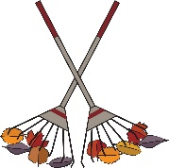
Maintenance Day – UW Big Event – October 14
The UW Big Event is October 14th. We will have UW students here to rake, clear flower beds, check bikes, and prep the school grounds for winter. We would love your help on this maintenance day, just come by the school on the 14th between 9:30-12:30. Children are welcome and bring a rake if you have one. Thanks!

Developmental Screenings
If your child was screened in September, paperwork has been placed in each child’s cubby with the results. If your child did not receive a screening, you can schedule a screening at Developmental. If you have any questions after receiving information, you can contact Developmental Early Intervention as well:
307-742-3571. https://albany.wyokids.org/developmental-services.html

Fall-Winter Weather & Recess
Please remember to send your child coats/jackets for our chilly mornings. We will continue to play outdoors all year, so layers and warm clothing are essential. Lost and found is in the office by the front door if your child has misplaced anything. Labeling items helps us get it back in the proper cubby as well. We go outside for recess unless it is below zero with the windchill factor.

Halloween Classroom Parties
Each class will have a Halloween party on October 31st in the morning around 10 a.m. If your child does not normally attend on Tuesday mornings, they are welcome to attend the party portion of the morning without charge. If you want your child to attend the entire morning session (8:30-11:30), and they aren’t already scheduled to, there would be an extra session charge for the morning session. Each teacher will have a sign-up sheet for party treats and supplies. Children can wear costumes, just please no weapon toys with costumes.

Weather permitting: Costume parade: 11:15 on October 31st – please join us on the bike path for a school-wide costume parade! The classes will all walk around the bike path so we can all enjoy seeing the costumes. (weather permitting – otherwise it will be inside the school).

Scholastic Bookfairs and Classroom Orders
We will have a Scholastic bookfair in the office in October. You will be able to select books to purchase and take home from the fair. Books make great gifts! The Bookfair purchases give the school points to purchase items from Scholastic – like our circle time carpets, bookshelves, and new learning materials. Classroom orders through the catalogs benefit each classroom with points to purchase class items as well. Thank you for supporting reading and the school with your Scholastic purchases!

Drop-Off/Pick-Up
Please remember to check your child in/out with the ProCare app each day. If you forget, let us know so we can check them in/out for you. The children are checked in on clipboards with teachers in the classrooms when they arrive as well, so we know they are present, and the teacher keeps an accurate classroom count at all times. Please walk your child to/from to the playground or classroom. This will make sure that we have marked your child in/out on the teacher’s attendance clipboard and that they are staying safe at all times.
Please do not allow or teach children to operate the black gate safety latches. We do not allow children to push the black latches to go through the gates. It is our number one job to keep the children safe. The gates were recently updated to have these safety features, and we appreciate your help with this policy.

It is also helpful to establish routines for the drop-off/pick-up transition times. Dropping your child off with a special hug or kiss with a smile and confidence, even if they are crying, shows them that you are comfortable here and they are safe. Lingering with tears in the morning often makes children upset longer. Our staff is able to comfort children at the transition. Typically, it is a 5 minute or less transition and they move on to being at school and being happy. If not, and they were having a longer time of upset, we would call you to work that out.

The same with pick-up: setting the tone with the transition from school to home in these early days will make the year flow smoothly. Letting the children know what to expect – we pick them up from school, pack up our backpack, head home or to activities – gives them security. Early days at preschool/PreK are all about setting up the routines and transitions that make the days ahead flow much more smoothly. Predictable pick-up/drop-off transitions help set the tone.
Also, if you have siblings that come with you at pick-up/drop-off, we ask that you watch them on the playground, as our staff is focused on the students, and make sure that the older/younger siblings are safe around all the students. We will have opportunities coming up to have extended free play at the school and on the playground for families, where everyone will have time to explore the rooms and playground together.

*Monday afternoon –UW PE class (here while weather permits) PreK and TK classes; &
Sign language with Miss Savannah – all classes
*Tuesday afternoon (every other) – story time at the library PreK/TK for September, Preschool will join starting in October
*Wednesday morning – Music with Miss Aysia all students
*Wednesday afternoon – swimming – whenever Rec Center pool is complete PreK/TK this semester, Preschool joining next semester
*Thursday morning – Spanish with Miss Brea all students
*Thursday afternoon – UW PE class (here while weather permits) PreK and TK classes
*Friday afternoon – Music with Mr. Bravo all students
*Other offerings like cooking, science, field trips are scheduled in individual classrooms as well

Board Corner
The board would like to welcome Megan Candelaria and Ray Tupling, as our newest board members! Our board meets on the 2nd Tuesday at 6:00 at school. In October the board will meet off site for a board retreat. We also have new officers: Kelly Carpenter, President; Davina Lockhart, Vice-President; & Stefanie Milam, Secretary. Other continuing members include Brant Schumaker & Shelly Donner. We had more applicants than open spots this year, and we appreciate everyone who applied and has expressed an interest in helping with committees at The Open School. We will be in touch with those that have signed up for committees as needed. Your support of the school and staff is appreciated!

Water/Snacks
Please remember to send your child a water bottle each day, and then to take the water bottle home regularly to wash. Alternatively, we do have dish soap in the kitchen, and you can wash it out here and refill it if that is easier. Also remember snacks for the day (morning snacks, after school if they stay). You can leave bulk snacks in their cubby if that is easier as well. Snacks and water help keep everyone moving! Thank you!

Monthly Parent Workshops
I am a member of the Albany County Early Development Coalition (ACED). ACED is a coalition of 17 Albany County organizations supporting children ages 0-6 and their families/caregivers.

For more information visit https://acedit.acplwy.org/
ACED will be hosting monthly family workshops (next dates 10/14, 11/11, 12/16) on a Saturday morning. Free childcare (Open School staff are typically there as childcare providers), food, and a workshop on relevant parenting topics. You will receive information from me before these events and we encourage you to sign up and take advantage of these free workshops.

Field Trip
We hope you enjoyed the Fort Collins Museum as much as we did! It was great to see so many of you there enjoying the day together! If you haven’t already paid, the fees will be added to your statement, and you can pay the fees in October with tuition. Thanks for attending!

Communication
We have many methods to reach us – phone, app, email, etc. We do prefer that concerns, issues, classroom questions, etc. go through the lead teachers and director as much as possible, just to avoid miscommunication of information. Please let us know if you need to visit outside of conference time – we are always here to listen, problem solve, and work together as a team for your child. You are always welcome in the front office – stop by and see me if I can be of any assistance.

Find us
Facebook: https://www.facebook.com/laramieopenschool/
Website: http://www.laramieopenschool.org/
Lesson Plans are posted weekly on the website under the Lesson Plans tab
Miss Shelly’s Email: openschool1@hotmail.com
Miss Laura’s email: prek1class@laramieopenschool.org
Miss Joni’s email: prek2class@laramieopenschool.org
Miss Reanna’s email: preschoolclass@laramieopenschool.org
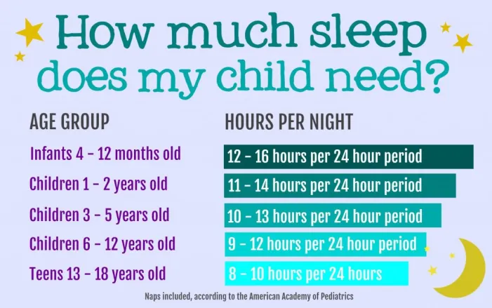

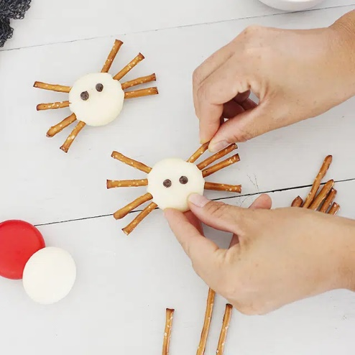
Spider Bites – superhealthykids.com

Ingredients
- 4 ounce pretzel sticks or twists
- 4 piece Mini Babybelin Original Cheese
- 2 tablespoon mini chocolate chips

Instructions
- Have the kids stick pretzels into the sides of their cheese for legs.
- Add chocolate chips on top for eyes; use a dab of nut butter if necessary to make them stick.

