 | July 2023
Sun | Mon | Tue | Wed | Thu | Fri | Sat
Other field trips, splash pad, parks and water play tbd in July |  |  |  |  |  | 1
2 | 3  CLOSED | 4 4th Of July Holiday  CLOSED | 5  Music –afternoon | 6  Civic Center Gym – afternoon | 7  Visit library - afternoon | 8
9 | 10  Sign Language | 11  Healthy Kids 1:30-2:30  Crossfit 7220 | 12  Storytime WA Park am  Music – afternoon  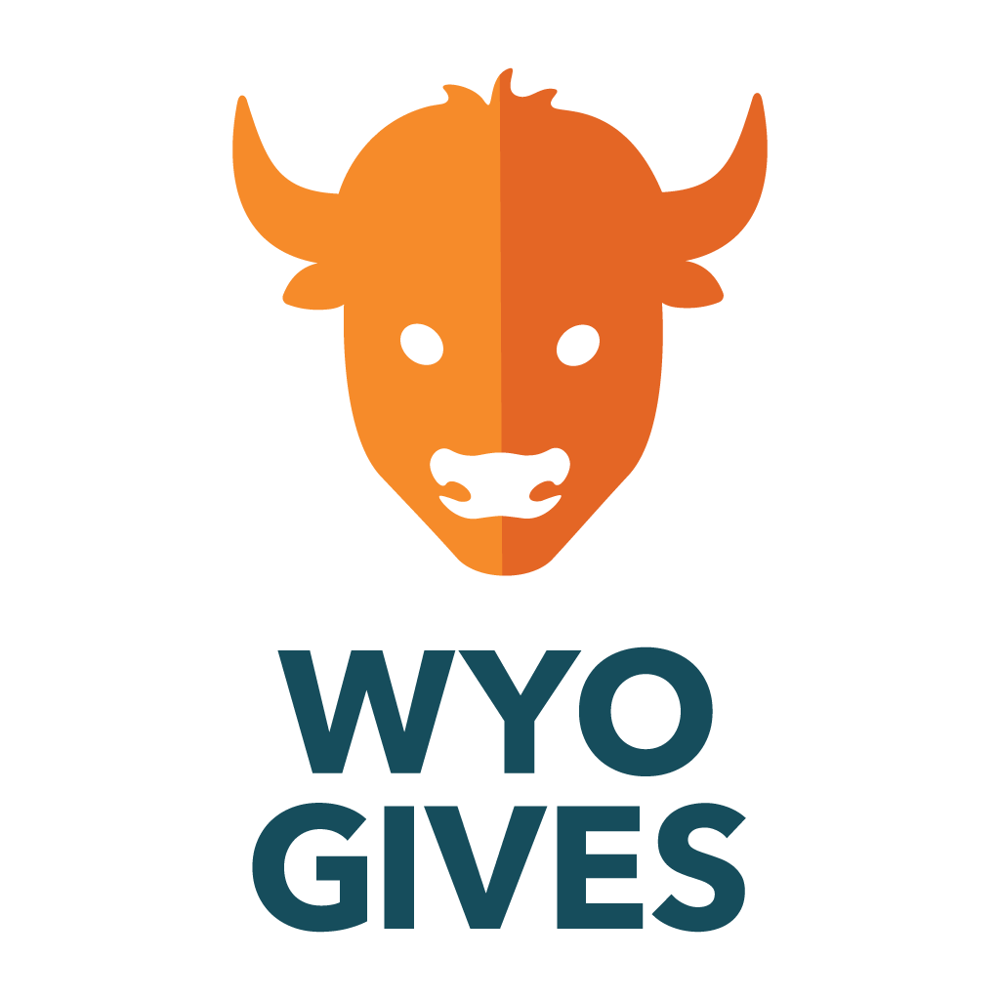  Donate to The Open School online today at Wyogives.org | 13  .Play at Parks - afternoon | 14  Visit library - afternoon | 15
16 | 17  Sign Language | 18  Healthy Kids 1:30-2:30  Crossfit 7220 | 19  Storytime WA Park am  Music – afternoon | 20  Civic Center Gym – aft. | 21  Library –  parking lot concert 1-2 p.m. | 22
23  Bring in July reading logs for a prize! | 24  Sign Language | 25  Healthy Kids 1:30-2:30  Crossfit 7220 | 26  Storytime WA Park am  Music – afternoon | 27  Civic Center Gym – aft. | 28  This Photo by Unknown Author is licensed under CC BY-NC-ND  Last Day of  Summer School  Ice Cream Party! | 29
30 | 31  CLOSED | Closed August 1-August 24  August 22 - 6-7 p.m. Parent Zoom Orientation  August 23 – 9-12 Open House  August 24 – First Day of School

