Sun | Mon | Tue | Wed | Thu | Fri | Sat
 | 1 | 2 | 3  Spanish – morning with  Miss Shoshana  Gym - afternoon | 4 | 5 Cinco De Mayo  Fiesta at 10:00 with  Miss Shoshana | 6
7  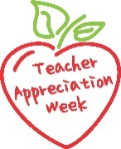 | 8  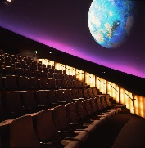  Planetarium – morning | 9  Board Meeting 6 p.m. | 10  Staff Lunch  (Thank you Graham family!)  Gym - afternooon | 11  UW Art Museum – afternoon | 12  Geology Museum –  Miss Reanna’s class - morning | 13
14 Mother's Day | 15 | 16  Graduation/Year-End Ceremony  6:00 p.m. Civic Center South Gym – all students and families welcome! | 17 | 18 | 19  Insect Room UW–  Miss Reanna’s class - afternoon | 20
21 | 22 | 23 | 24  Cake Boss – afternoon | 25 | 26  LAST DAY  Regular Hours | 27
28 | 29 Memorial Day  CLOSED | 30  CLOSED | 31  CLOSED | Summer School runs June 5- July 28  (closed July 3 and 4)

