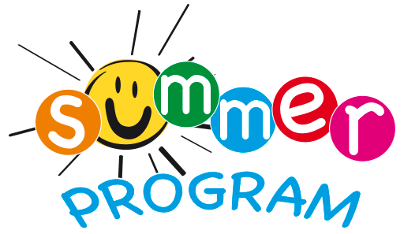

Tuition Agreement Form Summer – on back ----›

Enrollment Information:
Summer enrollment is now open for current and incoming Open School students!

The summer program begins June 5th and ends July 28th. We will be closed July 3 & 4 for the holiday. The 2023-2024 school year will begin August 24th.

Tuition for the summer is below. It is a separate program than our school year program. You can enroll your child for June, July, or both months. Indicate your schedule preferences on the form. The class and teaching staff arrangements will depend on enrollment and may be different than the regular school year.

Activities will include fun themes, academics, walking to parks, arts and crafts, science, water fun days, outdoor exploration, and a lot of fun with friends!

Please see Shelly with any questions about our summer program.

SUMMER 2023 Enrollment

Enrollment | Sessions/times | Monthly Tuition | Select one package
5 Full Days  With before/after school care | 7:30 a.m. to 5:30 p.m. | $855
5 Full School Days  Without before/after school care | 8:30 a.m. to 3:00 p.m. | $700
3 Full Days  Without before/after school care | 8:30 a.m. to 3:00 p.m.  List Choice of Days | $610
5 Half Days  Monday-Friday | 8:30 a.m. to 11:30 a.m.  OR  12:30 p.m. to 3:00 p.m.  Circle your choice | $425
Indicate months enrolling for (June or July or both)
Other Information:

Child’s Name: ________________________________ Birthday: ______________

Child’s Name: ________________________________ Birthday: ______________

Parent/Guardian Signature: Date:

Received by Director: Date:

