 | March 2023
Sun | Mon | Tue | Wed | Thu | Fri | Sat
 |  |  | 1  Spanish – morning  Swimming - afternoon | 2  Art – afternoon  Dr. Seuss Birthday &  Read Across America Day | 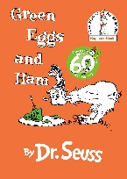  3  Green Eggs & Ham – story & snack -a.m. | 4
5  Spirit Week | 6  Hat Day | 7  UW Day  Civic Center Gym - afternoon | 8  Pajama Day  Spanish – morning  Swimming - afternoon | 9  Beach Day  Art - afternoon | 10  Backwards Day  Movie & Popcorn- afternoon  G rated | 11
12 Daylight Saving Begins  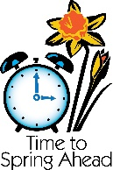 | 13  SPRING BREAK  SCHOOL CLOSED  Work on Lucky Family Project Shamrock this week – turn in after break | 14  SPRING BREAK  SCHOOL CLOSED | 15  SPRING BREAK  SCHOOL CLOSED | 16  SPRING BREAK  SCHOOL CLOSED | 17 St Patrick's Day  SPRING BREAK  SCHOOL CLOSED | 18
19 | 20 Start of Spring  (Spring Equinox)  Turn in Lucky Family Project Shamrock to teacher | 21  Civic Center Gym - afternoon | 22  Spanish – morning  Swimming - afternoon | 23  UW Art Museum - afternoon | 24 | 25
26 | 27 | 28  Library - afternoon | 29  Spanish – morning  Swimming - afternoon | 30  Art - afternoon | 31  Complete March Reading Logs – Turn in on 4/3

