 | April 2023
Sun | Mon | Tue | Wed | Thu | Fri | Sat
1
Week of the Young Child
Family Resource Fair
9-12 Civic Center
North Gym
2  Week of the Young Child  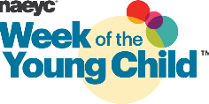 | 3  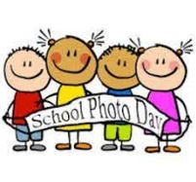  Photo Day | 4  Photo Day 2  Class Photos  10:00 – Joni  10:15 Laura  10:30 Reanna  Civic Center Gym - afternoon | 5 Work Together Wednesday – recycled art  Class Egg Hunts  Spanish – morning  Swim - afternoon | 6  Art – afternoon  Parent/Teacher Conferences  3:30-6:30 p.m. | 7  SCHOOL CLOSED | 8
9 | 10 | 11  Library - afternoon | 12  Spanish – morning  Swim - afternoon | 13 Music morning  UW Art Museum – bottom level, 6-7 p.m.  Silent auction & kids’ art | 14 | 15
16 | 17  Miss Reanna’s Morning Conferences  Book Fair in Office Begins | 18  Miss Joni’s Morning Conferences  Civic Center Gym - afternoon | 19  Spanish – morning  Swim - afternoon | 20  Music morning  Geology Museum 10 a.m. –  Miss Joni’s class | 21 | 22
23 | 24 | 25  Library - afternoon | 26  Spanish – morning  Swim – afternoon  (last swim session) | 27  Music morning | 28  Book Fair Ends | 29
30 | Upcoming Dates:  May 17 – graduation/year end celebration at school 10:30-11:30  May 26 – last day of school for school year; closed May 29-June 2  June 5 -summer school starts

