 | November 2022
Sun | Mon | Tue | Wed | Thu | Fri | Sat
 |  | 1 | 2  Spanish – all classes - morning  Swimming – PreK Afternoon | 3  Music – all classes – morning  Art – all classes -afternoon | 4 | 5
6 Daylight Saving Time Ends | 7  UW PE - afternoon PreK classes only | 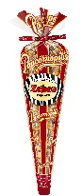  8 Election Day  Story Time at Library - afternoon  POPCORN ORDER FORMS DUE TODAY | 9  Spanish – all classes - morning  Swimming – PreK Afternoon | 10  Music – all classes – morning  Art – all classes -afternoon | 11 Veterans Day  UW PE - afternoon PreK classes only | 12
13 | 14  UW PE - afternoon PreK classes only | 15 | 16  Spanish – all classes - morning  Swimming – PreK Afternoon | 17  Music – all classes – morning  Art – all classes -afternoon  Family Night 6:00-7:00 p.m. | 18  Last PE  UW PE - afternoon PreK classes only | 19
20 | 21 | 22 | 23  CLOSED | 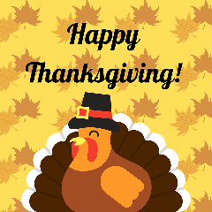  24 | 25  CLOSED | 26
27  Book fair in office through 12/7 | 28 | 29 | 30  Spanish – all classes - morning  Swimming – PreK Afternoon | Upcoming:  December 8TH – 6:00 p.m. Peppermint Parade at  Gryphon Theater  December 19-January 2 – closed for winter break

