 | October 2022
Sun | Mon | Tue | Wed | Thu | Fri | Sat
 |  |  |  |  |  | 1
2 | 3  UW PE – PreK afternoon | 4 | 5  Fire Truck visit at 10 a.m.  Spanish – all classes morning  UW PE – PreK afternoon | 6  Music – All classes morning  Art – All classes afternoon | 7 | 8  UW Big Event/Fall Clean Up  9:00-12:00 a.m.  Bring a rake and help clean school grounds – donuts!
9 | 10 | 11  Library – All classes afternoon  Board Meeting 6 p.m. | 12  Spanish – all classes morning  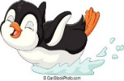  Swimming – PreK afternoon | 13  Music – All classes morning  Art- All classes afternoon | 14 | 15
16 | 17  UW PE – PreK afternoon  Popcornopolis Fundraiser Begins | 18  Staff Meeting 5:30 p.m. | 19  Spanish – all classes morning  Swimming – PreK afternoon | 20  Miss Laura conferences a.m.  Music – All classes morning Art– All classes afternoon | 21  UW PE – PreK afternoon | 22
  23 | 24  Miss Reanna conferences a.m.  UW PE – PreK afternoon | 25  Miss Joni conferences a.m.  Library – All classes afternoon | 26  Spanish – all classes morning  11:30 Dismissal All Classes | 27  CLOSED  District Wide | 28  CLOSED  District Wide | 29
30  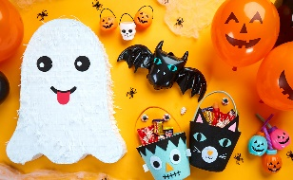 | 31 Halloween  Parties at 10:00 a.m.  Costume parade at 11:15 | Upcoming:  Popcornopolis Fundraiser – begins October 17 – forms due by November 1st  November 23-25 Closed for Thanksgiving break  Scholastic Book Fair in Office – week of November 28th  December 17-January 2nd – Closed for winter break

