
OPEN SCHOOL – DIRECTOR’S NEWSLETTER
June 2022

SUMMER UPCOMING DATES
June 6- first day of summer program
June 6-10 - planting flowers/garden days
July 4 – closed for holiday
July 29 - last day of summer school
July 30- August 24 – school closed
August 25 – first day of 2022-23 school year

Summer Info:
Classes:
We have 2 classes this summer:
Miss Laura’s – main building
Miss Reanna’s -secondary building
Support staff:
Miss Laura’s room: Miss Megan M., Miss Savannah
Miss Reanna’s room: Miss Emma, Miss Autumn
Both Rooms: Miss Brea, Miss Maggie
Office Assistant: Miss Savannah

What to Bring?
Food:
*Morning snack (see food paragraph)
*Packed lunch (see food paragraph)
*Afternoon snack (see food paragraph)
Other:
*Change of clothing (entire change, including socks/undies)
*Slippers or inside shoes like Crocs
*Swimsuit and towel – if you have an extra you can leave for the summer in case we have outside water play that would be great! (see water play paragraph)
*Water bottle (with child’s name on it, take home regularly to wash and return)

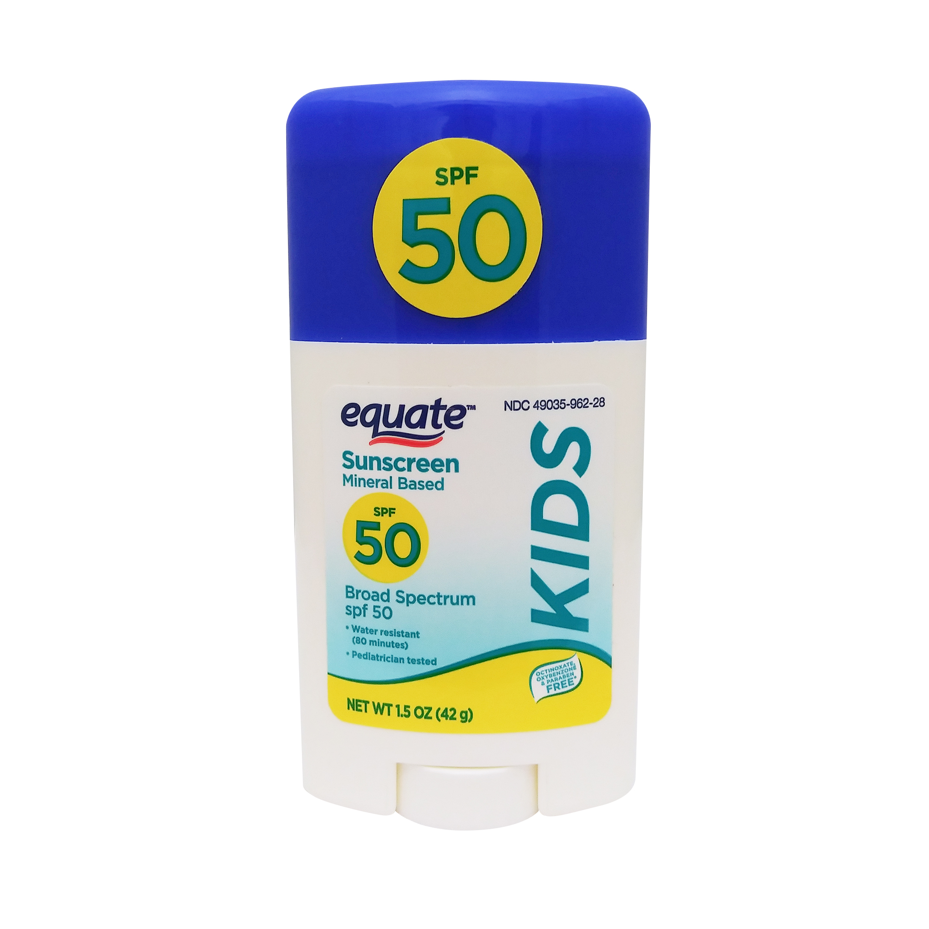
*Sunscreen Spray – please bring 2 bottles of spray sunscreen to be shared between all children and restocked during summer as needed (unless your child has special requirements, then bring their own labeled and give it to teacher)
*Sunscreen Stick – please bring 1 stick of sunscreen (the wider sticks) labeled with your child’s name for use on their face only and restocked during the summer as needed. Examples →
*Walking shoes – ideally, we would love to have an extra pair that you can leave here for walks to the park in case they arrive in sandals or other summer shoes. Otherwise, please make sure they wear comfortable walking shoes daily for walks and playground play. The pea gravel on the playground is uncomfortable with sandals/flip flops and we will be walking a lot.
*Flowers – if you would like to contribute to our flowerpots, your child can bring a small pack of annuals to plant the first week of summer school.
*Backpack – to carry snack and water bottles to the parks, bring items to/from school, an easy to carry bag
*White T-Shirt - we will tie-dye shirts to wear to parks, etc. Please bring a white t-shirt for your child their first day of school.
*Bikes/helmet: A helmet fitted to your child and labeled. See paragraph below

Contact Info:
307-745-7256 school phone
www.laramieopenschool.org school website
FB: https://www.facebook.com/laramieopenschool

Shelly McFate - Director
I will have summer hours – I will post my weekly schedule on my desk. Please let me know if you need to visit with me outside of these hours. I will check email 8-5 M-F. Email openschool1@hotmail.com

School Day Assistant Directors:
Please see the following staff for assistance during the day if I am not available:
Laura Shuler – Assistant Director
prek1class@laramieopenschool.org email
or
Miss Savannah -Office Assistant
Miss Brea - After School

Water Play:
We will have days that we play in the water throughout the summer. It would be helpful to have a towel/suit here at the school throughout the summer. We may put out sprinkler toys or use small pools to play on hot days. We may also visit the splash pad and wading pool. They can leave them hanging in cubbies and we can wash periodically here or send them home for a towel exchange as needed. Please label suits and towels.

July 4th Holiday:
The school will be closed on July 4^{h} for the holiday. We will have normal hours the rest of that week.

Enrichment:
Music – Miss Kennedy will teach music this summer (Thursday morning)
Storytime at the Park – we will be attending the library story time at Washington Park on Wednesday mornings at 10:00 a.m. starting June 15
Cooking – weekly in classroom, teacher’s choice of days/times
Sign Language - Miss Savannah will teach sign language this summer (Monday morning)
Soccer - 4 weeks of soccer lessons, Kirsten Cushman (Tuesday morning)
Other field trips, walks to the parks, soccer, art museum, etc. will be included as well.


Food:
Morning snack – please send a morning snack for your child each day or leave a box of snacks in the classroom for your child. Healthy and portable snacks would be appreciated. We will be eating snack at parks on occasion, and they will take their snacks with them for those days. Ideas – fruit, cheese, vegies, applesauce, crackers, pretzels
Lunch – If your child stays for lunch (11:30-12:30) please pack a daily lunch. We do have a microwave and refrigerator and can assist with opening and warming up food for your child.
After School snack – if your child stays for after school (3:00-5:30) please pack an afternoon snack. You can pack it in in their lunch box, and if you label it “after school” lunch staff will know to keep that aside for later.

Sunscreen:
Please apply sunscreen to your child before bringing them to school for the day. A teacher will check with you to make note of time sunscreen was applied for the day. Morning drop-off will be on the playground, so they should arrive sun screened and ready for the playground each morning (weather permitting).

Drop Off and Pick Up:
Drop Off- Upon arrival, your child can put their belongings in the classroom and then you should then walk them to the playground. You can assist as needed in the classroom. A teacher will be at the gazebo area to check children in on the attendance board and to confirm sunscreen time with you. Please walk your child to the gazebo/cone area and connect with the morning teacher before leaving your child. You will also check your child in/out on the ProCare app.

New families – you will be getting an email invite to download the ProCare app, and I will walk you through using the app on your first day. Please download the app and turn on location services for the app prior to the first day drop-off. We do use the ProCare app to send messages to families as well.

In the event the weather does not allow for starting on the playground, the children will start in their classrooms, and you can check in with a teacher in the classroom instead.

Pick Up – if the classes are outside, please walk over to the gazebo area and the teacher will send your child over. If the classes are inside, you can come in to pick them up. If your child stays for after school (3:15-5:30), they will be in the main building classroom.
We will ask that the children not run to/from the playground without a teacher/parent/guardian so that we know they have arrived or departed safely with the appropriate adult. We check them in on a teacher clipboard for accurate attendance numbers.


If/when we are able to use the vans for trips, we will put the orange cones on the sidewalk, to indicate that we are in transit and we will be parking there to load/unload children. Please avoid parking in that area during that time.

We thank you for your cooperation with these policies to help keep the children safe.

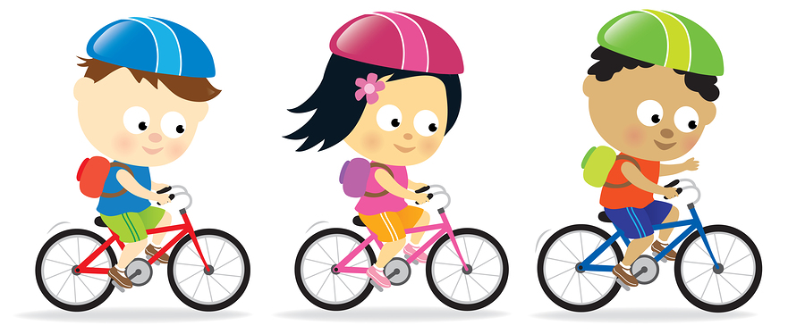
Bike Path:
Helmets: Each child should bring their own bike helmet, fitted to their head (please adjust them and double check them regularly for proper fit), and labeled with their name (duct tape, sharpie, etc.). They will be stored inside the classrooms, not left on the playground. We would recommend bringing a helmet that stays here at the school, so your child always has one available. If your child does not have a helmet at the school, they will not be able to ride a bike that day.
Bikes: If your child would like to bring their own bike back and forth, they are welcome to do that. Your child’s bike should be the proper size for them and a bike they are able to manage safely. Please label your child’s bike as well. There is a bike rack in front for storage of personal bikes. Please remember that our playground is not locked at night, so there is a risk if you leave the bike here overnight. We cannot assume any liability for bikes that are stolen, broken, etc.

We do have bikes, trikes, cars, etc. available for children to use as well in the bike rack next to the bike path. Your child should be able to touch the ground while seated on any bike they are riding on the bike path. The children will be taught bike path safety and rules to follow. The bike path is not open during first morning drop-off recess or in inclement weather.

Schedules:
We understand that your summer plans may change. If you need to change your child’s schedule entirely, please see Shelly. If you need to add a session (add a morning, afternoon, lunch, after school session, etc.) that your child is not signed up for, check with staff to see if we have room. If we do have room, they are welcome to attend, and the extra session charge will be added to your next statement. We do have to adhere to required teacher:child ratios, so we have to look at our numbers to accommodate any schedule changes or add-on sessions. We do not have make-up sessions. If your child misses a day they were scheduled to attend, they can’t make it up on another day without the extra session fee. This is our policy all year, as we have to schedule staff for the number of children scheduled to attend to stay in compliance with our licensing ratios. Thank you for your understanding of our policies.

Website:
Our website contains our parent handbook, monthly calendar, school year calendars, school alerts, and much more information. www.laramieopenschool.org

We look forward to a fun summer together!


