 | June 2022
Sun | Mon | Tue | Wed | Thu | Fri | Sat
 |  |  | 1 | 2 | 3 | 4
5 | 6  First Day of Summer School | 7 | 8 | 9  Music with Miss Kennedy – a.m. | 10 | 11
12 | 13  Sign language – a.m.  Art – afternoon | 14  Soccer – a.m. | 15  Storytime with Library  Washington Park – a.m. | 16  Music with Miss Kennedy – a.m. | 17 | 18
19 | 20  Sign language – a.m.  Art - afternoon | 21  Soccer – a.m. | 22  Storytime with Library  Washington Park – a.m. | 23  Music with Miss Kennedy – a.m | 24 | 25
26 | 27  Sign language – a.m.  Art - afternoon | 28  Soccer – a.m. | 29  Storytime with Library  Washington Park – a.m. | 30  Music with Miss Kennedy – a.m | 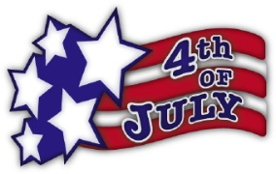  Closed July 4th for holiday
Other trips will occur throughout the month: splash pad, UW campus trips, parks around Laramie, wading pool, water days at school, cooking days, etc. Please make sure your child has a swimsuit, towel, walking shoes, and a water bottle daily. Thank you!

