 | April 2022
Sun | Mon | Tue | Wed | Thu | Fri | Sat
 |  |  |  |  | 1 | 2
3  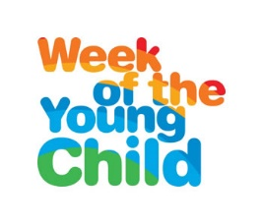 | 4  Music Monday  Miss Laura’s Conferences a.m. | 5  Tasty Tuesday Tacos  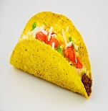  This Photo by Unknown Author is licensed under CC BY-SA  Miss Reanna’s Conferences a.m. | 6  Work Together Wednesday  Miss Joni’s conferences a.m.  Spanish – morning  Music - afternoon | 7  Artsy Thursday  Art – morning & afternoon  Domino’s Pizza Night  Parent-Teacher Conferences 5:30 p.m. begin | 8  Family Friday | 9
10  Kindergarten Registration Begins in District | 11  NO SCHOOL  DISTRICT WIDE | 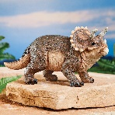  12  Geology Museum Trip – Preschool – morning  Story Time Library – afternoon PreK Classes  Board Meeting 5:30 p.m. | 13  Book Fair Begins  Spanish - morning  Music - afternoon | 14  Art - afternoon | 15 | 16
17 Easter | 18 | 19 | 20  Spanish - morning  Music - afternoon | 21  Art - afternoon | 22 Earth Day | 23
24 | 25  Staff Meeting 5:30 p.m. | 26  Story Time Library – afternoon PreK Classes | 27  Book Fair Ends  Spanish - morning  Music - afternoon | 28  Art – afternoon | 29 Arbor Day | 30
Upcoming Dates: May 2 & 3 – Traditions Photography Photo Days – spring & graduation photos
May 27th – last day of school year (regular hours) June 6th – summer school starts

