 | March 2022
Sun | Mon | Tue | Wed | Thu | Fri | Sat
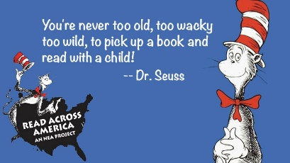 | Read Across America Week | 1  Reanna 1st Recess | 2  Laura 1st Recess  Spanish – am  Music - aft  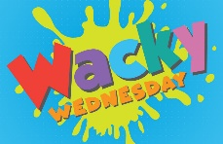  Wacky Wednesday | 3  Joni 1st Recess  Domino’s Pizza party –  Miss Reanna’s Room  11:00 a.m.  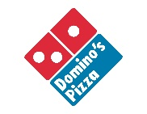  Domino’s Pizza Fundraising Night – Whose class will win the next party?  Art - aft | 4  Joni1st Recess  Pajama Friday  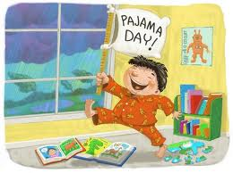 | 5  Fall Enrollment Forms Due by March 4 to Reserve a Fall Spot
6 | 7  Laura 1st Recess | 8  Reanna 1st Recess | 9  Laura 1st Recess  Spanish – am  Music - aft | 10  Joni 1st Recess | 11  Reanna 1st Recess | 12  Summer Enrollment Forms Due by March 11 to Reserve a Summer Spot
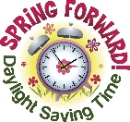  13 | 14  CLOSED  SPRING BREAK | 15  SPRING BREAK | 16  SPRING BREAK | 17 Saint Patrick's Day  SPRING BREAK | 18  SPRING BREAK | 19
20 Start of Spring (Spring Equinox) | 21  Joni 1st Recess | 22  Reanna 1st Recess | 23  Laura 1st Recess  Spanish – am  Music - aft | 24  Joni 1st Recess  Art - aft | 25  Laura 1st Recess | 26
27 | 28 | 29  Reanna 1st Recess | 30  Laura 1st Recess  Spanish – am  Music - aft | 31  Joni 1st Recess  Art - aft | Upcoming Dates:  *April Parent/Teacher Conferences –  Week of April 4 – sign up after spring break  *Scholastic Book Fair –  Week of April 11th  *Kindergarten Registration –  Begins Week of April 11th in District

