THE OPEN SCHOOL
MISS SHELLY’S NEWSLETTER
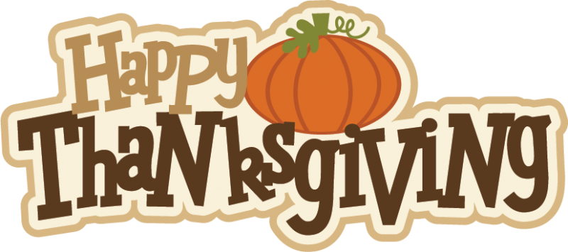

UPCOMING DATES
November 15 – Family project turkeys due
November 18 – Popcorn fundraiser brochure orders due to office
November 23 – Online Popcorn fundraiser ends
November 24-26 – School closed, Thanksgiving Break
December 6-14 – Scholastic Bookfair in office – cash & carry books
December 20-31 – School closed, winter break, reopen on January 3rd normal hours
Disguise a Turkey
You should have found a turkey family project in your child’s cubby this month. If you need an extra one let us know. Please have your child bring it back to their teacher by November 15th to share and hang at the school. We can’t wait to see your disguises!

Miss Laura’s Room Access
You are always welcome to enter the classroom through the office if Miss Laura’s side door is closed. We try and keep office traffic down, but it is perfectly fine to come through the office. If you are bringing a stroller or otherwise need a ramp to enter, a portable ramp is available in the office to help enter her classroom. (next to water cooler, lightweight and easy to place at stair as needed).

Native American Heritage Month
We will be learning about Native Americans this month, with the help of Chandelle Macdonald, Weston’s mother. We will be reading stories, doing crafts, and learning about Native American culture this month. Thank you Chandelle for sharing your knowledge with us!

Food Drive
We are hosting a food drive to gather food to take to Interfaith & Laramie Soup Kitchen before Thanksgiving. Food items needed: mashed potatoes, sweet potato cans, cream of mushroom soup, French fried onions, stuffing, turkey gravy, canned pumpkin, graham cracker pie crusts, cranberry sauce, marshmallows, corn, and cornbread mixes. They accept monetary donations to them directly to help purchase turkeys. Food drive boxes are in each classroom.
https://www.laramiesoupkitchen.org/thanksgiving-donations.

Trick or Trash
The Trick or Trash recycling bin is still available in the office to recycle wrappers. Feel free to bring wrappers in and recycle them when you have them. I will ship it back when it is full, no deadline.

Popcornopolis Fundraiser
Our fundraiser is underway! Samples and extra order forms are available in the office, help yourself! Brochure orders need to be in by November 18, popcorn delivered here around the 10th of December for you to pick up and deliver. Online orders ship directly to customers and are available to place through November 23. The top seller in each classroom will receive a $20 gift card to our book fair in December! (Online orders can be tracked and credited accordingly following the close of the online portion). Fundraising is important this year as we have decreased enrollment, increased staffing, and increased expenses to assist with following COVID protocols. Please see the fundraiser and brochure for more information. Thank you for your support.

Scholastic Book Fair
We will be having a book fair in the office in December before break. Books will be available for purchase directly from the fair for gift giving or winter break reading!

Lost and Found
Lost and found bin is in the office, feel free to take a look to find any lost items.

General Illness
As a reminder – as we enter cold and flu season, along with continuing to navigate through COVID policies:

If your child has symptoms of COVID-19 they will need to be screened by their healthcare provider. If the provider determines that the symptoms are due to another illness or diagnosis, they may return to school after following the Parent Handbook illness policies and with the healthcare provider’s recommendations. (If allergies, lingering side effects of another illness, etc., please provide a doctor’s note with the diagnosis).

If the healthcare provider does not determine another illness is the cause, the child may return after 24 hours of resolution of fever without the use of fever reducing medications AND resolution of any other symptoms and when recommended by the provider. Your child’s physician should be able to email a note to the school with a school clearance.

It is important that we all work together to keep our entire school family well this winter. Please continue to screen your child for illness, determine the illness, and stay home if not well. Staff must also stay home when not feeling well/symptoms. We know this is a hardship on families and staff and appreciate everyone working together to keep the classrooms healthy. Thank you.

COVID-19 Vaccine ages 5+
The COVID-19 vaccine is now available for ages 5-11. Check with your child’s physician for more information. Below is information from Ivinson regarding an upcoming vaccination clinic:

Ivinson Medical Group will be holding a COVID-19 vaccine clinic to offer the Pfizer vaccine to ages 5 and older. The vaccine clinic will be held on the main floor of Ivinson Medical Group. Individuals do not have to be a patient of Ivinson Medical Group to receive their vaccine but must be accompanied by a parent or guardian.
Walk-ins will be accepted; we recommend pre-registering prior. Please call or text 307-755-4540 to pre-register or to reserve an appointment time. Snacks will be provided.

If you choose to have your child vaccinated, please bring their updated vaccinated records when complete for their file. If your child is 3-4, vaccinations should be available next year.

Information about the vaccine:

https://www.healthychildren.org/English/health-issues/conditions/COVID-19/Pages/The-Science-Behind-the-COVID-19-Vaccine-Parent-FAQs.aspx

https://health.wyo.gov/publichealth/immunization/wyoming-covid-19-vaccine-information/covid-19-vaccine-questions-and-answers/

Amazon Smile
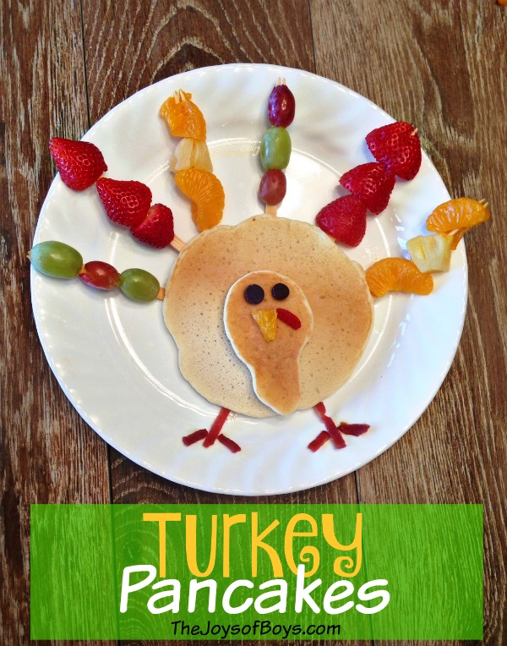
A simple way to support the school is to choose Open School as your charity of choice on Amazon. Simply log in to Amazon through smile.amazon.com and then search Open School as your charity. We will automatically receive a percentage of profit based on your order. (Order details are never shared, just a donation made by Amazon to us). It is sometimes tricky to remember to go through the smile.amazon site when you order, but it is an easy way to benefit the school.




