 | January 2022
Sun | Mon | Tue | Wed | Thu | Fri | Sat
 |  |  |  |  |  | 1 New Year's Day
2 | 3  Joni – 1st recess | 4  Reanna – 1st recess | 5  Laura – 1st recess  Spanish – morning  Music - afternoon | 6  Joni – 1st recess  Art - afternoon  DOMINO’S PIZZA NIGHT | 7  Laura – 1st recess  Storytime and Yoga - afternoon | 8
9 | 10  Reanna – 1st recess | 11  Reanna – 1st recess  Board Meeting 5:30 p.m. | 12  Laura – 1st recess  Spanish – morning  Music - afternoon | 13  Joni – 1st recess  Art - afternoon | 14  Joni – 1st recess  Storytime and Yoga - afternoon | 15
16 | 17 Martin Luther King Jr.  NO SCHOOL  DISTRICT WIDE | 18  Reanna – 1st recess  Library Visit- afternoon | 19  Laura – 1st recess  Spanish – morning  Music - afternoon | 20  Joni – 1st recess  Art - afternoon | 21  Laura – 1st recess  Storytime and Yoga - afternoon | 22
23 | 24  Reanna – 1st recess  Staff Meeting 5:30 p.m. | 25  Reanna – 1st recess | 26  Laura – 1st recess  Spanish – morning  Music - afternoon | 27  Joni – 1st recess  Art - afternoon | 28  Joni – 1st recess  Storytime and Yoga - afternoon | 29
30 | 31  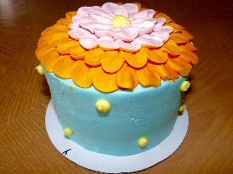  Laura – 1st recess  Cake Decorating Contest – Cake Boss! – all classes | Reminders:  Please bring warm clothing daily– snow pants, boots, waterproof mittens, hats, etc.  Please bring clean water bottles daily

