 | November 2021
Sun | Mon | Tue | Wed | Thu | Fri | Sat
 | 1  Reanna – 1st recess | 2  Reanna – 1st recess | 3  Laura – 1st recess  Spanish – morning  Music - afternoon | 4  Joni – 1st recess  Art – afternoon  Domino’s Pizza Night | 5  Joni – 1st recess  Virtual Library Story time - afternoon | 6
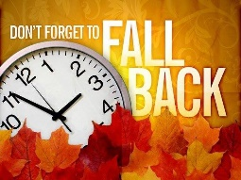  7 Daylight Saving Time Ends | 8  Laura – 1st recess | 9  Reanna – 1st recess | 10  Laura – 1st recess  Spanish – morning  Music - afternoon | 11 Veterans Day  Joni – 1st recess  Art - afternoon | 12  Reanna – 1st recess  Virtual Library Story time - afternoon | 13
14 | 15  Joni – 1st recess | 16  Reanna – 1st recess | 17  Laura – 1st recess  Spanish – morning  Music - afternoon | 18  Joni – 1st recess  Art – afternoon  Popcorn Fundraiser Orders Due | 19  Laura – 1st recess Virtual Library Story time - afternoon | 20
21 | 22  Reanna – 1st recess | 23  Reanna – 1st recess  Thanksgiving in classrooms | 24  CLOSED | 25  Thanksgiving Day  CLOSED  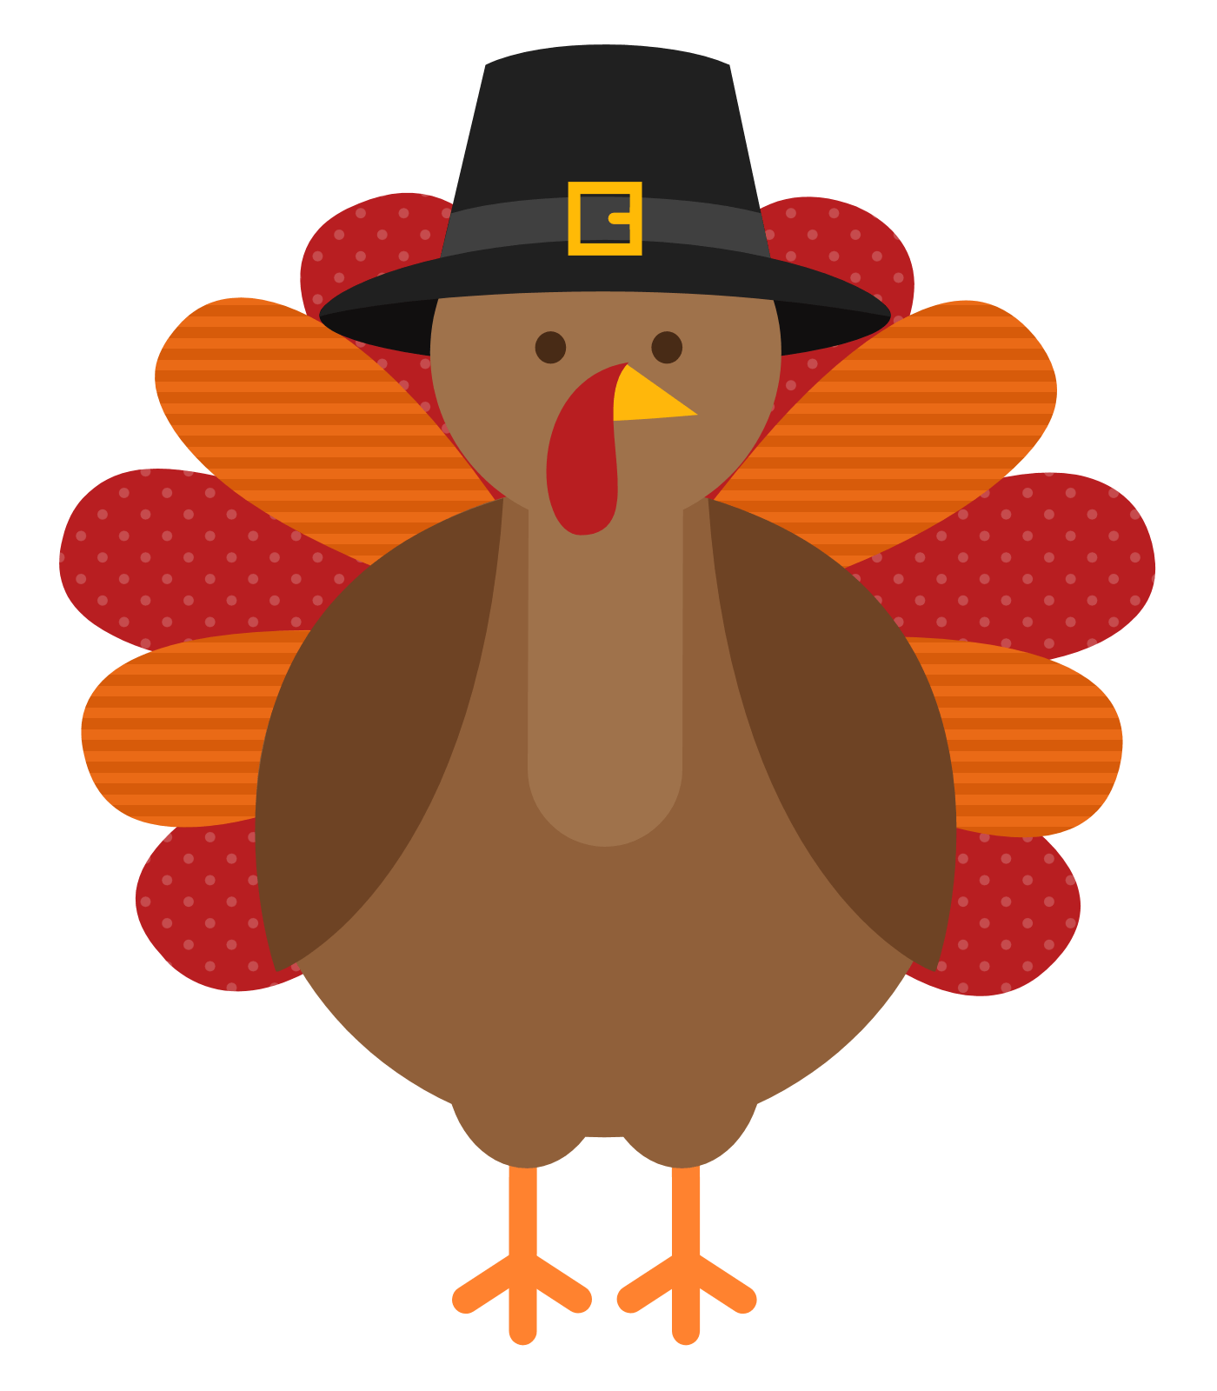 | 26  CLOSED | 27
28 | 29  Joni – 1st recess | 30  Reanna – 1st recess | Any other field trips and special guests will be noted in classroom newsletters  December – Winter Break December 20-31  school resumes January 3

