Pre-K 1 Class Newsletter 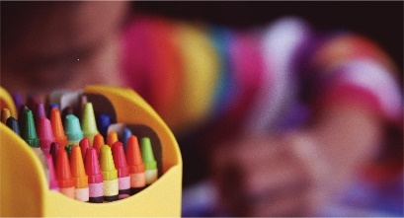 | March 22, 2021
Hi!  We will begin a 2-week ocean unit after break. We will look at the different ocean zones, what lives in each and learn what makes each ocean different or same.  We will begin walking to Washington Park in April for soccer sessions.  The Scholastic book fair will be held online and in the school office for purchase beginning April 12th.  Parent/Teacher Conferences for our class will be on April 14th with sign-up slot available the last week in March.  Pictures have been moved to April 27th.  Have a great Spring Break!  Thanks! --Laura | Upcoming Dates:  - p/t Conferences april 14th via zoom  - Scholastic Book Fair April 12th

