Pre-K 1 Class Newsletter 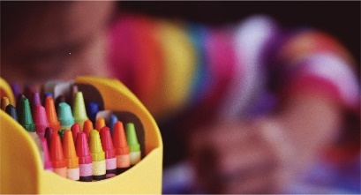 | March 8, 2021
Hi!  We will have a bit of fun this week with rainbows, shamrocks, and a pajama party on Friday before our break. On Friday afternoon we will watch a G-rated movie. When we return from break, we will start a two-week unit on the Ocean.  Parent teacher conferences for our class will take place on Wednesday, April 14th via Zoom.  Pictures have been moved to April 27th.  Have a great weekend!  Thanks! --Laura | Upcoming Dates:  - Spring Break March 15th-19th School Closed

