 | March 2021
Sun | Mon | Tue | Wed | Thu | Fri | Sat
 | 1  Music – afternoon | 2  Dr. Seuss Birthday | 3  WACKY WEDNESDAY  Spanish - morning | 4  Art - afternoon  Domino’s Pizza Night  (use flyer) | 5  Library Storytime (virtual) | 6
7 | 8  Music – afternoon | 9 | 10  Spanish – morning | 11  Art – afternoon | 12  Library Storytime (virtual) | 13
14 Daylight Saving Begins  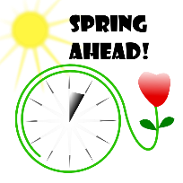 | 15  SPRING BREAK  School closed all week – enjoy your spring break! | 16  SPRING BREAK | 17 Saint Patrick's Day  SPRING BREAK | 18  SPRING BREAK | 19  SPRING BREAK | 20
21 | 22  Music – afternoon | 23 | 24  Spanish – morning | 25  Art – afternoon | 26  Library Storytime (virtual) | 27
28 | 29  Music – afternoon | 30  Traditions Photography Photos  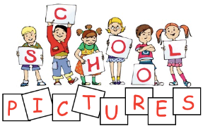 | 31  Traditions Photography Photos  Spanish - morning | Cooking, science, yoga – in classrooms, see class lessons for details  Traditions Photography – taking individual and graduation photos – more details to come in newsletters  Upcoming: parent/teacher conferences week of April 12th

