Pre-K 1 Class Newsletter 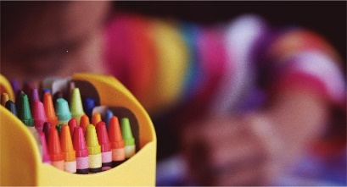 | January 4, 2021
Hi!  I hope you all had a great and restful break! We will be starting a new unit on fairy tales when we return. We will look at the Little Red Hen and The Three Little Pigs as we begin the unit. We will begin matching lowercase and capital letters and introduce last names during our writing centers.  Thank you for bringing back slippers, extra clothes, snow clothes and water bottles daily.  Thanks! --Laura | Upcoming Dates:  - MLK Day January 18th – School Closed

