 | December 2020
Sun | Mon | Tue | Wed | Thu | Fri | Sat
 |  | 1 | 2 | 3  Art - afternoon | 4 | 5
6 | 7  Music - afternoon | 8 | 9  Spanish – a.m | 10  Art - afternoon | 11  Library Story Time - afternoon | 12
13 | 14  Music - afternoon | 15 | 16  Spanish – a.m | 17  Art - afternoon | 18  Movie 8:30 | 19
20 | 21  CLOSED | 22  CLOSED | 23  CLOSED | 24  CLOSED | 25 CHRISTMAS DAY  CLOSED  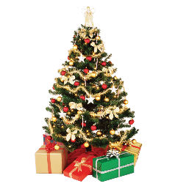 | 26
27 | 28  CLOSED | 29  CLOSED | 30  CLOSED | 31  CLOSED | SCHOOL RESUMES JAN 4

