THE OPEN SCHOOL
MISS SHELLY’S NOVEMBER - NEWSLETTER

UPCOMING DATES
November 9-22 – Online Scholastic Book Fair
November 10– Board Meeting 5:30 p.m. via ZOOM
November 16 – Popcorn in person orders due to office
November 21 – Online Fundraising Auction Ends 9:00 p.m.
November 25-27 – No School Thanksgiving Break
November 30 – Online Popcornopolis orders last day

Online Auction
The online auction is up and running! Bidding ends November 21st at 9:00 p.m. Links are on our Facebook page to share on your social media, as well as our website under the Fundraisers tab. Please share with your family, coworkers and friends! A lot of awesome items are available. Some are displayed in the office if you want to take a closer look at anything. Thank you for your support!

Popcorn Fundraiser
Popcorn in person orders are due November 16th to the office (payments and order form). Online orders can be placed through November 30th for direct shipping. The link on our website under the Fundraisers tab will take you directly to the order page. There are different options available on the website as well, including snack packs. Let me know if you have any questions!

Scholastic Bookfairs
We will have an online bookfair in November. Once I receive the information from Scholastic, I will pass it along. You will be able to order books for delivery prior to Christmas. Book fairs give the school points to purchase bigger items – like our great circle time carpets, bookshelves, and new learning materials.

Find us
Facebook: https://www.facebook.com/laramieopenschool/
Website: http://www.laramieopenschool.org/
Lesson Plans are posted weekly on the website under the Lesson Plans tab
Email: openschool1@hotmail.com
Smile.amazon.com choose Open School as your charity

Enrichment
Some of you asked about enrichment during conferences. Unfortunately, until things improve we cannot resume swim lessons and cross fit classes. We know swim lessons are a big deal, but the steps involved in providing lessons off site just are not feasible right now. However, our onsite enrichment is up and running and the children are enjoying all of the following:

Monday afternoon – music with Miss Willow
Tuesday afternoon – Yoga with Miss Amber (starting 11/10)
Wednesday morning – Spanish with Miss Elizabeth
Thursday afternoon – art with Miss Tasen
Friday afternoon – library story time (virtual with activity kits) and 1x a month UW Art Museum (virtual) with art activity

The next UW Art Museum projects include a multi-week museum curator project that Miss Tasen will be working on with the Thursday afternoon children. If your child does not attend Thursday afternoons, we will be sending the kits home, as they have supplied us with enough for every student. Instructions will be in the kits.
The UW Art Museum is also having a virtual Happy Holidays event. Normally we decorate a tree for the festival, but this year we will be decorating ornaments that will be in the museum’s virtual event

Science Kitchen
We have also had Science Kitchen from UW drop off fun science experiment kits! You may see some of the kits or activities come home once the teachers have completed some of the experiments in class.

http://wyomingspacegrant.org/sciencekitchen/

WELCOME TO THE SCIENCE KITCHEN!
The UW Department of Physics and Astronomy and Wyoming NASA Space Grant have launched the Science Kitchen! In the Science Kitchen K-12 students and teachers can build, create, and explore scientific ideas through interactive experiments and group work. The Science Kitchen is a center for introducing students to physical sciences through hands-on exploration and problem solving. (Funded by the Ellbogen Foundation)

COVID-19 Update
I am in constant contact with State and County public health, keeping up with current information. A new protocol: when a masked student/staff within the school/childcare setting tests positive and close contacts were wearing masks, then they may not require the entire classroom/school to quarantine. Close contacts would be asked to self-monitor for 14 days. We will be continuing to encourage children to wear their masks throughout the day, including the playground now, in order to avoid having to shut classrooms/school down if/when we have a positive case. I have ordered buffs/neck gaiters in fun designs for the children – they might prefer to wear the buffs outside on the playground, especially when it is cold. Staff, of course, always are wearing masks at school. We will offer mask breaks when we can keep the 6 feet distance. Hopefully, this new protocol will allow us to stay open and not have to quarantine students/staff as often.

FREE testing is available from the State for individuals and employers. We will have tests for staff testing. Some of our staff are UW students, so they are already tested regularly. I would highly encourage you to take advantage of the free testing – it is at home, and saliva, so it should be an easy process. Visit the WY Dept of Health website for ordering instructions. This would be a good way to have peace of mind, at no charge, and protect our school population from spread:

https://health.wyo.gov/publichealth/infectious-disease-epidemiology-unit/disease/novel-coronavirus/covid-19-at-home-testing/

I am attaching a flyer from the WY Dept of Health on “What to Expect if a Student or Staff Member Tests Positive for COVID-19” that will provide you with more information on the process, quarantine, and isolation process. Currently, we have not had to go through this process, but I wanted you to be informed on what that would look like.

If you hear that your family has had a COVID-19 exposure, please notify the school. The Dept of Health may not contact you to quarantine after an exposure, as they have a backlog of cases currently, but you should still quarantine for 14 days and not have your child attend school until the 14 days pass. If they test positive or develop symptoms during those 14 days, then it would be a longer timeframe. We appreciate your support with this policy in order to minimize our exposures here at the school.

The new air purifiers that we received thanks to a United Way grant are installed in all 3 classrooms and the office. We will keep doing all we can to keep everyone safe and healthy.

Staff Corner
This month I will introduce our lead teachers! They are 3 amazing women with a lot of talent and passion for early childhood education.
PreK1 Teacher
Miss Laura and Clark
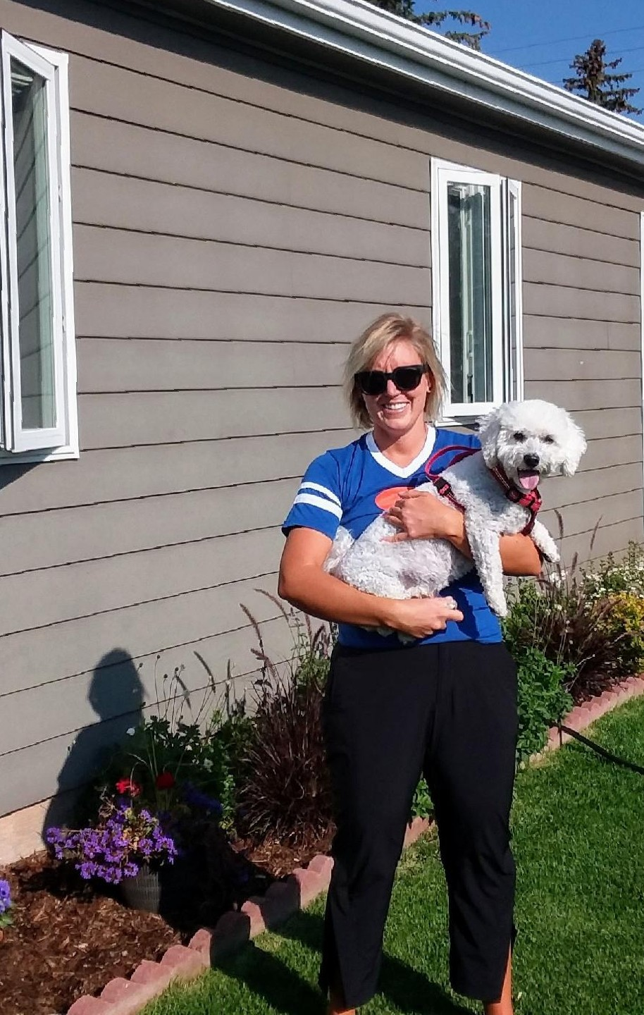
Hi! I am Laura Shuler and I am the lead teacher for the Pre-K 1 classroom. I am a native of Laramie and I graduated from the University of Wyoming in 2011 with a Bachelor’s Degree in Family and Community Studies. I joined the Open School in 2014 as an assistant. I am always up for a hike or a bike ride with my dog Clark. I also enjoy spending time with my family and catching the latest movie at the theater! Each year is always so exciting, and I look forward to seeing the kids grow, learn and create throughout the year!

Preschool Teacher, Yoga Teacher
Miss Amber, husband Joseph, Benni and Jet
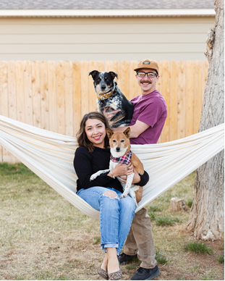
Hi, I am Amber, and I teach in the preschool classroom. This is my fourth year as head teacher, but I have been working at the Open School since 2014. I graduated from UW with a Bachelor's Degree in Child Development. I am from Cheyenne, but stayed in Laramie after graduation because it felt like home and I love the community! Outside of teaching, I like to hang out on my little "farm" with my husband, dogs, ducks, and chickens. If you ever want to talk chickens, I'm all ears! I also like to attend yoga classes/events in town and became a certified yoga teacher (RYT-200) last winter. See you around!

PreK2 Teacher, Assistant Director
Miss Carrie, Rachel, Russell, Joshua, Rick
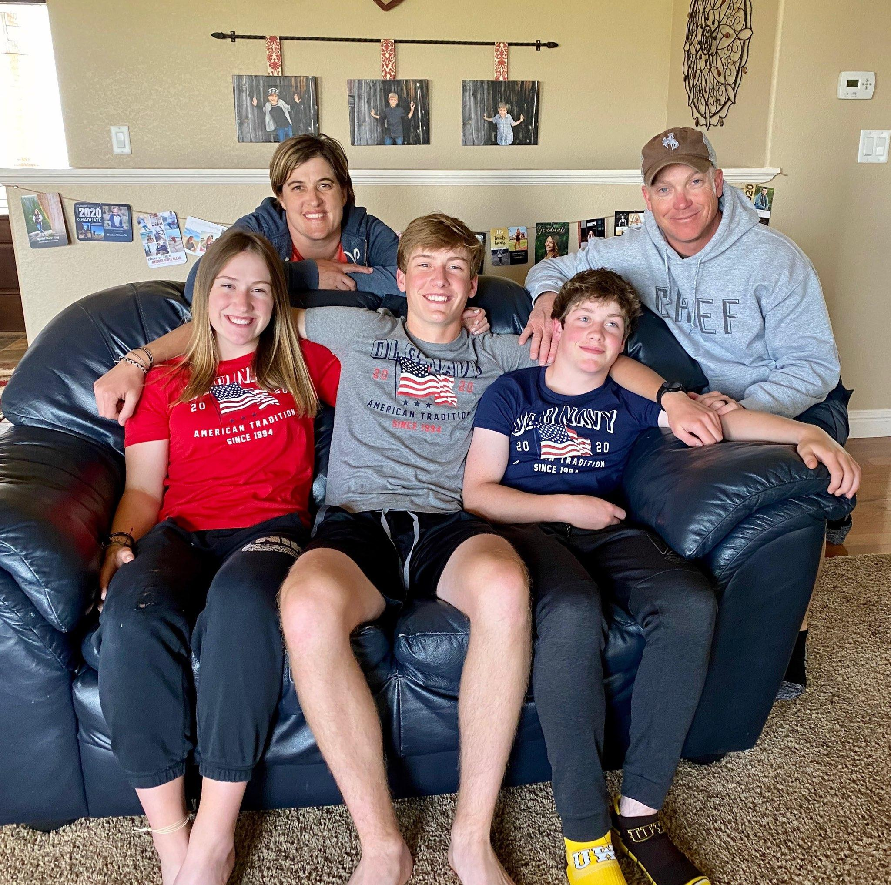
Established in 1997, the King family consists of Rick, Carrie, Rachel, Russell and Joshua. Rick and Carrie moved to Wyoming in 1998 so Rick could begin his career with the Wyoming Game and Fish Department (WGFD). The King’s Wyoming adventure began in Laramie, where Carrie completed her Bachelor’s Degree in Elementary Education, and included stops in Casper, Newcastle, Mountain View, and Lovell before circling back to Laramie in 2011. Rick continues to work for the WGFD, and Carrie is entering her 9th year at The Open School. Rachel, 18, is a UW freshman studying Kinesiology, has several part-time jobs including a few hours at the The Open School helping with lunch. She keeps her brothers lined out and frequently reminds them she can back squat more than they can. Russell is a Junior at Laramie High School, runs cross-country and track, and is practicing his salesmanship skills at the Laramie Basecamp store. Joshua, an Open School Alum, is an 8th grader at Laramie Middle School, plays hockey, soccer and way too much Fortnite. The King’s like to hike, fish (Carrie just completed her Wyoming Cutt-slam – ask her about it) and spend time outdoors. Two yellow Labrador retrievers and a spoiled black cat are currently part of the family.

