Pre-K 1 Class Newsletter 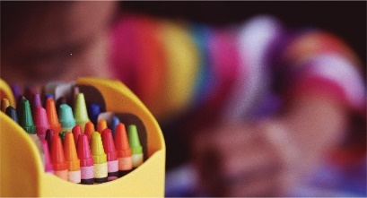 | September 21, 2020
Hi!  We will have a “Fall Festival” week as we celebrate the beginning of fall on Tuesday. We will enjoy fun learning games, create funny scarecrows and make and eat yummy caramel apples, along with kettle corn for cooking.  Music will start on Monday afternoon and Spanish starts on October 7th at 10:15.  If you could please send me a picture of your child, I would like to put it on our classroom board. Thank you!  Have a great weekend!  --Laura | Upcoming Dates:  - September 28th -Closed- Staff Development  - OctoBer 21st 11:30 a.m. Release  - October 22nd-23rd Closed- Parent/Teacher Conferences  We are trying to put together a school wide virtual photo album without masks. If you could please send a family photo letting us know who is in the picture and a short sentence of what you like to do as a family. You can send it to Miss Shelly. Thank you!

