Pre-K 1 Class Newsletter 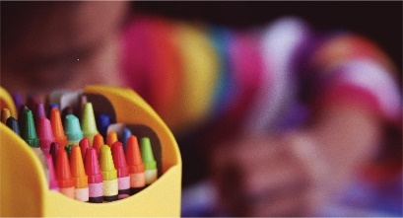 | September 8, 2020
Hi!  We will start our first unit on Apples this week. We will practice “apple shapes”, graph our favorite apples and make apple pie in a cup for cooking.  Thank you for labeling snack and lunches it has been so helpful!!  The book order flyer in the take home folders can stay home and you can order online.  Dominos’ Pizza Night is on September 10th. There is a flyer in their take home folder.  I’m trying to check messages on ProCare, but I might not get back to you right away. But I will do my best! You can always email me between 8-5 as well.  Have a great weekend!  --Laura | Upcoming Dates:  - September 28th -Closed- Staff Development  Please make sure to Wash masks regularly and take home water bottles to clean, Thanks!

