Pre-K 1 Class Newsletter 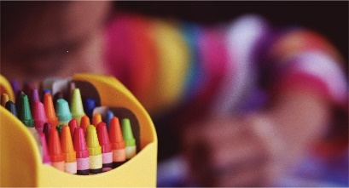 | August 31, 2020
Hi!  We will continue to work on the classroom routine and have fun with friends this week!  All the kids are doing a great job and they are making new friends each day! I hope they are enjoying coming to school so far.  Please make sure to bring inside shoes/slippers for the classroom. Thank you for packing a morning snack—please make sure to label either the container or sack it is in even if it is in their lunchbox.  Please remember we are keeping a limited number of people coming into the classroom. I will try to have your child ready to go at pick up times so a staff member can bring your child to you. Please drop your child with a staff member in the morning as well.  Have a great weekend! --Laura | Upcoming Dates:  - Sepetmber 7th-Closed - Labor  - September 28th -Closed- Staff Development  Please make sure to Wash masks regularly and take home water bottles to clean, Thanks!

