The Open School
Spring Raffle Fundraiser 2019
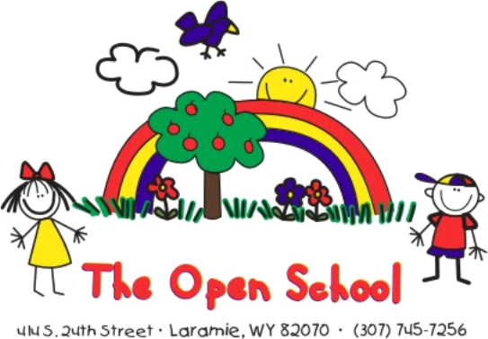

$1 Tickets/ Buy 10 Get 1 Free
We are excited to bring you our 12th annual Raffle Fundraiser featuring valuable prizes and merchandise. We have solicited coupons, gift certificates and passes from businesses around Laramie, Fort Collins and Denver, which we have divided into themed gift baskets to be raffled off. This fundraiser is open to anyone who wishes to join in and support The Open School!

Here is how it works:
- Tickets are $1.00 each or buy 10 and get 1 free (11 tickets for $10)
- Fill out the back of the ticket with your name, phone number, and the item number that corresponds to the item you want
- Each family is given 55 tickets to start, and you can get as many as you need from the office
- The family who sells the MOST raffle tickets will get $200 off tuition for the Open School (for families who have children going into Kindergarten in the fall we will reimburse you the $200).
- When you have sold your tickets please return the tickets and money to the office.
- All tickets must be purchased and turned in by May 20th
- The drawing will be held at noon on May 22nd, during our year-end/graduation and winners will be posted on our website
- Need not be present to win
- If you have any questions regarding this fundraiser, please feel free to call at 307-745-7256.
- We hope to reach our goal to raise $4000.00 to add additional playground toys and science materials!

ITEMS LISTED BY ITEM # - PLEASE LIST THE # ON BACK OF TICKET
THANK YOU FOR YOUR SUPPORT!
GOOD LUCK!

#1 Beauty Basket  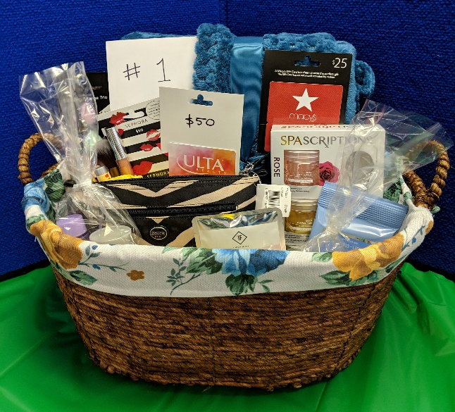  A luxurious basket of beauty supplies! $50 gift card to Ulta, $50 to Sephora, $25 to Macy’s, a Coach make-up bag, velvet plush oversized throw blanket, skin card products, as well as a variety of make-up. All inside a Pioneer Woman cloth-lined basket!  Donated by Greg and Samantha Wallace | #2 Cozy Home Basket  Home linens, The Little Book of Hygge – Danish Secrets to Happy Living, Essential oil diffuser and lemon essential oil, 3 small pottery bowls, and a house plant in a cozy basket.  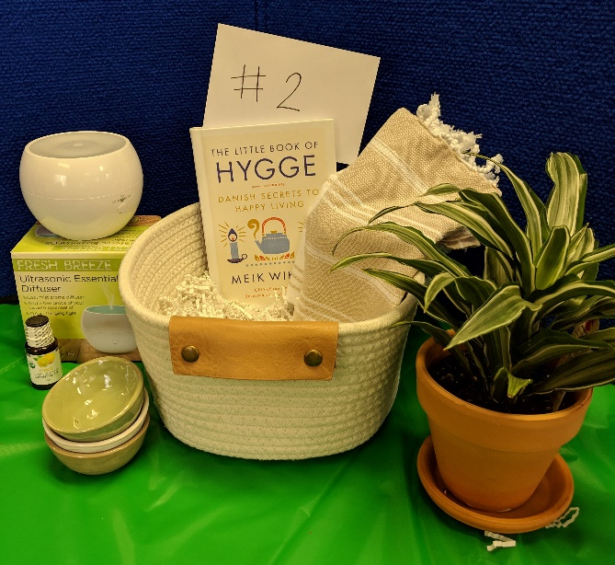  Donated by Doug and Lisa Faus
#3 Creative Crayola Easel  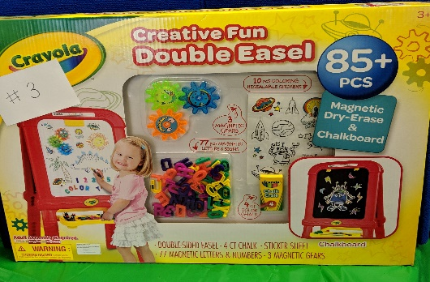  Easel with 85+ pieces -magnetic dry erase and chalkboard, 77 magnetic letters/numbers, 3 magnetic gears, stickers and chalk.  Donated by Casey and Lydia Mullins | #4 3-in-1 Kid Connection Wood Tabletop Easel  Set includes:  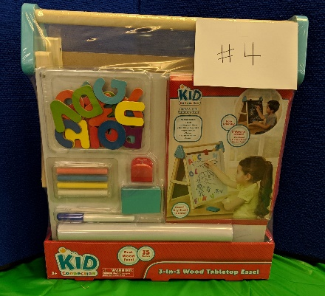  Easel, 26 magnet letters, 16-foot paper roll, paper roll clip, market, chalk and eraser. Chalkboard and dry erase board.  Donated by Casey and Lydia Mullins

#5 Usborne Books Basket  A variety of Usborne books inside a medium and large stacking wire basket.  *Horses & Ponies  *The Alphabet of Peculiar Creatures  *Unicorn Embroidery Kit  *Big Picture book Dinosaurs  *Now and Then  *Shine a Light on Literacy  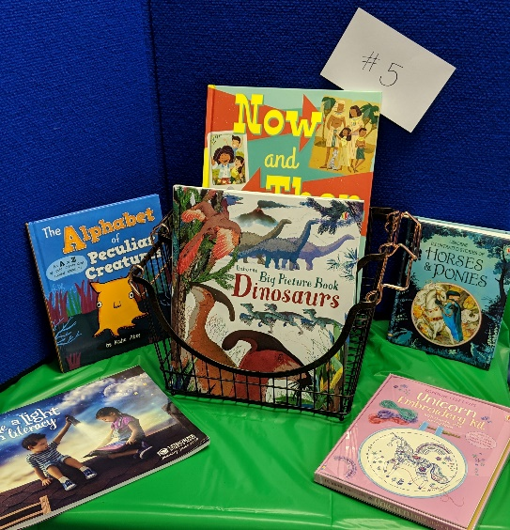  Donated by Heather Storey | #6 Toyota of Laramie  Gift Package 1 – Car Detail  Gift Certificate for full vehicle detail  (detail valued at $199.95)  Exterior car care kit, 2 baseball caps, 2 key chains, 2 pairs of sunglasses, a tee shirt, a water flask, a drawstring bag, and 2 chapsticks in a Blessed bin.  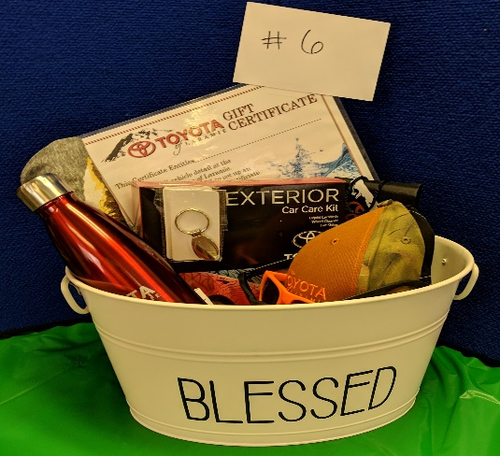  Donated by Toyota of Laramie
#7 Toyota of Laramie  Gift Package 2 - Car Detail  Gift Certificate for full vehicle detail  (detail valued at $199.95)  Interior car care kit, 2 baseball caps, 2 key chains, 2 pairs of sunglasses, a tee shirt, a water flask, and a drawstring bag in a Blessed bin.  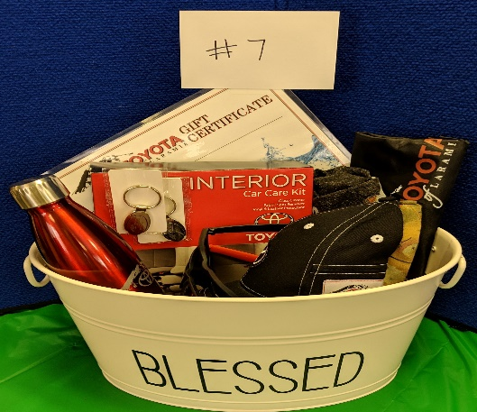  Donated by Toyota of Laramie | #8 Mary & Martha Kids  God Made Just One tote bag filled with goodies -4 melamine bowls and plates, faith building ABC magnets, a plush bear, a washable coloring placemat, and a God Made Just One book. Valued over $150  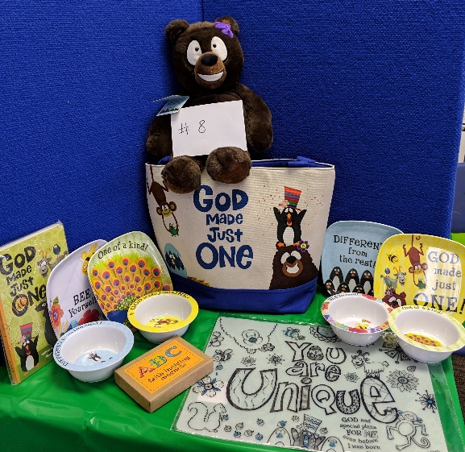  Donated by Shaunna Baysinger
#9 Mary & Martha Christmas  A beautiful Christmas celebration set!  Shepherd on the Search:  - Set includes plush, storybook and keepsake box  Nativity Set  - Set includes manger, shepherd with sheep, three kings and holy family, made from resin  Happy Birthday to the King  - Metal wall décor  Valued over $375  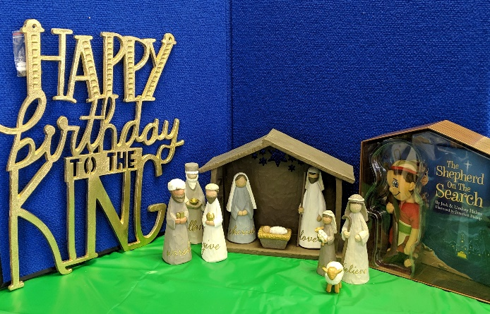  Donated by Shaunna Baysinger | #10 Pete The Cat Gift Set  Pete the Cat Book set:  *I Love My White Shoes  *Pete the Cat and His Four Groovy Buttons  *Groovy Joe Ice Cream & Dinosaurs  *Groovy Joe Dance Party Countdown  *Pete the Cat Rocking in My School Shoes  *Pete the Cat plush  *Open School youth medium hoodie  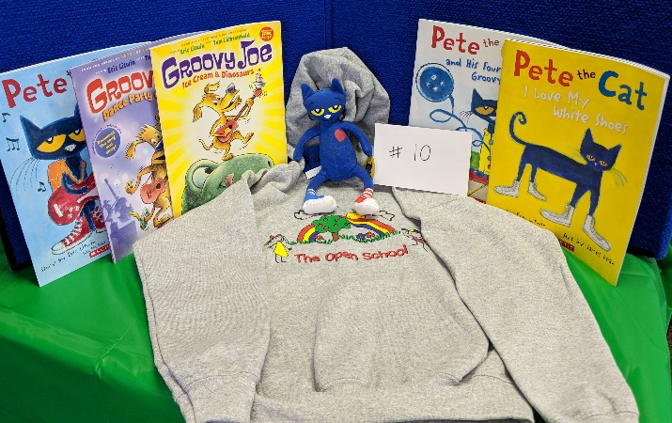  Donated by The Open School
#11 Open School  Tuition Gift Certificate for $100!  Redeemable through May of 2020.  Includes a youth medium t-shirt  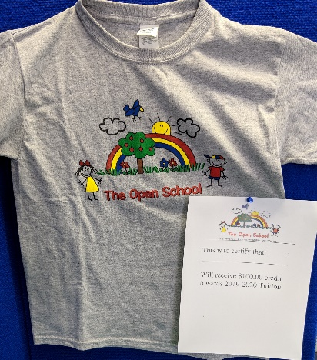  Donated by The Open School | #12 Premiere Design Necklace Trio  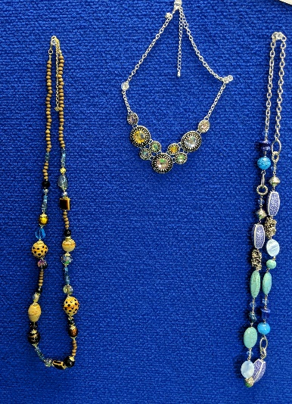  A trio of jeweled and beaded designer necklaces.  Approximately $150 value  Donated by  Penny Ogden

#13 Vee Bar Guest Ranch  Get away for a night and enjoy a stay for 1 night for 2 people at the Vee Bar Bed and Breakfast  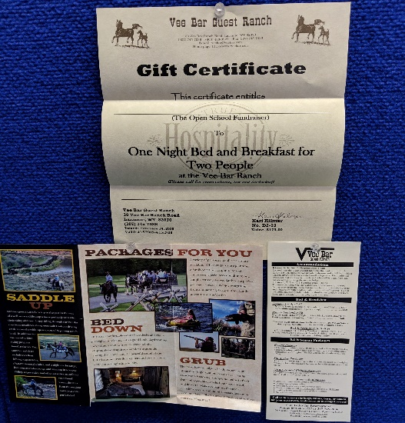  .  (Call for reservations – non-peak rates, taxes not included)  Donated by the Vee Bar Guest Ranch |  | #14 Aspen Family Chiropractic  1 Hour Massage – Gift #1  Pamper yourself with a one-hour massage from Aspen Family Chiropractic  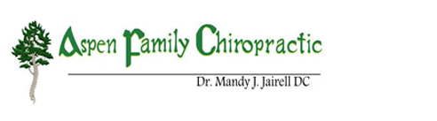  Donated by Aspen Family Chiropractic
#15 Aspen Family Chiropractic  1 Hour Massage – Gift #2  Pamper yourself with a one-hour massage from Aspen Family Chiropractic  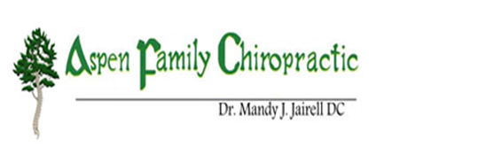  Donated by Aspen Family Chiropractic |  | #16 Flowering Journey Wellness  Sound Bath  One individual session or two spaces in a full moon sound bath. Expires 10/11/2019. Relax with this sound and vibration therapy session.  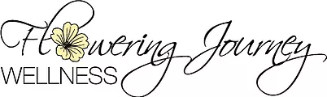  Donated by Theresa Chavez, Flowering Journey Wellness
#17 The Denver Zoo – 4 Passes  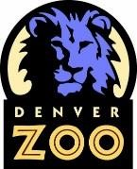  4 Daytime Pass tickets to The Denver Zoo! Enjoy a trip to explore the exhibits and hang out with the animals for the day!  Donated by The Denver Zoo |  | #18 Denver Museum of Nature and Science – 4 Passes  4 passes to the Denver Museum of Nature & Science, use before 01/09/2021  Valued at $80  Donated by the Denver Musem of Nature & Science
#19 Fort Collins Family Fun  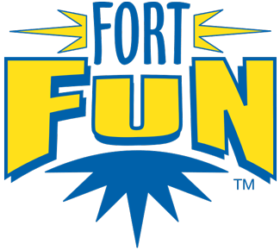  Take the family for a day of fun in Fort Collins at Fort Fun!  our muscles. Muscles  4 – rounds of mini-golf  4 – 2 hour slide passes  4 – bumper car rides  4 – games of laser tag  Valued at $96  Donated by Fort Fun, Fort Collins Colorado |  | #20 Elitch Gardens Admissions  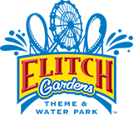  2 admissions for the 2019 season to Elitch Gardens in Denver  Valued at $109.98  Donated by Elitch Gardens Denver
#21 Butterfly Pavilion – 4 Passes  4 Admission Passes to The Butterfly Pavilion,  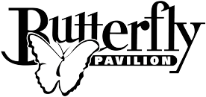  located in Westminster, Colorado.  Expiration 4/15/2020  Donated by the Butterfly Pavilion |  | #22 Fort Collins Museum of Discovery  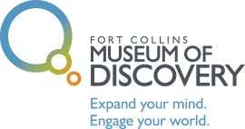  2-for-1 Passes  Enjoy multiple visits throughout the year to the Fort Collins Museum of Discovery. Ten total 2-for-1 passes, buy one admission get the second free. Expire on April 30, 2020.  Donated by The Fort Collins Museum of Discovery
#23 Brown and Gold Outlet  Wyoming Poke Pride! A Nalgene water bottle, coffee mug and 2 adult Nike Dri-Fit t-shirts (1 medium, 1 large).  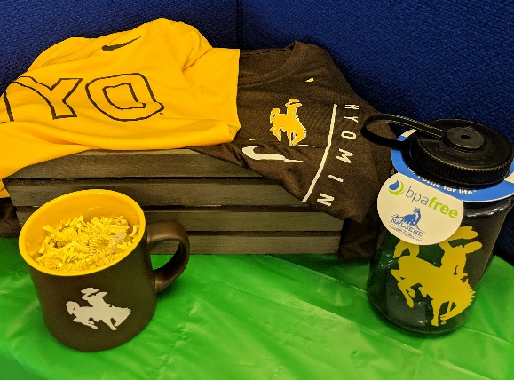  Retail Value $90  Donated by Brown and Gold Outlet |  | #24 Handmade Home Décor  A fun prize for crafters!  A WYO wooden plaque (1 ½” wide x 5” height x 5” length)  And a gift certificate for $25 both from Fae’s Family Creations Wood Decor crafts  Along with:  2 handmade wreaths (around 12”) from Willow Den Goods (Etsy: willowdengoods)  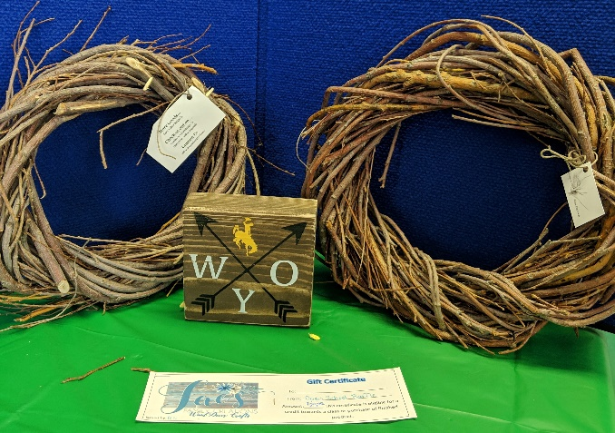  Donated by Fae’s Family Creations and  Wreaths donated by Willow Den Goods
#25 Discovery Toys  teach.play.inspire  Pick out a new toy from Discovery Toys! A $15 gift certificate and a Cascade Caterpillar rattle toy from Discovery Toys. Certificate expires 7/31/19.  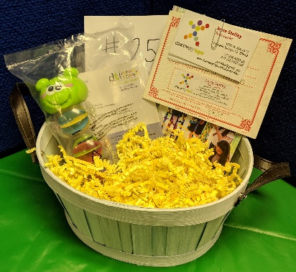  Donated by Joyce Stoffey, Discovery Toys |  | #26 Laramie Lanes  Bowlers Special! A 14 pound T-Zone Candy Apple Red bowling ball. Includes free drilling to customize it just for you!  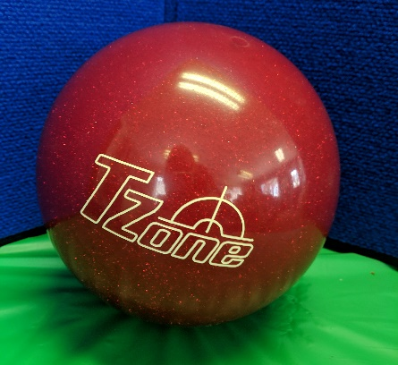  Donated by Laramie Lanes
#27 Art and Soul Pottery  Enjoy painting your own pottery at this downtown pottery studio. A gift certificate for $25.00 and 2 mugs to get you started!  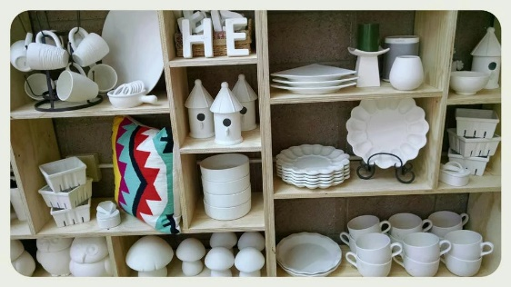  Donated by Caley Meyers, Art & Soul Pottery |  | #28 Jamberry Deluxe Set  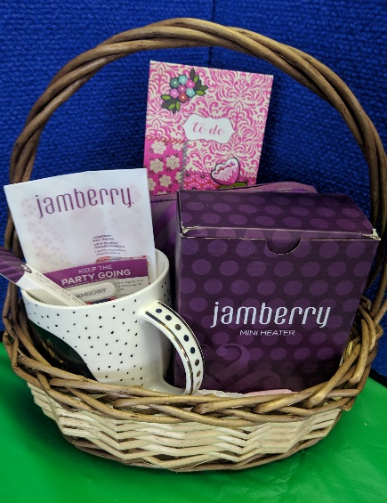  A basket full of Jamberry Nail supplies:  Manicure set, mini heater, full sheet of adult wraps, full sheet of kid wraps,  metal cuticle spoon,  several sheets of accent nails, memo pad book, and a mug  Donated by Sara Roberts
#29 Massage Time  Take a friend and relax with two 60-minute massage gift certificates courtesy of Spine & Injury Clinic of Laramie  Donated by Spine & Injury Clinic |  | #30 Downtown Dining and Wine Package  Enjoy eating in downtown Laramie with this $25 gift certificate to either Altitude or Lovejoy’s and a $20 gift certificate to Prairie Rose!  Along with 2 bottles of wine:  A bottle of Merlot and a bottle of Chardonnay  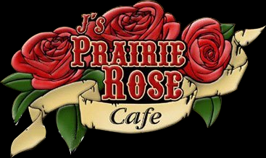  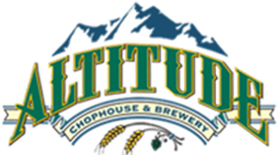  $25 Donated by Altitude/Lovejoy’s  $20 Donated by Prairie Rose  Wine donated by Gateway Fuel and Liquor
#31 Steamboat Wood Art  Show off your Poke pride in your home with a 15.5”H x21.5”W handmade wooden pallet art piece!  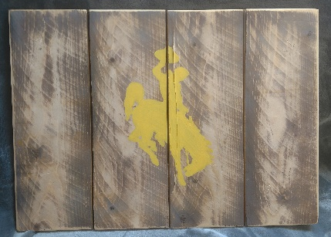  Made by and donated by Cody and  Jessica Liggett | #32 The Wild Rose  $50 gift certficate to The Wild Rose to splurge on yourself or treat someone to flowers or a gift!  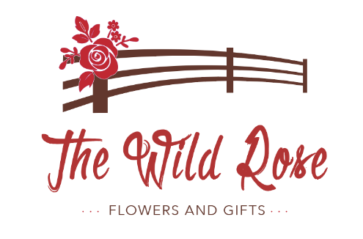  Donated by The Wild Rose
#33 Scripture Wood Art  A beautiful handmade art piece for your home - (16.5”Hx 19”W)  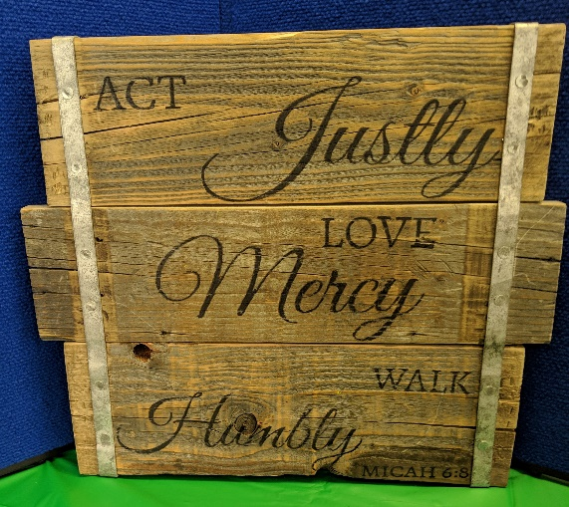  Made and donated by  Gracefully Weathered, Kim Gianakon | #34 Lemongrass Spa Bliss Box  Pamper yourself with this Spring Renewal Bliss Box of all natural beauty products:  *Island Coconut Prebiotic Hand Wash  *Kaleidoscope Mineral Eyeshadow with Mini Shadow Brush  *Rose Water Facial Mist 2 oz.  *Revitalizing Hair Mist 2 oz.  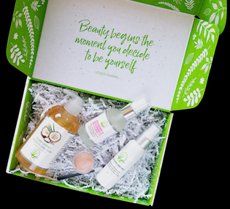  Donated by Shelly McFate

#35 Wyoming Legend Steamboat Wooden Art  Made by Wyoming Legend Laser Engraving, a wooden plaque adorned with Steamboat! (15”H x 19 ½”W)  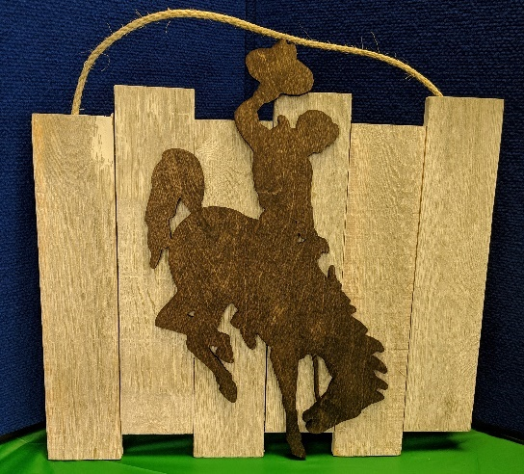  Donated by UniWyo Federal Credit Union | #36 The Library Sports Grille & Brewery  Craft beer special! Enjoy 3 t-shirts from The Library “Don’t Lie To Your Mom, Tell Her You’re at The Library” (1 sm, 1 med, 1 2xl)  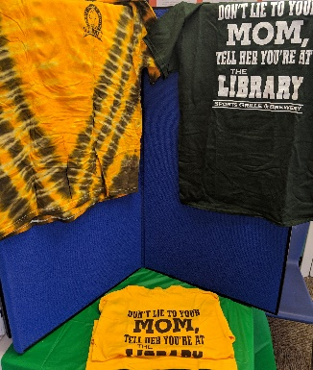  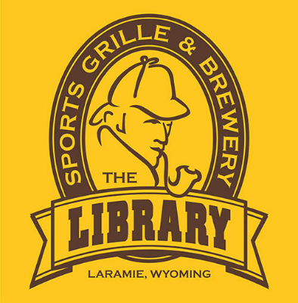  Plus 2 growlers of craft brews!  Donated by The Library (shirts) and  Dan and Delilah Pasman (growlers)
#37 Western Kid Fun Pack  Take your favorite kiddos to All Points West Laser Tag with a $25 gift certificate while they sport a couple of Western Express, Inc. cowboy hats! (Size 6 3/8 and 6 ¼)  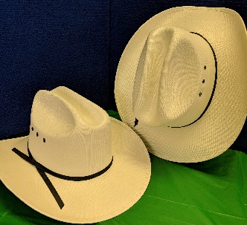  Gift certificate donatd by All Points West Laser Tag  Hats donated by Craig & April Jamison | #38 Family 4 Pack – Movie Tickets  Take the family out to the movies! 4 movie pass admissions, expire 3/31/2020/  Donated by Studio City UW Plaza

#39 Snowy Range Lift Tickets  Take the family skiing with four 1-day lift tickets, for the 2019-20 season.  Donated by Snowy Range Ski Area | #40 Jacoby Golf Course #1 package  Golf fun – take a friend golfing with this gift certificate for 18 holes for 2 with a cart  Expires 10/31/2019  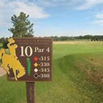  Donated by Jacoby Golf Course
#41 Jacoby Golf Course #2 package  More golf fun! Take a friend golfing with this gift certificate for 18 holes for 2 with a cart  Expires 10/31/2019  Donated by Jacoby Golf Course | #42 Meat Bundle – Butcher Block  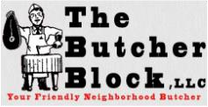  A bundle of quality meat from The Butcher Block – includes:  2 – 12 oz Ribeyes  2 – 12 oz Sirloins  2 – 12 oz New Yorks  2 – 8 oz Coho Salmon Filets  5# Ground Beef  5# Bone in Pork Chops  Donated by The Butcher Block
#43 Wyoming Rib & Chop House  Enjoy dinner out with $50 in gift certificates! “Home of premium steaks, fresh seafood and award-winning baby back ribs, all served in a casual atmosphere”  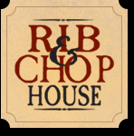  Donated by Wyoming Rib & Chop House | #44 Deluxe Craft Fun Basket  Great for those rainy days! A deluxe kit:  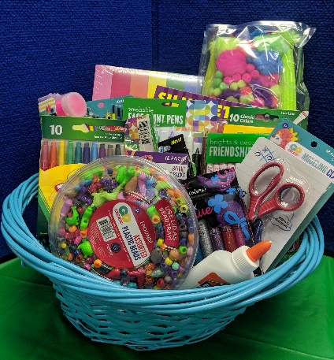  Construction paper, ultimate fuzzy kit, face paint pens, feathers, sticker book, paintbrushes, paint, kid scissors, glue, markers, glitter glue, beads, colored pencils, modeling clay, and friendship thread tucked into a wicker basket!  Donated by Tara Springsteen
#45 Wine and Long Sleeve Tee  Cuddle up in this soft long sleeve Wyo Clothing Co. tee (size L) and enjoy a bottle of California Rose Wine!  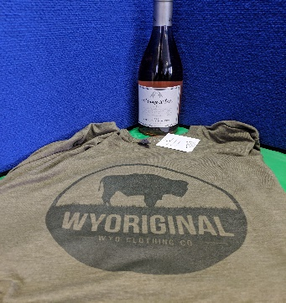  Shirt donated by Poppy’s  Wine donated by Gateway Fuel and Liquor | #46 Calvaryman Steakhouse  A $50 gift certificate to treat yourself to a steak dinner! Celebrate your special occasion at this historic steakhouse.  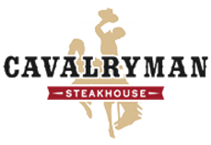  Donated by Cavalryman Steakhouse
#47 Paddleboard Adventure  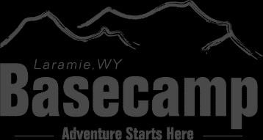  One 4-hour stand up paddleboard rental from Laramie Basecamp to enjoy this summer.  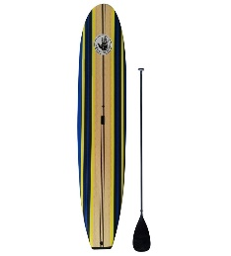  Donated by Basecamp | #48 Downtown Shopping Spree  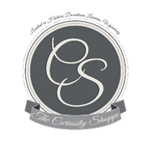  Enjoy shopping in beautiful downtown Laramie!  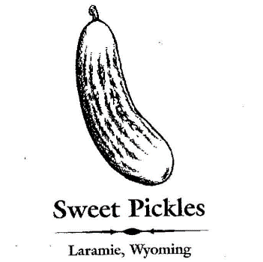  $25 gift certificate to  The Curiosity Shoppe downtown Laramie! Unique gifts, housewares, and cards  Also:  $25 gift certificate to Sweet Pickles for unique toys and clothing items for your special child.  Donated by The Curiosity Shoppe and Sweet Pickles
#49 Laramie Recreation Center  Party Package  A certificate valid for a party package at the Laramie Recreation Center (Value up to $222). Expires 4/30/2020  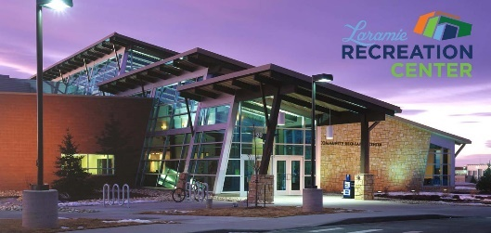  Donated by The Laramie Recreation Center | A special thanks to all our Donors!  We appreciate your support of early childhood education and  The Open School!  We truly appreciate your generosity!

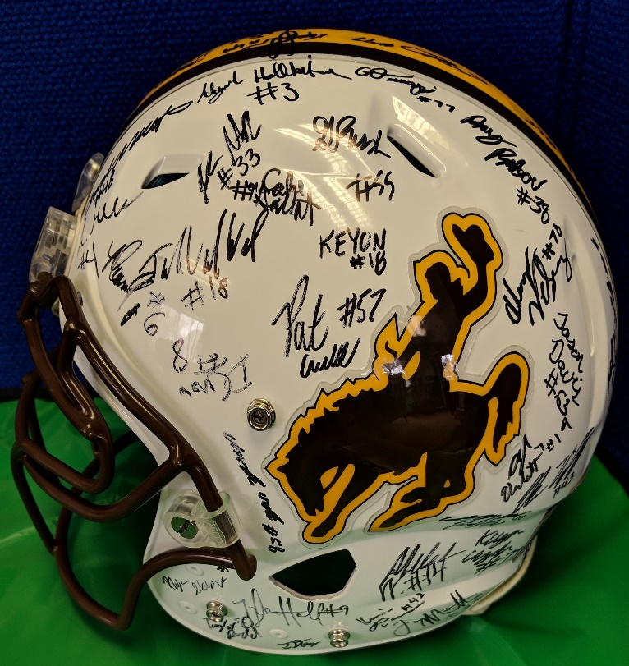
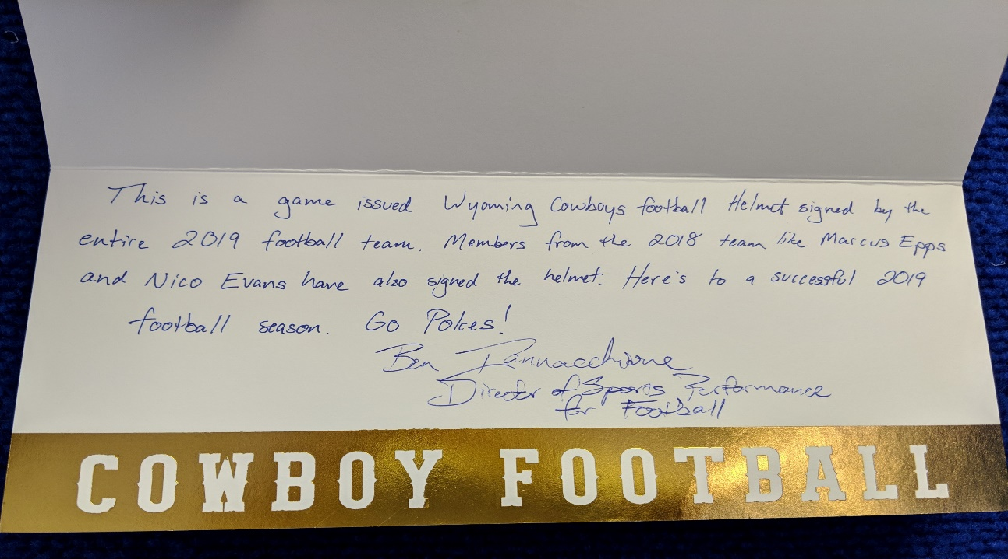
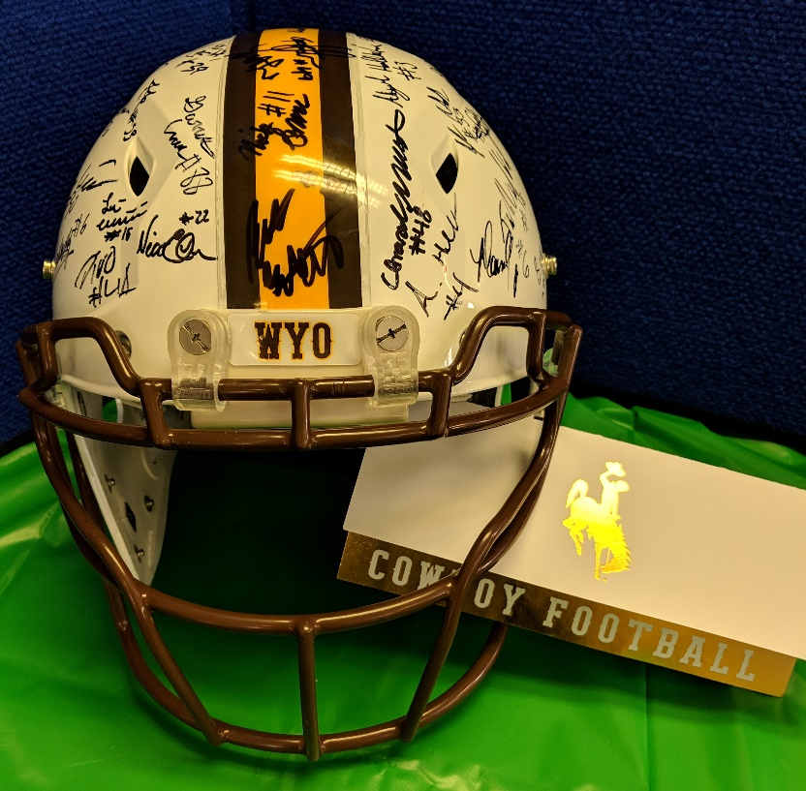
A special Silent Auction item!
A University of Wyoming football helmet autographed by the entire 2019 football team, as well as Marcus Epps and Nico Evans from the 2018 team! We will be having a silent auction in May at the school for this item. A big thank you to Ben Iannacchione for this awesome donation! Details for the auction coming soon!

