The Open School Spring
Raffle Fundraiser 2018

$1 Tickets/ Buy 10 Get 1 Free
We are excited to bring you our 11th annual Raffle Fundraiser featuring valuable prizes and merchandise. We have solicited coupons, gift certificates and passes from businesses around Laramie, Fort Collins and Denver, which we have divided into themed gift baskets to be raffled off. This fundraiser is open to anyone who wishes to join in and support The Open School!

Here’s how it works:
- Tickets are $1.00 each or buy 10 and get 1 free (11 tickets for $10)
- Fill out the back of the ticket with your name, phone number, and the number that corresponds to the item you want
- When you have sold your tickets please return the tickets and money to the office.
- All tickets must be purchased and turned in by May 14th
- The drawing will be held at noon on May 16th, with results posted at graduation that evening and listed on our website
- Need not be present to win
- If you have any questions regarding this fundraiser, please feel free to call at 307-745-7256.
- The family who sells the MOST raffle tickets will get $200 off tuition for the Open School (for families who have children going into Kindergarten in the fall we will reimburse you the $200).
- If we all chip in for this fundraiser, we hope to reach our goal to raise $3000.00 to help upgrade our toys, curriculum materials, and furnishings and add to our building and maintenance funds!

ITEMS LISTED BY ITEM # - PLEASE LIST THE # ON BACK OF TICKET
THANK YOU FOR YOUR SUPPORT!
GOOD LUCK!

#1 UL Swag Set  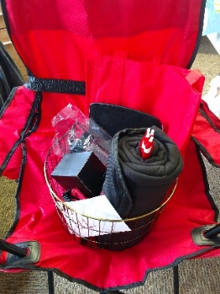  All the swag! A camp chair, power bank, blanket, pens, mouse pad and mouse, shopping bags, water bottle, and a travel first aid kit. | #2 Kid’s Summer Fun Basket  Beach towels, squirt guns, bubbles, bucket, balls – all you need for a fun summer day!  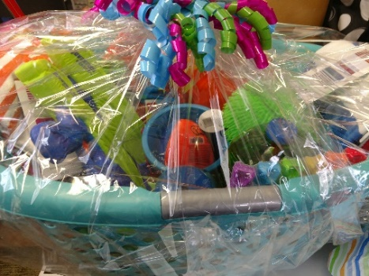
#3 Toyota of Laramie  Gift Package 1  Gift Certificate for oil change  Gift Certificate for full vehicle detail  (detail valued at $199.95)  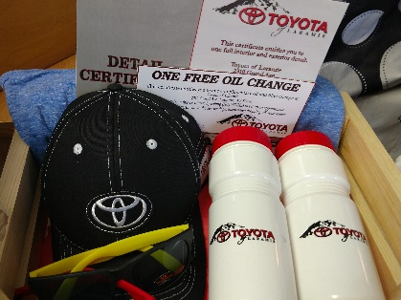  Baseball hat  2 water bottles  2 sunglasses | #4 UniWyo Ice Cream Party  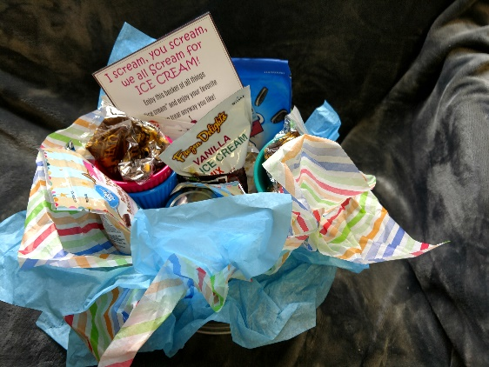  Enjoy an ice cream party with a tin full of toppings, ice cream bowls and mixes, along with $30 gift certificate to Dairy Queen!

#5 Chancey Williams and the Younger Brothers Band  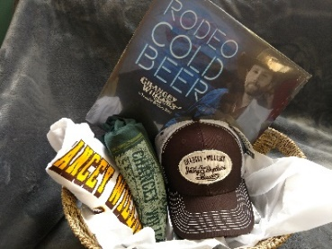  Enjoy the latest music from the Chancey Williams band. A vinyl record, 4 CD’s, 2 tee shirts and a hat to show your love of this WY band!  You can also share a bottle of Jim Beam Maple Bourbon Whiskey with your friends while you enjoy the tunes.  www.chanceywilliams.com | #6 Turtle Rock Coffee Set  Wooden box with chalkboard front, mug, towel, honey sticks, Numi tea box, vanilla syrup, 1 lb TR coffee beans, single cup French press, TR table coaster, and a free drink card  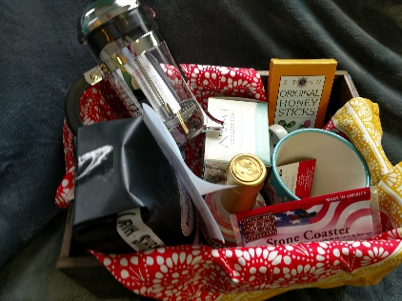
#7 Nordic Package  Enjoy Nordic skiing next season!  *Basecamp Gift certificate for 2 free daily adult Nordic ski rental packages  *Basecamp Gift certificate for 1 free seasonal preschooler Nordic ski rental package  *Gift certificate for the Medicine Bow Nordic Association (MBNA) Wee Ski program for the 2019 season  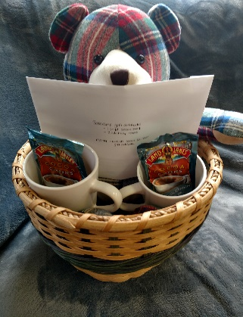  And after skiing snuggle with a Pendelton bear and enjoy some cocoa. All items nestled  in a handmade basket!  Basecamp (formerly Cross Country Connection) | #8 MVP - All Time Favorites Bag  Thirty-One, Pampered Chef and Pioneer Woman!  Try a new casserole recipe with this gift set! A lovely Thirty-One large tote bag filled with a Pampered Chef rectangular baker, a recipe book, and a Pioneer Woman floral casserole mitt.  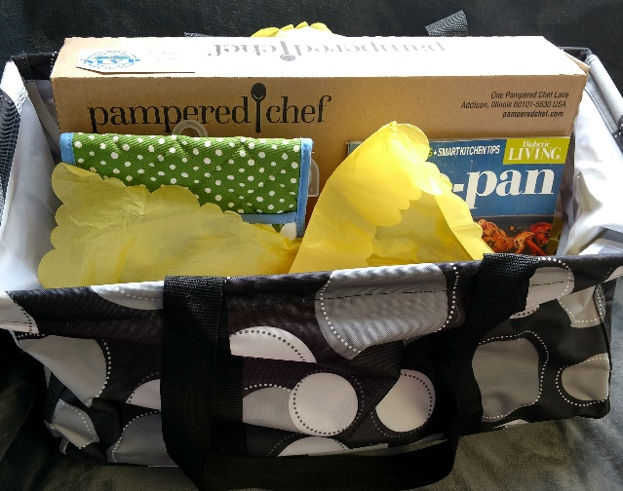
#9 Toyota of Laramie  Gift Package 2  Take care of your car!  Gift Certificate for oil change  Gift Certificate for full vehicle detail  (detail valued at $199.95)  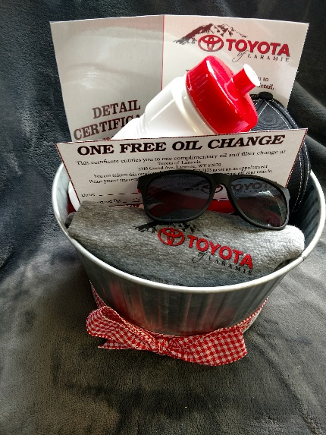  Baseball hat  Water bottle  Sunglasses  Tee Shirt | #10 Vee Bar Guest Ranch  Get a way for a night and enjoy a stay for 1 night for 2 people at the Vee Bar Bed and Breakfast.  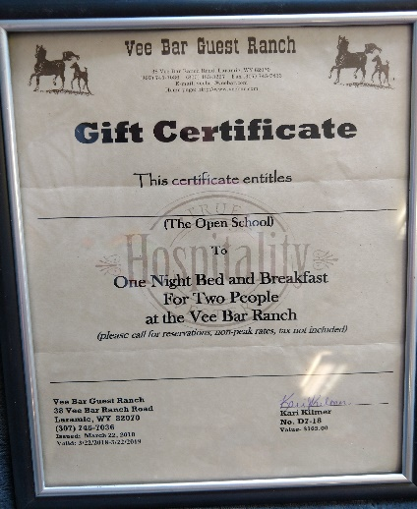  (Call for reservations – non-peak rates, taxes not included)
#11 Lemongrass Spa Gift Basket  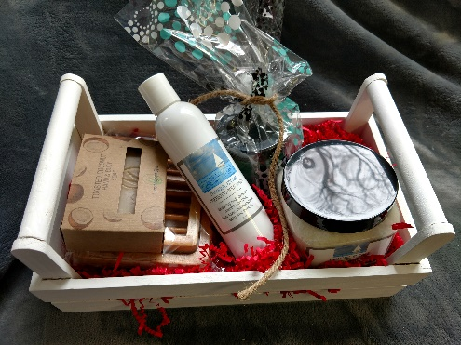  Tropical escape! Pamper yourself with this Lemongrass Spa set – Tranquil Escape body wash, body polish and bath soak, along with a bar of toasted coconut soap, and a wooden soap tray. | #12 Handmade UW Fleece Blanket  Handmade Steamboat Pallet Art  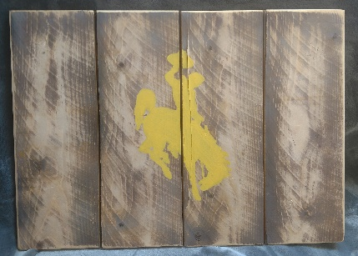  Support our favorite University – UW!  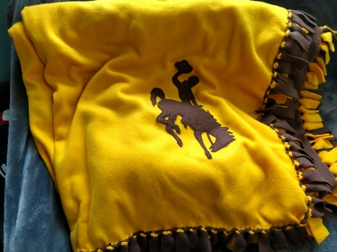  Cuddle up at the next UW football game in this soft and warm UW fleece blanket. Then show off your Poke pride in your home with a 15.5x11.5 handmade wooden pallet art piece!

#13 Kid’s Transportation Gift Set  A collection of fun books, puzzle, and trains for your favorite travel enthusiast! Usborne travel themed books and sticker books, a Melissa and Doug 50 states puzzle with sounds, a Little People zoo train, and a handmade in Wyoming wooden toy train.  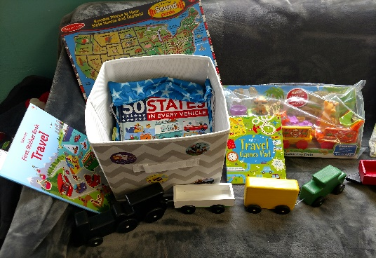 |  | #14 UW Golf Package  Sport your UW windbreakers (2 size large) and enjoy 4 rounds of golf with cart at Jacoby. Golf balls and a UW divot tool included!  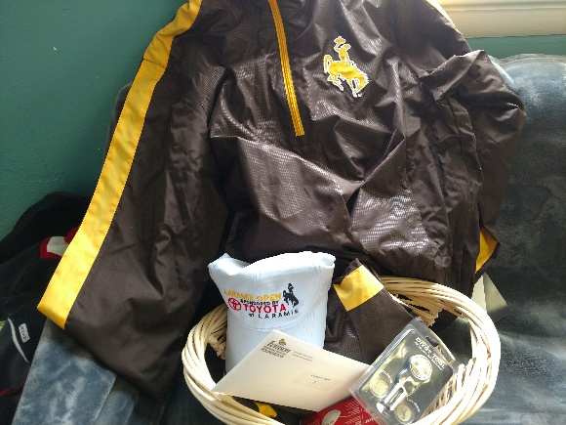
#15 Mary & Martha  A special gift for your special child. “God Made Just One” book, rewards coupon, floor puzzle and stuffed monkey nestled in an “It Is Well” wooden serving tray.  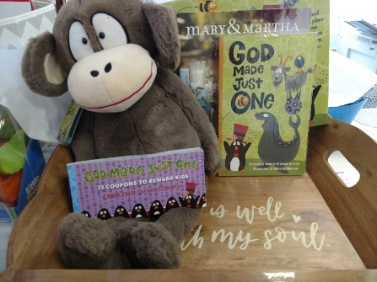 |  | #16 Fort Fun Family Day  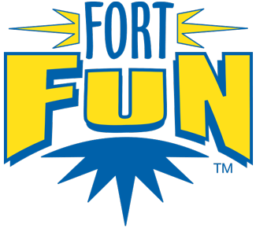  Take the family for a day of fun in Fort Collins at Fort Fun!  4 – rounds of mini-golf  4 – 2 hour slide passes  4 – bumper car rides  4 – games of laser tag
#17 All Points West Laser Tag  Family fun night – A $25 gift certificate for All Points West Laser Tag Family Fun Center |  | #18 Healing Foundations Massage #1  Relax with a 1 hour Swedish Massage at Healing Foundations Massage, 302 S. 2nd St, Ste 200, Laramie. Lauren Cruff, CMT  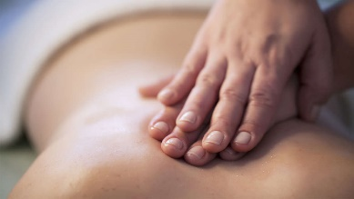
#19 Healing Foundations Massage #2  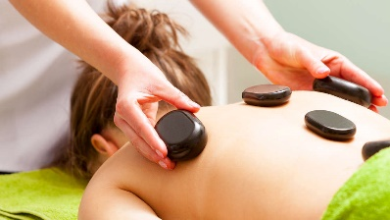  Destress with a hot stone therapy massage. Healing Foundations Massage, 302 S. 2nd St, Ste 200, Laramie. Lauren Cruff, CMTin your muscles. Muscles that |  | #20 Custom Ear Plugs or  Ear Phone Inserts from Laramie Hearing Aid Clinic  $100 value – Increase your comfort - Laramie Hearing Aid Clinic will custom make your choice of ear plugs or ear phone inserts!  Laramie Hearing Aid Clinic 253 N. 3rd St, Laramie
#21 Open School Tuition  Gift Certificate for $100!  Redeemable through May of 2019.  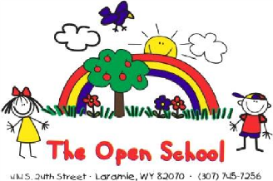  . |  | #22 Jacoby Golf Course #1 package  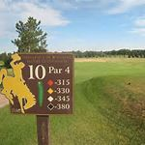  Gift certificate for  18 holes for 2 with a cart  Also, a hat, golf gloves and tees.
#23 Jacoby Golf Course #2 package  Gift certificate for  18 holes for 2 with a cart  Also, a hat, golf gloves and tees. |  | #24 The Denver Children’s Museum  4 admission passes to the Children’s Museum of Denver, expires 10/31/2018  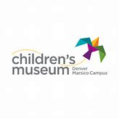  Along with a grow your own crystal set, a dinosaur tissue paper craft, and a small globe for your little scientist!
#25 The Butcher Block Package  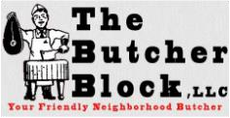  2 – 12 oz Ribeyes  2 – 12 oz Sirloins  2 – 12 oz New Yorks  2 – 8 oz Coho Salmon Filets  5# Ground Beef  5# Bone in Pork Chops  Along with a bbq towel, mitt and tongs. | #26 Bab’s Boutique Custom Earrings  Adorn yourself with 3 pairs of custom made unique earrings, made in WY by Bab’s Boutique.  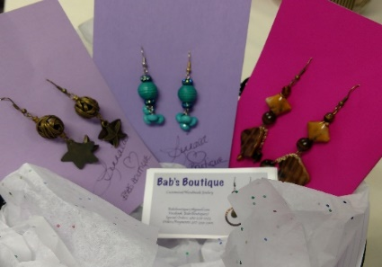
#27 Laramie Recreation Center  Party Package  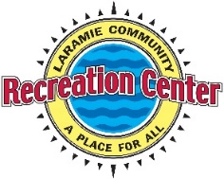  Host your child’s next birthday at the Laramie Recreation Center. Package includes their party package #2, sports or pool. Two hour room rental, 10 rec center admissions, party host, 2 pizzas and drinks for 10, party room decorations, tableware and balloons. | 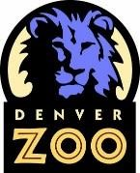  #28 The Denver Zoo  4 Daytime Pass tickets to The Denver Zoo! Enjoy a trip to explore the exhibits and hang out with the animals for the day! Along with a basket of sunscreen, animal crackers, a water bottle and mini plastic animals for the trip!
#29 TigerTree Tree Planting  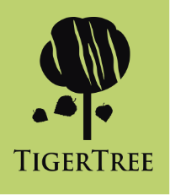  A tree valued at $250, covers the cost of labor and materials to plant an approximately 6 foot tree. Species selection discussed with TigerTree, selections that grow well at 7000 ft. | #30 Butterfly Pavilion  4 Admission Passes along with a bug catcher, gummy worms, and butterfly toys.  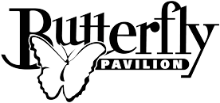  Located in Westminster, Colorado.

#31 Elitch Gardens Admissions  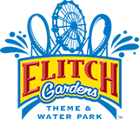  2 admissions for the 2018 season to Elitch Gardens in Denver  Plus a basket with water bottles, sunscreen, hand sanitizer and a misting fun to help keep you hydrated and cool all day! | #32 Honeywagon Sanitation Pumping  $275 Gift Certificate  A certificate for $275 towards any service they offer. These services include septic pumping, portable toilet rental and dumpster rental!  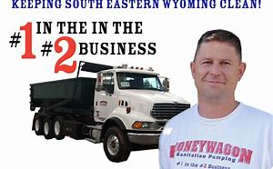
#33 Applebee’s Gift Certificates  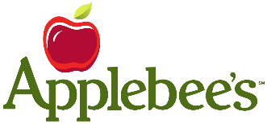  Take your family or friends to dinner at Applebee’s and enjoy $10 off each visit. This gift includes 10 gift certificates for $10 off each visit, total value $100 | #34 The Wild Rose  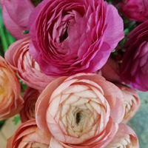  $50 Gift Certificate  $50 to The Wild Rose to splurge on yourself or treat someone to flowers or a gift!
#35 The Curiosity Shoppe  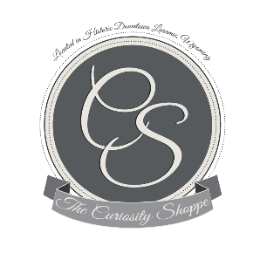  $25 Gift Certificate  Enjoy shopping at The Curiosity Shoppe downtown Laramie! Unique gifts, housewares, Alex&Ani, apparel, greeting cards – your choice – enjoy your shopping trip! | #36 Wyoming School of Gymnastics  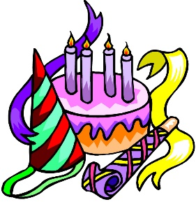  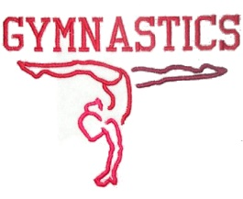  Have your next birthday party for 15 kids at Wyoming School of Gymnastics!
#37 Colorado Rockies Tickets  2 tickets for the May 29th game  CR vs. Giants  6:40 p.m.  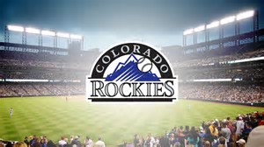  Sec 131 Row 15 seats 1 and 2 | #38 Damsel in Defense  Family Protection Kit  Family Board Game – Safe Hearts  Proactive Parent Guide  Pepper Spray  Daphne Wallet – digital theft protection  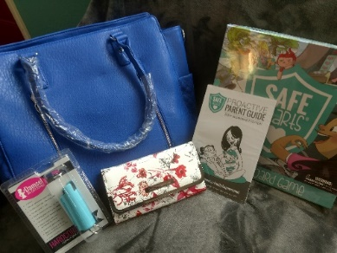  Large concealed carry purse
#39 Family Dinner and a Movie  Treat your family to a night out!  $75 gift certificate to Grand Avenue Pizza and a $55 gift certificate to Studio City Movies!  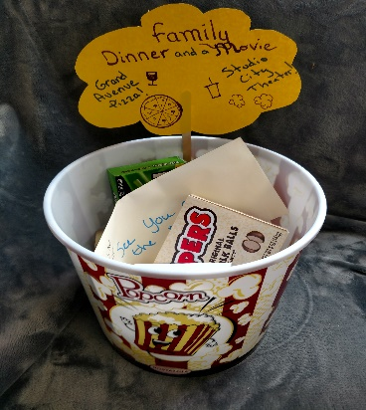 | #40 Ladies Pamper Kit  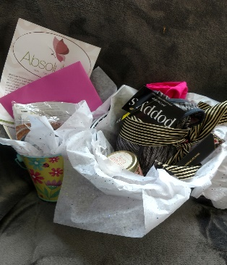  Absolute Acrylic Spa: $25 gift certificate from Absolute Acrylic Spa, along with bareMinerals blush, Marvelous Moxie lip gloss, foundation sample, blemish foundation sample  And  Poppys: sports tank top, sports bra, candle, and butter/London Plush Rush lip gloss
#41 Calvaryman Steakhouse  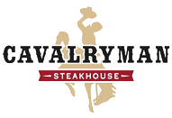  A $50 gift certificate to treat yourself to a steak dinner! Celebrate your special occasion at this historic steakhouse. | #42 Corona Village  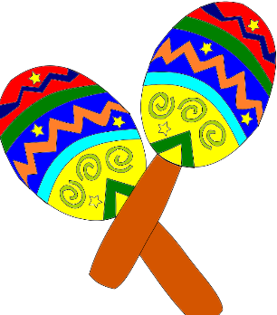  Fiesta Time!  A $35 gift certificate to Corona Village and a 750 ml bottle of Patron Citronge Lime Liquer!
#43 Speedgoat  $25 gift certificate  Dinner at Speedgoat - a locally owned burrito and street taco shop! | #44 Saratoga Hotsprings Resort  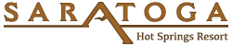  Relax and revive at Saratoga Hot Springs Resort! This gift includes a one night stay at the resort!
#45 Altitude Chophouse & Brewery  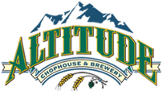  A $50 gift certificate to Altitude Chophouse and Brewery.  Unique food and hand-crafted brews! | #46 Lovejoy’s  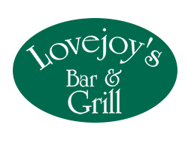  A $25 gift certificate to Lovejoy’s Bar & Grill. Casual cuisine, beer and cocktails!
#47 Wyoming Rib & Chop House  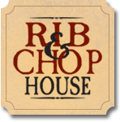  Check out Laramie’s newest restaurant with this $50 gift certificate! Premium Angus steaks, babyback ribs and fresh seafood. | 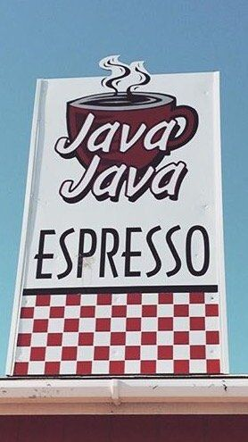  #48 Coffee and Wine  Start the day with a $20 gift certficate to Java Java and then enjoy a bottle of Mad Housewife Merlot later in the day
#49 Massage Time  Take a friend and relax with two 60 minute massage gift certificates from Spine & Injury Clinic of Laramie. | #50 Art & Soul Pottery  A $25 gift certificate and 2 pottery pieces to paint. Enjoy painting a camper and a mug at this unique pottery shop in downtown Laramie!  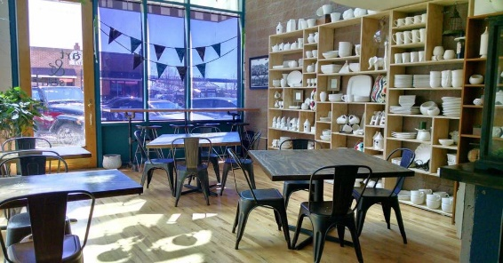

A special thanks to our Donors!
Listed by Raffle Item Numbers:

- UL – camp chair, mouse and pad and accessories
- Tara Springsteen – Kid’s Summer Fun basket
- Toyota of Laramie – oil change and detail basket
- UniWyo Credit Union – ice cream party supplies and $30 DQ gift certificate
- Wyatt Springsteen – Chancey Williams and the Younger Brothers band and
Gateway Liquors – Jim Beam
- Turtle Rock – coffee and tea gift basket, valued at $75
- Basecamp – 2 adult Nordic ski rentals, 1 preschool season Nordic ski rental and
MBNA Wee Ski season registration
Lindmier Family – Pendelton bear
Klinker Family – handmade basket
- Mountain Valley Properties – Pampered Chef casserole dish, Pioneer Woman casserole mitt, Thirty-One tote, recipe book
- Toyota of Laramie – oil change and detail basket
- Vee Bar Guest Ranch – 1 night bed and breakfast stay
- Lisa Faus, Lemongrass Spa gift basket
- Ashley Bean – handmade UW fleece blanket; and
Cody and Jessica Liggett handmade wooden pallet art
- Heather Storey – Usborne books, puzzles and
Schumaker Family – Little People train
McFate Family – wooden train
- Erin and Craig Rumsey – UW windbreakers, 4 rounds of golf and accessories
- Shaunna Baysinger – Mary & Martha set
- Fort Fun of Fort Collins – mini golf, slide, bumper car, laser tag
- All Points West Laser Tag - $25 gift certificate
- Healing Foundations – 1 hour Swedish massage
- Healing Foundations – 1 hour hot stone therapy massage
- Laramie Hearing Aid Clinic – custom ear plugs or ear phone inserts
- Open School - $100 tuition
- Jacoby Golf Course – 18 holes for 2 with a cart
- Jacoby Golf Course – 18 holes for 2 with a cart
- The Denver Children’s Museum – 4 admission passes
- The Butcher Block – Meat package
- Bab’s Boutique – 3 pairs of custom earrings
- Laramie Recreation Center – Birthday party package
- The Denver Zoo – 4 daytime passes
- TigerTree - a tree with planting, valued at $250
- Butterfly Pavilion – 4 admission passes
- Elitch Gardens - 2 admission passes
- Honeywagon Sanitation Pumping - $275 gift certificate
- Applebee’s – ten gift certificates for $10 off each visit
- The Wild Rose - $50 gift certificate
- The Curiosity Shoppe - $25 gift certificate
- Wyoming School of Gymnastics – birthday party for 15 children package
- Dr. Bragg and family – 2 Colorado Rockies Tickets
- Amanda Juarez – Damsel in Defense collection
- Neubauer, Pelkey, Merseal and Goldfinger, LLP – $75 Grand Ave Pizza and $55 Studio City certificates
- Absolute Acrylic Spa - $25 gift certificate and bareMinerals samples and
Poppy’s – sports tank tops, sports bra, candle, lip gloss and
- Calvaryman Steakhouse - $50 gift certificate
- Corona Village $35 gift certificate and
Gateway Liquors – Patron Citronge Lime Liquer
- Speedgoat - $25 gift certificate
- Saratoga Hotsprings Resort – 1 night stay at the resort
- Altitude Chophouse & Brewery - $50 gift certificate
- Lovejoy’s Bar & Grill - $25 gift certificate
- Wyoming Rib & Chop House - $50 gift certificate
- Java Java Espresso- $20 gift certificate and
Gateway Liquors – Mad Housewife Merlot
- Spine & Injury Clinic of Laramie – 2 gift certificates for 60-minute massages
- Art & Soul Pottery - $25 gift certificate and 2 pottery pieces – a camper and a mug
THANK YOU FOR YOUR SUPPORT OF THE OPEN SCHOOL!

