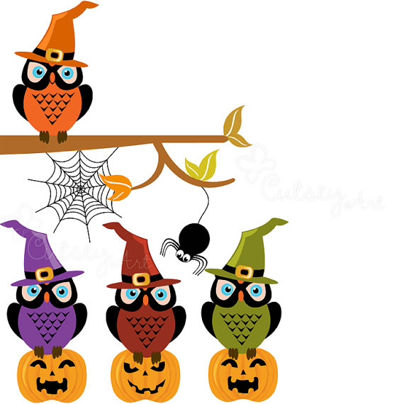
THE OPEN SCHOOL –
DIRECTOR’S NEWSLETTER

UPCOMING DATES
October 8 – Board Meeting 5:30 p.m. at the school
October 12– Maintenance Day- UW Big Event fall clean-up 8:00 a.m. - ? (noon at latest)
October 23 – Half day (District Wide) 11:30 Dismissal at Open School
October 24-25 – No School Parent/Teacher Conferences
Week of Conferences – Scholastic Book Fair
October 29 – Halloween Family Night 6-7 p.m.
October 31 – Halloween Class Parties

Parent/Teacher Conferences
Parent/Teacher conferences are scheduled for the week of the 21st. October 23 is a District Wide Half Day – 11:30 dismissal here. We are closed on the 24/25 for conferences (same as District schools). Each teacher has a morning during the week (Oct. 18 – Carrie, Oct. 21 – Laura, Oct. 22 – Amber) that they are going to have conferences as well. We have normal school those days, they will have a substitute teacher in the classroom that morning, so they can meet with parents. Please see the sign-up sheets in each classroom.

Maintenance Day/UW Big Event
Our fall maintenance day is October 12th starting at 8:00 a.m. until we are finished. (Noon at latest). We partner with the UW Big Event and should have several students to help pitch in as well. You do not need to come for the entire morning, we will take any help that you can provide. Bring a rake if you have one (put your name on it so it doesn’t get mixed up). We have landscaping jobs as well as minor repairs to complete. We appreciate your help in preparing our school for the winter.

Developmental Screenings
Developmental screening results will be in cubbies soon. If your child did not get screened, please see me to arrange a screening through Developmental. Please see me with any questions once you receive the results.

Halloween Family Night
We will have a fun family night on October 29th from 6-7 p.m. Costumes are encouraged, and we will have a costume parade at 7:00 p.m. around the school! We will have a couple of games in each classroom. We do need cupcakes for the cake walk, and always welcome parent volunteers. Please see me if you want to help during this event or provide cupcakes. We hope to see you there.

Halloween Classroom Parties
Your child’s teacher will be letting you know what activities are happening on Halloween day in their classroom. Costumes are allowed on Halloween. Each class will have their own party that day. If your child does not normally attend, you are welcome to bring them to the party. Please visit with your teacher for more specific details.

Popcorn Fundraiser
Thank you for helping with the popcorn fundraiser. We were able to raise $3400! The popcorn is scheduled to be delivered to the school on October 11th.

Popcorn pick-up times (assuming delivery happens on Friday)

October 12th (maintenance day) from 8-12
or
Monday October 14th. Morning 8:30-11:30 and afternoon 2:30-4:30.

If you missed out - we had to order popcorn by the case, so there will be some extra bags for sale in the office next week.

Scholastic Bookfair
We have 2 book fairs each year – one in the fall and one in the spring. It will be set up in the office mid-October once the books arrive and run through parent/teacher conferences. It is a cash and carry sale – just select the books you want and purchase them directly from the fair. Cash, credit cards and checks payable to The Open School are accepted. Books always make great Christmas gifts!

Winter Weather
Please remember to send your child with coats for our chilly mornings. We will continue to play outdoors all year, so layers and warm clothing is essential. Lost and found is in the office by the front door if your child has misplaced anything.

Drop-Off/Pick-Up
Please remember to walk your child to/from the playground or classrooms to drop off and pick up each day. Please make sure a teacher has checked your child in/out on the attendance clipboards so that the staff knows they are in attendance. We do ask the children to not run to you from the red line, so that we can make sure we are keeping track of children. We appreciate your help with this very important attendance procedure.
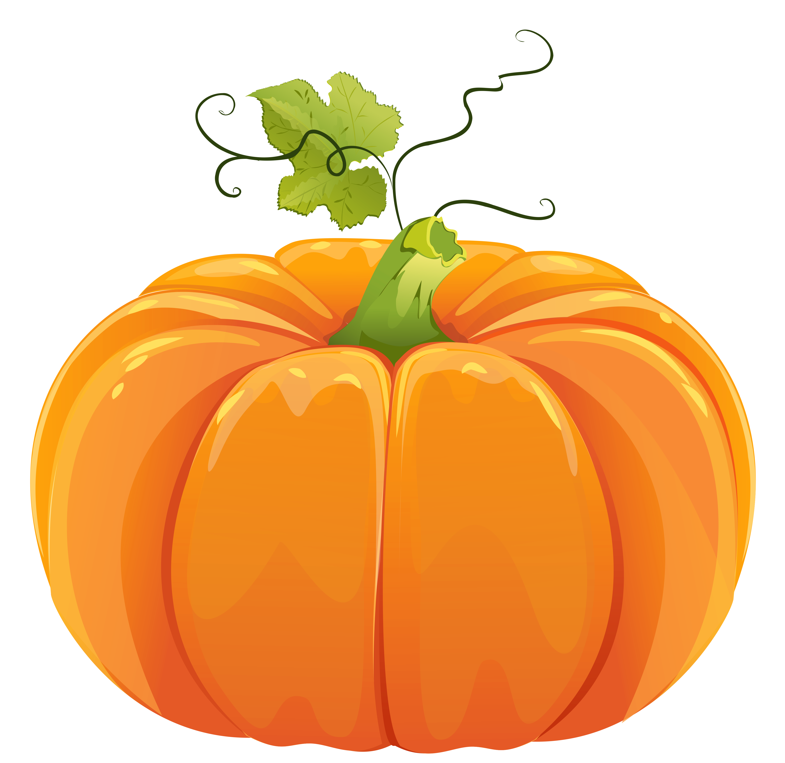

Spanish Corner – Miss Natalie
¡Hola parents!
This past month we started our Spanish classes! Your kids have been learning a lot and having fun! We’ve been working on our numbers 1-10 (uno, dos, tres, cuatro, cinco, seis, siete, ocho, nueve, diez). We have learned lots of new phrases, hola me llamo...., me gusta..., cómo estás?, and estoy bien/mal. We have started working on our colors and we’ve covered rojo, azul, verde, and amarillo. Your kids have been learning so much it would be great if you could review some of these new Spanish phrases and words with them!
¡Chao!

Sna. Natalie

Family Field Trip
We normally have gone on a family field trip, to a farm or museum, etc. However, last year we found it was tricky for parents to find a day off work in the fall with the start of school and fall sports. We have decided to have our family field trip in January or February, when there is less going on for everyone. I will give you details once we have worked out our final plan.
Amazon Smile
A simple way to support the school is to choose Open School as your charity of choice on Amazon. Simply log in to Amazon through smile.amazon.com and then search Open School as your charity. We will automatically receive a percentage of profit based on your order. (Order details are never shared, just a donation made by Amazon to us). It is sometimes tricky to remember to go through the smile.amazon, but it is an easy way to benefit the school.

Find us

Facebook: https://www.facebook.com/laramieopenschool/
Website: http://www.laramieopenschool.org/
Lesson Plans are posted weekly on the website under the “About” tab
Email: openschool1@hotmail.com
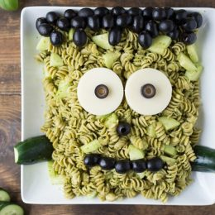
Frankenstein Pasta

Ingredients
- 1 cup basil, fresh
- 2 cloves garlic
- 1/3 oz (167 kernels) pine nuts, dried
- 1/3 cup Parmesan cheese, grated
- 1 dash salt
- 1/3 cup olive oil
- 16 ounce whole wheat pasta shells
- 3 medium cucumber
- 4 oz mozzarella cheese
- 1 cup black olives, canned

Instructions

In a blender or food processor combine basil, garlic, pine nuts, parmesan, salt (you can add pepper if you want as well) and olive oil. Taste and add more salt, pepper or garlic if desired.
Bring a pot of water (about 5 cups) to a boil and add whole wheat pasta. Cook according to box instructions. Drain and add pesto sauce. Stir well and let cool.
Peel and chop up 1 1/2 of the cucumbers and stir into pasta.
Pour out onto a platter and make a rectangle out of the pasta. Cut two slices of mozzarella and make them into circles using a cookie cutter or knife. Use olives to create Frank’s hair, pupils and mouth. Use the rest of the cucumber to make “bolts” in the side of his neck. Ta-dah!
Recipe from: www.superhealthykids.com

