Pre-K 1 Class Newsletter | October 7, 2019
Hi,  This week we will talk about bears and hibernation. On Wednesday, October 9th kids can bring in their favorite teddy bear. We will have a show and share that day and talk about what makes our bears so special to us!  The Open School will host Halloween Family Night at the school on October 29th from 6-7pm. There will be games, snacks and a costume parade. Costumes, siblings and family members are all welcome!  The classroom Halloween party snack sign up is on the board. The party will be from 9:30-10:30 a.m. Kids can come in costumes or change here. If your child stays for full days it might be a good idea to bring a change of clothes.  Have a great weekend! –Laura  Thank you to those who brought snack this week! | Upcoming Dates:  - October 12th UW Big Event/Maintenance Day 8-12pm Help with Fall clean up and winter prep  October 23-25 Parent/Teacher Conferences Parent/Teacher conferences are October 23rd, 24th and 25th. There will be a half day of school on October 23rd with an 11:30a.m.  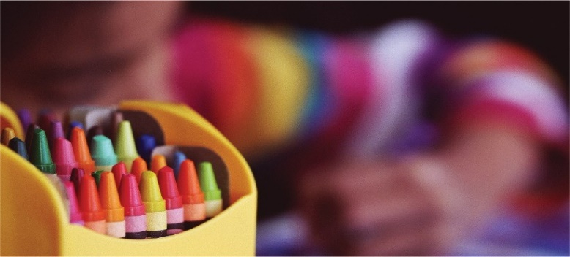  Conference sign-up sheet are hanging on the classroom board.

