Pre-K 1 Class Newsletter | September 9, 2019
Hi,  We will continue our apple unit this week along with practicing fine motor skills and shape recognition. We will make yummy apple pie in a cup for cooking, watch jumping apple seeds in science and play a fun apple alphabet game with friends.  The weather has been so nice and we have been enjoying staying outside longer during these beautiful days. Thank you for dressing your child in easy layers with the cool mornings and warm afternoons!  The first UW Art Museum class is on Friday from 1-1:45p.m.  Thank you to those who brought snack this week! -- Laura  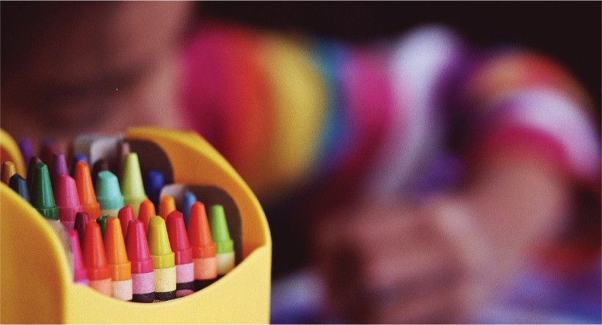 | Upcoming Dates:  - Art Museum—September 13th 1-1:45pm  - September 23rd—No school District wide staff Development  - September 24th –Swimming Begins, 1:30 p.m. Rec Center

