Hello Pre-K 1 Families,
We will continue our unit on the Rainforest this week. We will also celebrate The Week of the Young Child this week with some fun activities. On Musical Monday we will make our own instruments and learn a new song. Tasty Tuesday includes a cake decorating contest with Miss Amber’s class and Miss Carrie’s class. On Work Together Wednesday we will make binoculars and go on a jungle hunt looking for a lost animal and on Artsy Thursday we will create and label the layers of the rainforest. On Family Friday there will be breakfast treats available in Miss Amber’s room between 7:30-8:30 a.m. and we encourage you to have a small bite with your child as you drop them off for the day.
Wednesday will also include a bike safety assembly with a visit from the Pedal House.
Our class picture time will be at 11 a.m. on Wednesday, April 25th. If your child doesn’t attend this day and you would like them to be in the picture please bring them around 10:50 a.m. Thanks! Graduation/Year End Celebration is on May 16th at the LHS Auditorium. Please have children there by 5:45 p.m.
Upcoming Dates:
- Graduation/Year End Celebration –May 16th 6p.m.

Have a great weekend!
-Miss Laura

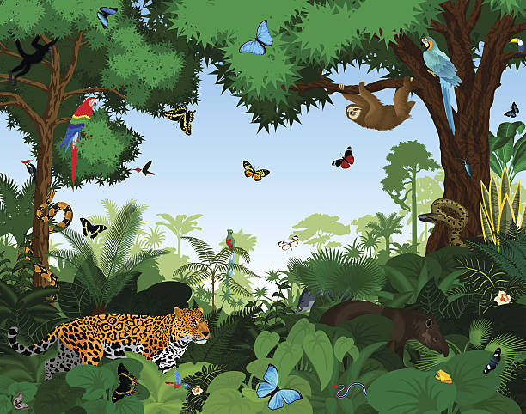

Library- Thursdays
Movement- Mondays
Music-Wednesdays
Cooking-Mondays
Spanish-Tuesdays
Art- Fridays

