Hello Pre-K 1 Families,
Thank you for attending parent teacher conferences! It was nice to visit with you all and share how wonderful your child is doing as we finish up the year. We will start a unit on the Rainforest environment this week. We will learn about the layers of the rainforest and what animals live there. We will do some fun crafts and make our own animals crackers for cooking.
Please hold the date for our Graduation/Year End Celebration on May 16th at 6p.m. It will be at the Laramie High School Auditorium. Please have kids there by 5:45 p.m. There will be light refreshments in the lobby afterwards.
Our class picture time will be at 11 a.m. on Wednesday, April 25th. If your child doesn’t attend this day and you would like them to be in the picture please bring them around 10:50 a.m. Thanks!
Upcoming Dates:
- Graduation/Year End Celebration –May 16th 6p.m.

Have a great weekend!
-Miss Laura

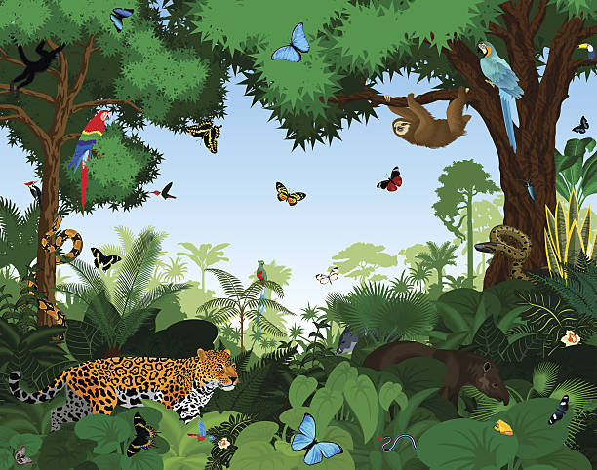

Library- Thursdays
Movement- Mondays
Music-Wednesdays
Cooking-Mondays
Spanish-Tuesdays
Art- Fridays

