Pre-K 1 Class Newsletter | September 2, 2019
Hi,  We have had a fun filled and busy first week! The kids are settling into the routine and finding lots of friends to play with. This week we will be learning about apples as we graph, taste test and create art with apples. We will also be starting our writing books. These books stay at school, but you can take a look at them during conferences. We will continue practicing fine motor skills like cutting with scissors, writing names and using just the right amount of glue.  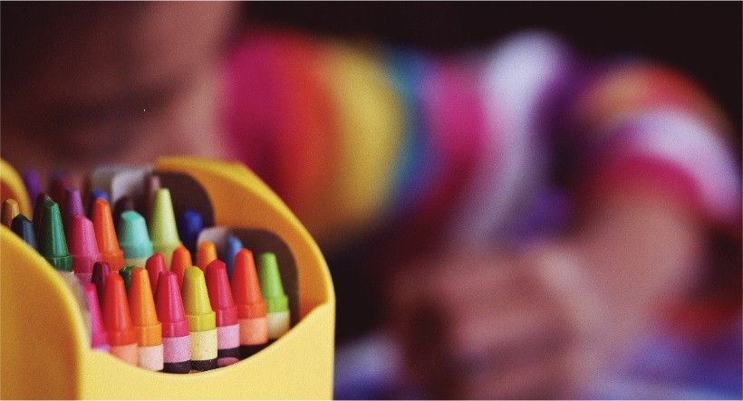 | Upcoming Dates:  - Art Museum—September 13th 1-1:45pm  - September 23rd—No school District wide staff Development  - September 24th –Swimming Begins, 1:30 p.m. Rec Center  Specials Schedule  Monday- Heathy Kids Rx 2p.m.  Tuesday- Swimming 1:30 p.m.(starting September 24th)  Wednesday –Spanish 10:30 a.m./Music 1:30p.m. (starting September 4th)  Thursday-Library 1p.m. (starting September 19th)  Friday- Art (starting September 6th)

